**[OFFICESUBLETNY](https://officesubletny.com/" \o "Officesubletny)**

126 5th Ave, New York

|

[212 242 6700](tel:2122426700)

VIEW EVERY SINGLE NYC OFFICE SUBLET  
THIS SITE IS STILL UNDER CONSTRUCTION

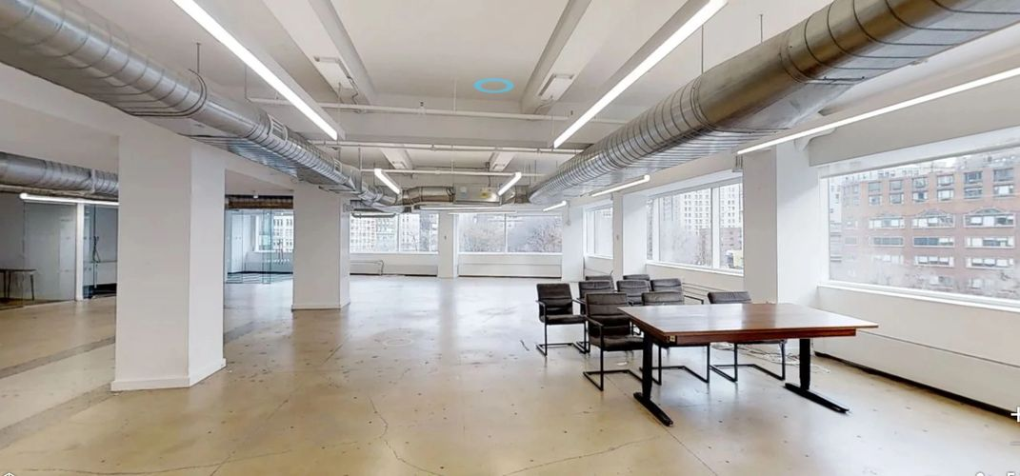

Midtown Sublets- July 1,2019

|  |  |  |  |  |  |  |
| --- | --- | --- | --- | --- | --- | --- |
| 1330 Avenue Of The Ame… | | P 6 |  | 100-1,600 |  | Withheld |
| 120 E 56th St |  | P 3 |  | 1,408 |  | 61.00/fs |
| 305-315 Madison Ave | | P 23 |  | 1,342 |  | 53.00/mg |
| 2 W 46th St |  | P 14 |  | 1,850 |  | Withheld |
| 650 Fifth Ave |  | P 17 |  | 4,116 |  | Withheld |
| 515 Madison Ave |  | P 20 |  | 2,778 |  | Withheld |
| 375 Park Ave |  | P 22 |  | 4,755 |  | Withheld |
| 211 E 43rd St |  | P 12 |  | 1,169 |  | 62.00/mg |
| 16-18 W 46th St |  | P 9 |  | 1,800 |  | 43.00/fs |
| 5 E 47th St |  | E 5 |  | 3,000 |  | 48.00/+util |
| 22 W 48th St |  | P 8 |  | 1,200 |  | 45.00/fs |
| 10 E 53rd St |  | P 6 |  | 3,652 |  | 62.35/mg |
| 60 E 56th St |  | E 8 |  | 4,947 |  | 35.00/mg |
| 1370 Avenue of the Americ… | | P 27 |  | 6,049 |  | 75.00-85.00/mg |
| 3 Columbus Cir |  | P 17 |  | 4,100 |  | 75.00/mg |
| 587 Fifth Ave |  | P 3 |  | 4,400 |  | 54.00/mg |
| 555 Madison Ave |  | E 26 |  | 5,826 |  | 55.00/TE |
| 654 Madison Ave |  | P 14 |  | 2,029 |  | 89.00/mg |
| 592 5th Ave |  | E 11 |  | 6,615 |  | Withheld |
| 888 7th Ave |  | P 4 |  | 2,130 |  | Withheld |
| 888 7th Ave |  | P 28 |  | 4,548 |  | Withheld |
| 888 7th Ave |  | P 40 |  | 8,250 |  | Withheld |
| 211 E 43rd St |  | P 5 |  | 3,943 |  | Withheld |
| 211 E 43rd St |  | P 11 |  | 4,008 |  | Withheld |
| 211 E 43rd St |  | P 17 |  | 1,300 |  | Withheld |
| 11 E 44th St |  | P 3 |  | 1,764 |  | Withheld |
| 19 W 44th St |  | P 7 |  | 4,704 |  | Withheld |
| 28 W 44th St |  | P 9 |  | 2,165 |  | Withheld |
| 321 W 44th St |  | P 9 |  | 7,622 |  | Withheld |
| 9 E 45th St |  | E 3 |  | 2,500 |  | Withheld |
| 140 E 45th St |  | P 16 |  | 9,402 |  | Withheld |
| 140 E 45th St |  | P 39 |  | 4,992 |  | Withheld |
| 228 E 45th St |  | P 6 |  | 5,200 |  | Withheld |
| 228 E 45th St |  | P 10 |  | 100-2,000 |  | Withheld |
| 2 W 45th St |  | P 15 |  | 2,032 |  | Withheld |
| 2 W 45th St |  | P 17 |  | 1,636 |  | Withheld |
| 25 W 45th St |  | P 12 |  | 5,342 |  | Withheld |
| 115 W 45th St |  | P 7 |  | 500-2,000 |  | Withheld |
| 16-18 W 46th St |  | E 6 |  | 4,400 |  | Withheld |
| 64 W 48th St |  | P 17 |  | 1,450-1,871 | | Withheld |
| 150 E 52nd St |  | P 14 |  | 4,357 |  | Withheld |
| 9 E 53rd St |  | E 5 |  | 2,000 |  | Withheld |
| 10 E 53rd St |  | E 29 |  | 8,925 |  | Withheld |
| 250 W 55th St |  | P 33 |  | 5,395 |  | Withheld |
| 127 E 56th St |  | P 4 |  | 1,000 |  | Withheld |
| 156 W 56th St |  | P 20 |  | 3,411 |  | Withheld |
| 32 E 57th St |  | E 2 |  | 4,480 |  | Withheld |
| 32 E 57th St |  | E 4 |  | 5,331 |  | Withheld |
| 32 E 57th St |  | E 5 |  | 5,297 |  | Withheld |
| 32 E 57th St |  | E 8 |  | 4,902 |  | Withheld |
|  |  |  |  |  |  |  |
| 32 E 57th St |  | E 9 |  | 4,902 |  | Withheld |
| 37 W 57th St |  | P 11 |  | 1,562 |  | Withheld |
| 152 W 57th St |  | P 41 |  | 4,242 |  | Withheld |
| 152 W 57th St |  | P 46 |  | 3,223 |  | Withheld |
| 152 W 57th St |  | P 49 |  | 6,800 |  | Withheld |
| 150 E 58th St |  | P 7 |  | 1,472 |  | Withheld |
| 1114 Avenue of the Americ… | | P 41 |  | 4,836 |  | Withheld |
| 1156 Avenue of the Americ… | | E 5 |  | 9,448 |  | Withheld |
| 1156 Avenue of the Americ… | | E 7 |  | 9,600 |  | Withheld |
| 1156 Avenue of the Americ… | | E 9 |  | 9,627 |  | Withheld |
| 1270 Avenue of the Americ… | | P 28 |  | 9,000-18,706 | | Withheld |
| 1370 Avenue of the Americ… | | P 3 |  | 5,587 |  | Withheld |
| 1700 Broadway |  | P 28 |  | 2,500-3,500 | | Withheld |
| 500 Fifth Ave |  | E 41 |  | 5,777 |  | Withheld |
| 546 Fifth Ave |  | E 14 |  | 8,553 |  | Withheld |
| 565 Fifth Ave |  | P 5 |  | 5,137 |  | Withheld |
| 576 Fifth Ave |  | P 5 |  | 2,100 |  | Withheld |
| 590 Fifth Ave |  | E 14 |  | 5,600 |  | Withheld |
| 597 Fifth Ave |  | E 6 |  | 6,381 |  | Withheld |
| 597 Fifth Ave |  | E 8 |  | 6,364 |  | Withheld |
| 600 Fifth Ave |  | E 27 |  | 7,980 |  | Withheld |
| 681 Fifth Ave |  | E 8 |  | 5,835 |  | Withheld |
| 712 Fifth Ave |  | P 45 |  | 2,298 |  | Withheld |
| 745 Fifth Ave |  | P 16 |  | 4,104 |  | Withheld |
| 745 Fifth Ave |  | P 16 |  | 3,989 |  | Withheld |
| 767 Fifth Ave |  | P 8 |  | 7,656-28,656 | | Withheld |
| 420 Lexington Ave |  | P 25 |  | 3,022 |  | Withheld |
| 600 Lexington Ave |  | E 33 |  | 6,780 |  | Withheld |
| 600 Lexington Ave |  | E 34 |  | 6,780 |  | Withheld |
| 330 Madison Ave |  | E 33 |  | 9,818 |  | Withheld |
| 330 Madison Ave |  | E 35 |  | 9,961 |  | Withheld |
| 330 Madison Ave |  | E 39 |  | 9,771 |  | Withheld |
| 366 Madison Ave |  | E 10 |  | 6,851 |  | Withheld |
| 400 Madison Ave |  | P 6 |  | 2,626 |  | Withheld |
| 437 Madison Ave |  | P 17 |  | 4,805 |  | Withheld |
| 444 Madison Ave |  | E 41 |  | 4,102 |  | Withheld |
| 540 Madison Ave |  | P 29 |  | 2,723 |  | Withheld |
| 595 Madison Ave |  | P 15 |  | 5,188 |  | Withheld |
| 595 Madison Ave |  | P 20 |  | 2,274 |  | Withheld |
| 595 Madison Ave |  | P 25 |  | 2,440 |  | Withheld |
| 625 Madison Ave |  | P 2 |  | 1,385-12,385 | | Withheld |
| 635 Madison Ave |  | P 12 |  | 1,500-2,000 | | Withheld |
| 645 Madison Ave |  | E 8 |  | 6,900 |  | Withheld |
| 660 Madison Ave |  | P 21 |  | 6,544 |  | Withheld |
| 200 Park Ave |  | P 17 |  | 100-3,000 |  | Withheld |
| 299 Park Ave |  | P 41 |  | 4,220 |  | Withheld |
| 400 Park Ave |  | P 12 |  | 6,562 |  | Withheld |
| 460 Park Ave |  | P 4 |  | 2,104 |  | Withheld |
| 1 Rockefeller Plaza |  | P 16 |  | 4,966 |  | Withheld |
| 1 Rockefeller Plaza |  | P 17 |  | 1,860 |  | Withheld |
|  |  |  |  |  |  |  |
| 810 Seventh Ave |  | P 4 |  | 2,000-4,324 | | Withheld |
| 685 Third Ave |  | P 16 |  | 9,288 |  | Withheld |
| 747 Third Ave |  | P 21 |  | 3,049 |  | Withheld |
| 750 Third Ave |  | P 23 |  | 8,572 |  | Withheld |
| 830 Third Ave |  | P 6 |  | 6,843 |  | Withheld |
| 850 Third Ave |  | P 15 |  | 9,821 |  | Withheld |
| 950 Third Ave |  | P 18 |  | 8,508 |  | Withheld |
| 52 Vanderbilt Ave |  | E 12 |  | 9,275 |  | Withheld |