**[OFFICESUBLETNY](https://officesubletny.com/" \o "Officesubletny)**

126 5th Ave, New York

|

[212 242 6700](tel:2122426700)

VIEW EVERY SINGLE NYC OFFICE SUBLET

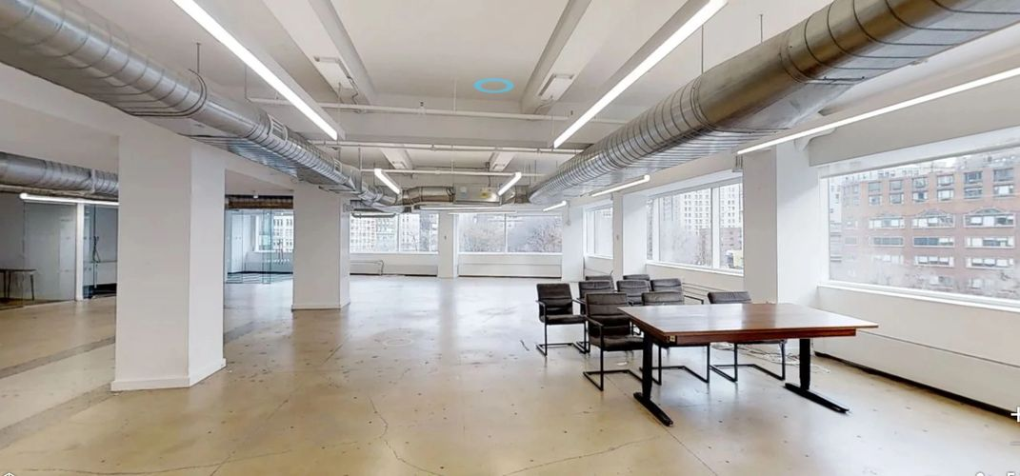

Soho Tribeca Sublets- MAY 1,2019

|  |  |  |  |
| --- | --- | --- | --- |
| 4 Bowery | P 2 | 1,500 | 60.00/tbd |
| 134 Bowery | P 4 | 1,000 | 50.00/tbd |
| 263 Bowery | P GRND | 1,900 | 105.60/mg |
| 285 W Broadway | P 6 | 1,275 | 65.88/mg |
| 181-183 Canal St | P 2 | 4,650 | 40.00/mg |
| 166 Mercer St | P 2 | 3,500 | 65.00/fs |
| 84-88 Wooster St | P 6 | 2,149 | 70.00/mg |
| 161 Bowery | E 2 | 3,300 | Withheld |
| 161 Bowery | E 5 | 3,300 | Withheld |
| 425 Broadway | E 2 | 3,330 | Withheld |
| 444 Broadway | E 3 | 8,425 | Withheld |
| 494 Broadway | P 2 | 2,979 | Withheld |
| 520 Broadway | E 9 | 5,500 | Withheld |
| 568-578 Broadway | P 6 | 6,498 | Withheld |
| 583-587 Broadway | P LL | 6,003 | Withheld |
| 583-587 Broadway | P GRND | 6,807 | Withheld |
| 584-590 Broadway | P 6 | 1,485 | Withheld |
| 594 Broadway | P 7 | 1,108 | Withheld |
| 594 Broadway | P 11 | 1,340 | Withheld |
| 412 W Broadway | P GRND | 560 | Withheld |
| 412 W Broadway | P MEZZ | 280 | Withheld |
| 412 W Broadway | P 2 | 560 | Withheld |
| 243 Canal St | E 6 | 4,950 | Withheld |
| 100 Crosby St | P 5 | 1,836 | Withheld |
| 41 Elizabeth St | P 7 | 2,049 | Withheld |
| 95 Grand St | P 2 | 1,400 | Withheld |
| 176-180 Grand St | P 6 | 2,182 | Withheld |
| 188 Grand St | E 4 | 3,300 | Withheld |
| 77 Greene St | E GRND | 2,200 | Withheld |
| 92-94 Greene St | P LL | 1,600 | Withheld |
| 92-94 Greene St | P GRND | 1,667 | Withheld |
| 122 Hudson St | P 5 | 2,205 | Withheld |
| 65 N Moore St | P 2 | 1,000-3,291 | Withheld |
| 92 Prince St | E GRND | 2,521 | Withheld |
| 92 Prince St | E 2 | 1,720 | Withheld |
| 96 Spring St | E 7 | 7,415 | Withheld |
| 96 Spring St | E 8 | 7,321 | Withheld |
| 155 Spring St | P 4 | 4,529 | Withheld |
| 40-42 Thompson St | E 2 | 5,193 | Withheld |
| 40-42 Thompson St | E 3 | 4,476 | Withheld |
| 415 West Broadway | P 5 | 3,287 | Withheld |