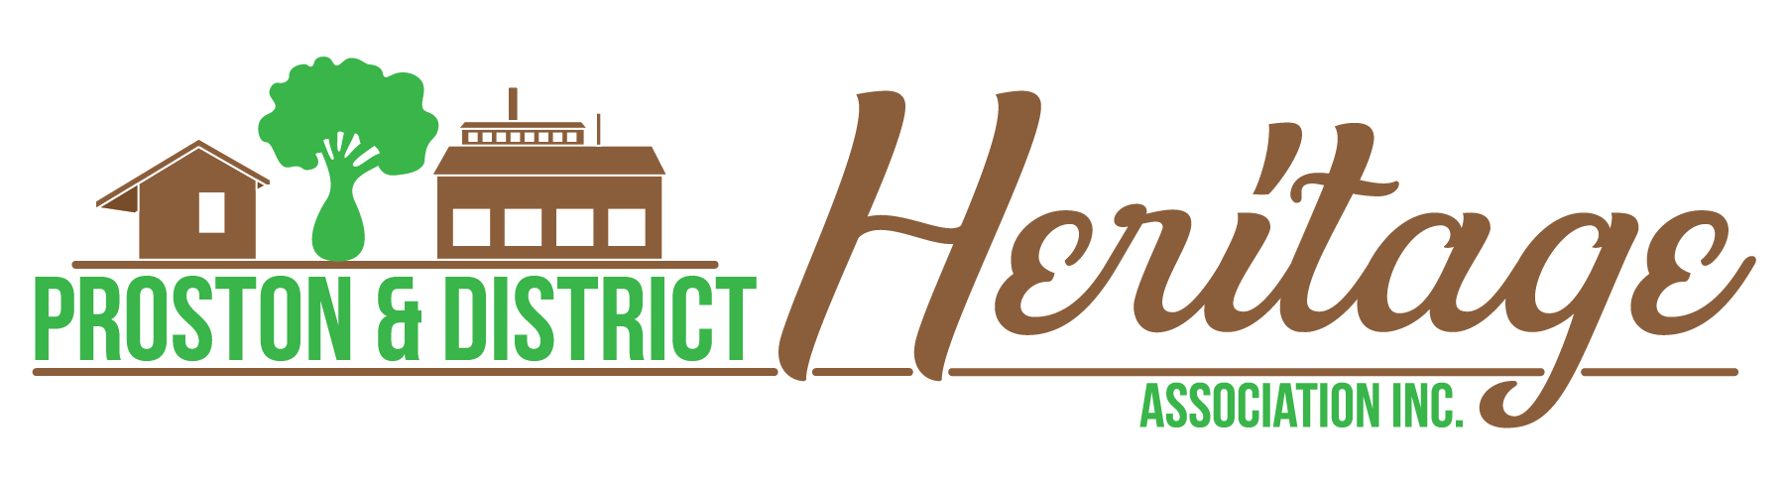

**EVENT STALL/VENDOR APPLICATION FORM**

This form is used when an individual or business wishes to apply for a stall or vendor space at the Proston & District Centenary 30 September to 1 October 2023. Complete the form and email to [prostonheritage@gmail.com](mailto:prostonheritage@gmail.com) or submit online at [www.prostonheritage.org.au/apply-for-stall](http://www.prostonheritage.org.au/apply-for-stall)

|  |  |
| --- | --- |
| **Name of Applicant** |  |
| **Business Name** |  |
| **ABN (if applicable)** |  |
| **Phone** |  |
| **Address** |  |
| **Email** |  |
| **Social media / Website** |  |
| **If selling food, do you have a valid food licence for the South Burnett?** | Yes / No  Note: a copy of your certificate of currency will be required. |
| **Do you have stallholder public liability insurance of minimum $10m?** | Yes / No  Note: a copy of your certificate of currency will be required. |
| **Do you need your vehicle on-site?** | Yes / No  Note: on-site vehicle access is limited and not guaranteed. |
| **Do you need access to power?** | Yes / No If Yes: 240V or Three-phase |
| Specify each appliance for which you require power: |
|  |
|  |
|  |
|  |
|  |
| Note: only appliances listed at the time of application may be used unless otherwise approved by the Event Director. |
| **Site requirement** | 3m x 3m  6m x 3m  9m x 3m  Other size, please specify:  Note: site availability is limited and not guaranteed. |
| **What date/s do you want your stall?** | Friday 29 September 2023  Saturday 30 September 2023  Sunday 1 October 2023  Note: site availability is limited and not guaranteed. |
| **Select your stall category** | Food & beverage (ready to eat)  Souvenirs  Arts & Crafts  Other (specify) |
| **Briefly describe the products you wish to sell and their connection to you** |  |
|  |
|  |
|  |
| Note: only goods listed at the time of application may be sold unless otherwise approved by the Event Director. |
| **What other markets or events do you trade at?** |  |
|  |
|  |
|  |
|  |
| **Provide any other information relevant to your stall application** |  |
| **Where did you hear about this event?** |  |

I give permission for the Proston and District Heritage Association Inc. to send information and news to me by email.

By submitting this form you confirm that you have read and agreed to our General Terms and Conditions.

By submitting this form you agree and commit to attending your stall on the agreed dates of the Centenary event.

We understand the Proston & District Heritage Association Inc. would appreciate a donation to support the running costs of our weekend in lieu of a site application fee where appropriate.

Name and Signature of Applicant:

________________________________________________

Date: __________________