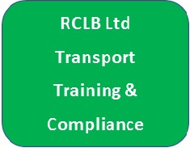
Driver CPC Training
Booking Form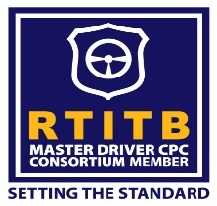

Customer Details
Company Name | Click or tap here to enter text.
Contact Name | Click or tap here to enter text.
Contact Tel No | Click or tap here to enter text.
Contact Email | Click or tap here to enter text.

Course Details
Course Tittle | Driver CPC Training
Course Date | 26/1/19 | Course Duration | 8Hrs | Start Time | 08.00
Venue | Earls Colne

Delegate Details
Name | Contact No | Email | D.O.B
Enter Name | Tel no | Click here to enter email. | DOB
Enter Name | Tel no | Click here to enter email. | DOB
Enter Name | Tel no | Click here to enter email. | DOB
Enter Name | Tel no | Click here to enter email. | DOB
Enter Name | Tel no | Click here to enter email. | DOB
Enter Name | Tel no | Click here to enter email. | DOB
Enter Name | Tel no | Click here to enter email. | DOB
Enter Name | Tel no | Click here to enter email. | DOB
Enter Name | Tel no | Click here to enter email. | DOB
Enter Name | Tel no | Click here to enter email. | DOB

Fees & Payment
Company / Delegate Name | Click or tap here to enter text.
Company address | Click or tap here to enter text.
Accounts contact | Click or tap here to enter text.
Accounts Tel no | Click or tap here to enter text.
Accounts email | Click or tap here to enter text.
Order Number | Click or tap here to enter text.
Course Title | Driver CPC Training
Course Date | 26 January 2019
Number of delegates | Click or tap here to enter text.
Course / exam fee per person | £60.00
DVSA Fees per person | £15.00
TOTAL | Click or tap here to enter text.

BACS payments to: Barclays, Account: RCLB Ltd 20-19-97 43481174
Please inform us at the time of booking if any delegate has any learning disabilities, access or special dietary requirements.

To confirm your booking please return this form, fully completed, along with confirmation of payment to:
RCLB Ltd - 07831 426991
roger@rclb.co.uk www.rclb.co.uk

Declaration: By completing and returning this booking form to RTITB you are agreeing to the terms and conditions of sale. Copy available upon request

Signed:Click or tap here to enter text.
Print: Click or tap here to enter text.
Date:Click or tap here to enter text.

