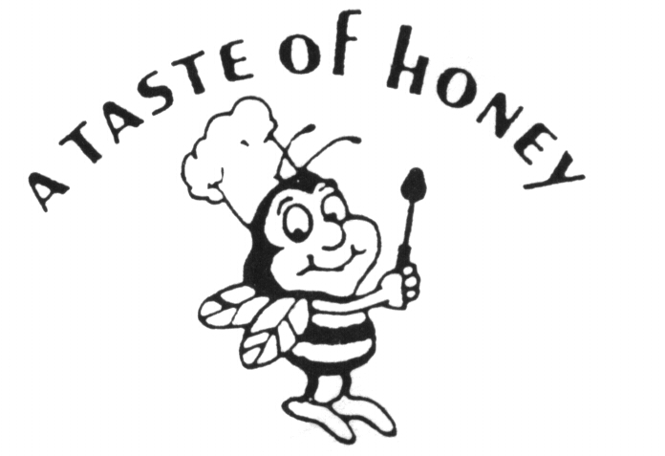
Banquet Hall Brunch

BRUNCH Buffet Pricing Starts at $45.50 per Adult for Saturday
BRUNCH Buffet Pricing Starts at $42.50 per Adult for Friday & Sunday

Plated Brunch Service Add $3.00 per Adult to Buffet Pricing
*Menu items selected with up charges must be added to base price*
Young Adults 13-20 are charged $35.00 ~ Children 5-12 are charged $20.00 ~ Children 4 & Under Free of Charge

Create your own buffet is built using the menu below
Plated brunch includes Basket of Breads, Salad, 3 Entrée Items chosen below, and 2 Sides
Additional entrée’s may be added for $3.75 per person / sides for $1.75 per person

Basket of Breads…
Mini Bagels, Muffins, Assorted Rolls & Danish

Choice of one (1) Salad…
~ Garden Salad ~ Caesar Salad ~ Spring Mix Salad ~ Broccoli Salad (Add $0.50) ~
Harvest Salad w/Mix Greens, Apples, Raisins & Pignoli Nuts, Raspberry Vinaigrette (Add $0.75)
Summer Salad w/Romaine Lettuce, Fresh Fruits, Roasted Walnuts, Goat Cheese and Raspberry Vinaigrette (Add $0.75)

Choice of five (5) Breafast items…
Starch Choices… Eggs/Dairy Choices…
Apple & Walnut Crepes Scrambled Eggs
Cinnamon Rolls Egg Tartlets
Baked French Toast Veggie Quiche
House Made Pancakes Trayed Omelets (Add $1.00)
Pancake Station (Staff Required) (Add $3.50) Omelet Station (Staff Required) (Add $3.50)

Potato Choices… Breakfast Meat Choices…
Roasted Red Skinned Potatoes Crispy Bacon
Home Fried Potatoes Turkey Bacon
Hash Browns Sausage
Corn Beef Hash (Add $2.00) Sliced Ham

Choice of two (2) Lunch items…

Poultry Choices… Seafood Choices…
Chicken Francaise Salmon w/Creamy Dill
Chicken Marsala Salmon Teriyaki
Chicken Parmesan Shrimp Francaise (Add $1.00)
Chicken Picatta Shrimp Lilley (Add $1.00)
Chicken w/Artichokes Shrimp Margherita (Add $1.00)
Chicken Milanese Mussels in Grand Marnier Sauce
Chicken Sorrentino (Add $2.00) Mussels Marinara
(Eggplant, Prosciutto & Fresh Mozzarella) Seasonal Whitefish Filet Oreganata
Chicken Sinatra (Add $2.00)
(Asparagus, Fresh Mozzarella & Champagne Sauce) Pork Choices…
Chicken w/Cognac & Mushroom (Add $2.00) Sausage & Peppers
French Cut Rosemary Chicken (Add $2.00) Pork Medallions in Apple Gravy
Chicken Cordon Blu (Add $3.50) Sliced Honey Ham
Included Beverages:
Unlimited Soft drinks, Sangria & Mimosa’s

Coffee, Tea, Custom Sheet Cake

Additional Bar Options:
Bottled Beer & Wine… $4.00 per person
Open Bar Options Available Upon Request

Fine Print

65 person Minimum / 120 person Maximum for Banquet Hall Events
Alcohol Bar Charges Only Apply to Guests over the Age of 21
Taxes and Gratuities NOT included in above pricing

A Taste of Honey Caterers Does Not Include Any Gratuities in its Pricing. Our Service Staff Works Hard to Ensure Your Event is a Special One. While Not Required, Staff Gratuities are Customary and Always Greatly Appreciated. If needed, management would be happy to offer guidance.

