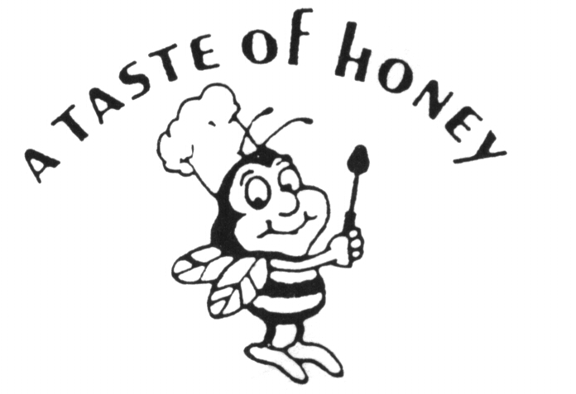
SPRING/SUMMER 2021 COVID-19 Event Rules

To our valued guests,

Thank you for considering A Taste of Honey Caterers for your celebration. The last year has been challenging for all of us and we are very excited to get back to celebrating and making memories.
The City and State have placed certain restrictions on all of our events. While these restrictions are meant to keep us all safe, some of you might find these restrictions a little too burdensome for your celebration. We understand how you feel. As the situation improves, we hope to see the restrictions evolve as well. However, during this time, if you wish to have an event with us, we expect all of our guests to comply with the current guidelines and ask that everyone respect the safety of our staff and the long term security of our business. We are looking forward to seeing you back with us soon!

Current OUTDOOR Guidelines
- Capacity limits are as follows: Outside Pavilion Min 75 - Max 200 Guests
- Temperature Checks of all Guests & Staff must occur before entering facility, Anyone with an elevated temperature will not be permitted entry
- Masks must be worn when entering, in facility common areas, such as the bathrooms and whenever proper distance cannot be maintained
- Tables will be spaced 6ft apart with a maximum of 10 guests at each table
- All seating must be assigned and members of the same family should sit together
- Host must maintain a guest contact list for tracing purposes
- Staff will wear masks at all times

Current INDOOR Guidelines
- Capacity limits are as follows: Indoor Banquet Room Min 50 - Max 100 Guests
- Temperature Checks of all Guests & Staff must occur before entering facility, Anyone with an elevated temperature will not be permitted entry
- Masks must be worn at all times except when eating or drinking.
- Tables will be spaced 6ft apart with a maximum of 10 guests at each table
- All seating must be assigned and members of the same family should sit together
- Host must maintain a guest contact list for tracing purposes
- Staff will wear masks at all times
- Due to room size constraints, dancing may be restricted

