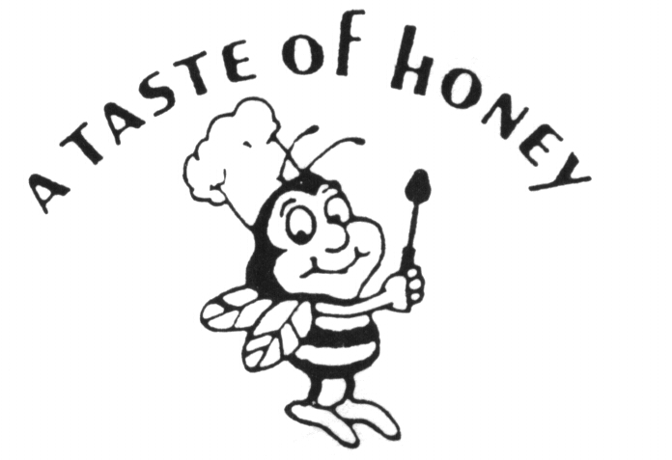
Fall / Winter 2020 Banquet Hall Brunch

ALL FOOD TO BE SERVED INVIDUALLY PLATED TO EACH GUEST

Guest Choice of Bread…
Mini Bagels, Muffins, Assorted Rolls & Danish

Host Choice of…
Yogurt Parfait or Fruit Plate

Host Choice of…
Caesar Salad or Garden Salad

Guest Choice of Breakfast Sampler…
House Made Pancakes, Bacon, Sausage,
Scrambled Eggs and Home Fried Potatoes

OR

Guest Choice of Lunch Plate #1…
Chicken Piccata, Roasted Red Skinned Potatoes and Mixed Vegetables

OR

Guest Choice Lunch Plate #2…
Salmon w/Creamy Dill Sauce, Roasted Red Skinned Potatoes and Mixed Vegetables

Beverages:
Red & White Sangria, Mimosas & Soft Drinks
**Expanded Bar Services Available**

Dessert:
Custom Sheet Cake, Coffee & Tea Service

All Events Include:
- 4 Hour Party Block w/Full Service Staff
- Host Choice of Linen Color w/All Tables, Chairs & Set-ups
- Minimum of 35 Guests – Max Currently Allowed 50 Guests

$50.00 per Adult - $42.00 per Young Adult (13-20) - $20.00 per Child (4 thru 12)

Sales Tax Additional

A Taste of Honey Caterers Does Not Include Any Gratuities in its Pricing. Our Service Staff Works Hard to Ensure Your Event is a Special One. While Not Required, Staff Gratuities are Always Greatly Appreciated.

**Please See List of Required Guidelines and Mandates Required for all Events**

