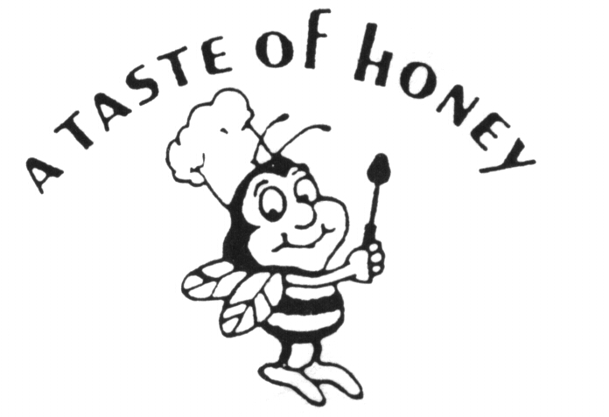
Fall / Winter 2020 Banquet Hall Dinner

Pasta
Select one
Penne with Vodka Sauce, Bowties w/Basil Pesto, Penne w/Arrabiata or Penne w/Marinara

Salad
Select One
Garden Salad, Caesar Salad or Spring Mix

Build Your Dinner Menu
Select Chicken Dish Option
Chicken w/Artichokes, Chicken Marsala, Chicken Sorrento, French Cut Rosemary Chicken,
Chicken Parmesan, Chicken Francaise, Chicken Piccata, Chicken Milanese or Chicken w/Cognac & Mushrooms

Select Beef or Pork Dish Option
Skirt Steak w/Caramelized Onions or Mushroom Sauce, Beef Roulade, Sliced Roast Beef Au Jus, Beef Bourguignon, Pork Medallions w/Apple Gravy or Stuffed Loin of Pork

Select Seafood Option
Salmon w/Creamy Dill or Teriyaki, Sautéed Seasonal Whitefish Filet w/Red Wine Reduction, Crabmeat Stuffed Filet of Fish, Garlic Roasted Shrimp or Shrimp Francaise,

All Dinners served with Roasted Potatoes & Sautéed Vegetables

Coffee, Tea & Custom Sheet Cake

Saturday price per Adult… $55.00 / Child… $25.00
Friday & Sunday price per Adult… $50.00 / Child… $20.00

Prices Do Not Include Beverage Package & Sales Tax

*Please see Beverage Menu for our Bar Packages*

All Events Include:
- 4 Hour Party Block w/Full Service Staff
- Host Choice of Linen Color w/All Tables, Chairs & Set-ups
- Minimum of 35 Guests – Max Currently Allowed 50 Guests

**Please See List of Required Guidelines and Mandates Required for all Events**

A Taste of Honey Caterers Does Not Include Any Gratuities in its Pricing. Our Service Staff Works Hard to Ensure Your Event is a Special One. While Not Required, Staff Gratuities are Always Greatly Appreciated.

