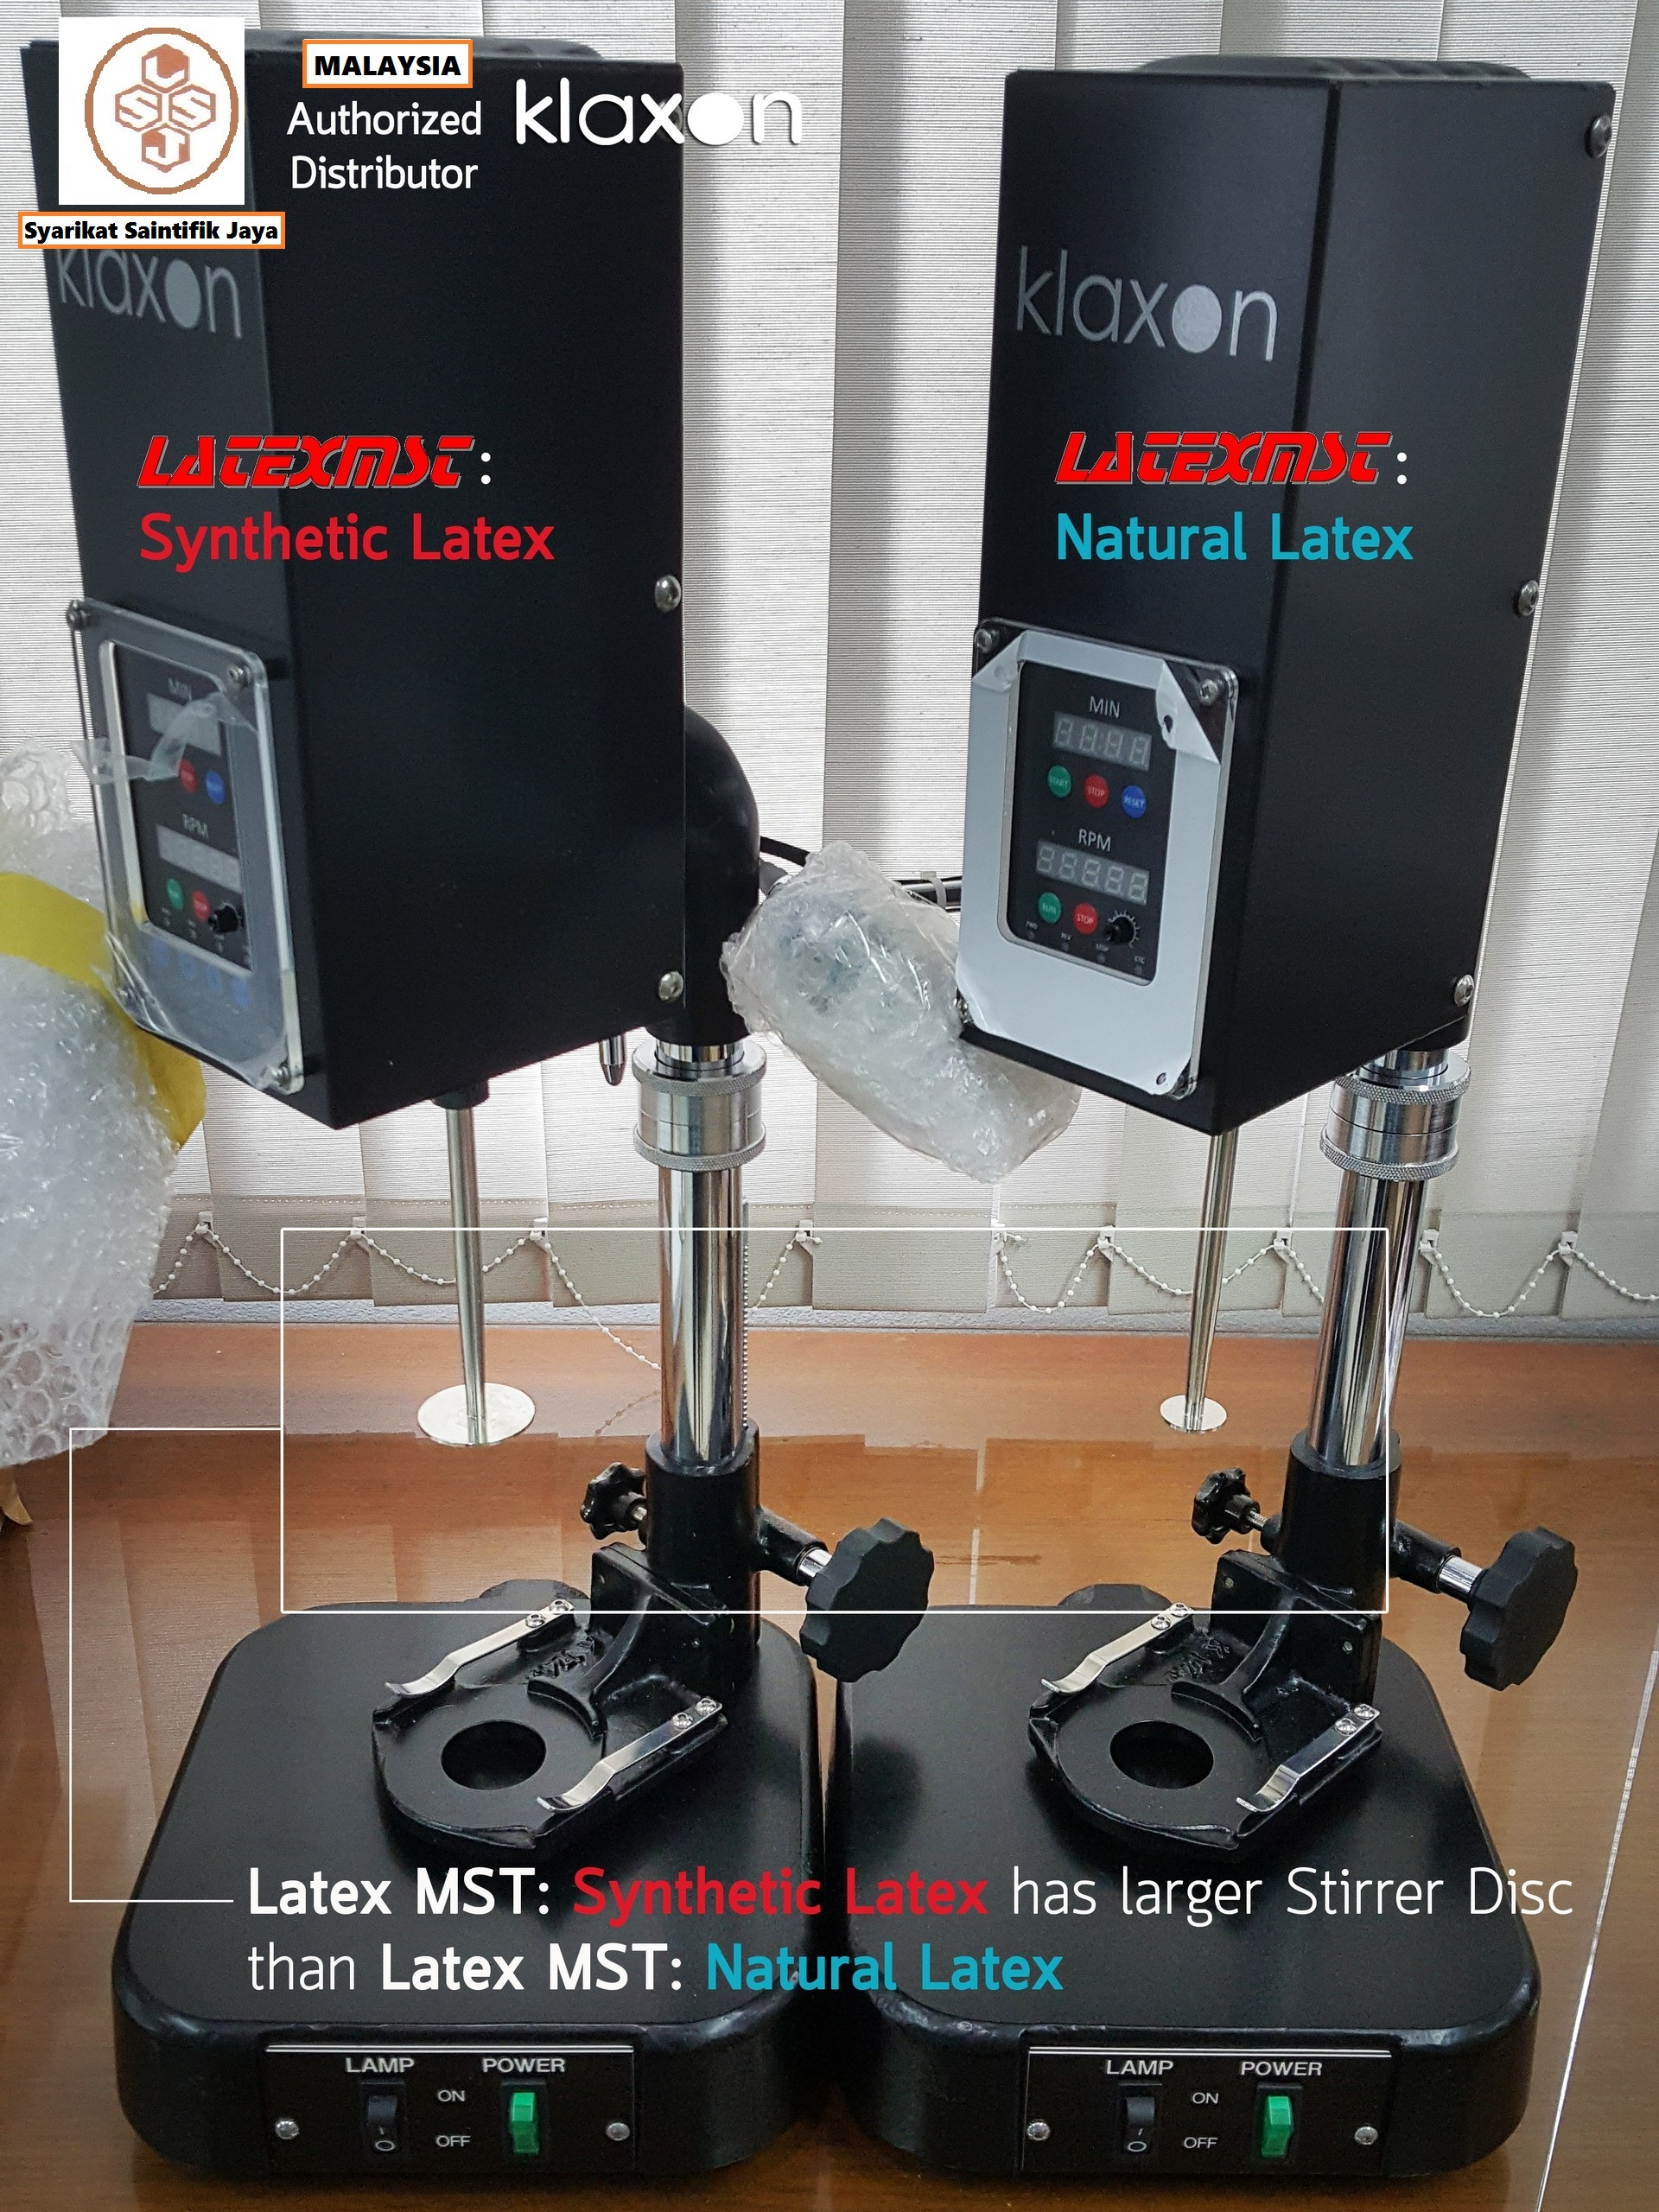
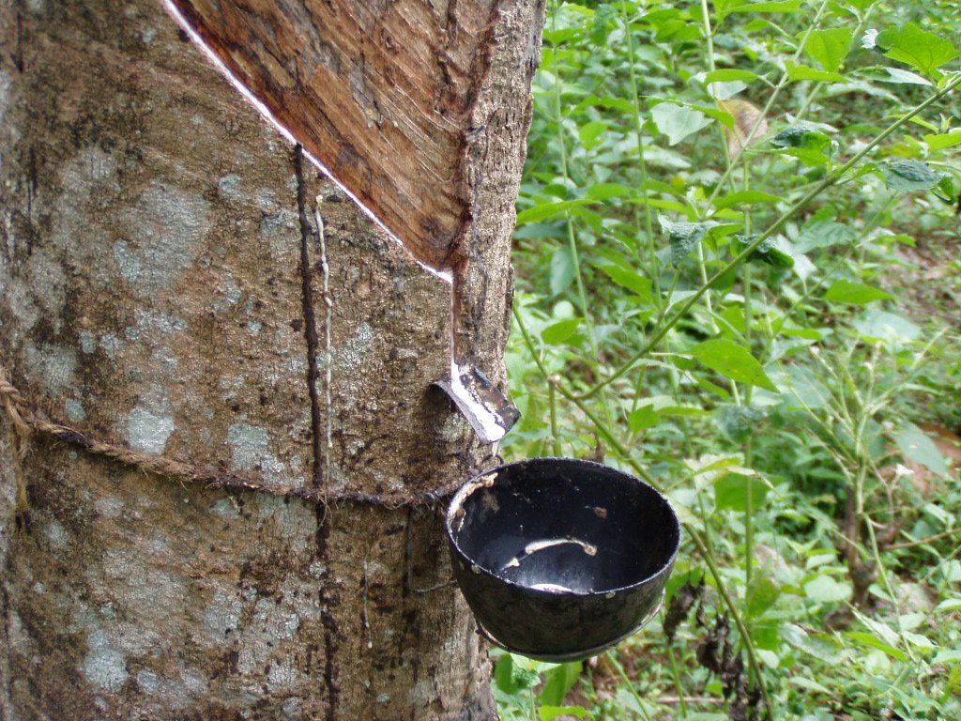
- BEAKER
Glass Breaker for (Synthetic)
Perspex Beaker (Natural)

- SHAFT & PADDLE
Natural (Smaller Paddle), Synthetic (Larger Paddle)

- BULB
- FUSE

MST MACHINE
KLAXON
Syarikat Saintifik Jaya
Laboratory Equipments & Chemicals Supplier

MK4 KLAXON Latex Mechanical Stability Testing Machine
.
The MK4 machine is the next generation of Latex Testing.
The new design features new digital controls and readouts for improved accuracy and reliability of results.
The new inverter driven controls reduce any variability in motor speeds, maintaining a continuous speed of 14,000 rpm as displayed on the new digital readout.

The controls also feature an easy to use digital timer.
The sealed motor and controls require no maintenance and servicing
The glass (synthetic) or Perspex (natural) beaker is secured on a stable aluminum table which is fully height adjustable using the easy hand operated controls.

No 69 Jalan Penerbit U1/43 Temasya Industrial Park 40150 Shah Alam Tel 03-5569 0758/59 Fax 03-5569 0763

https://sites.google.com/view/syarikatsaintifikjaya

MST MACHINE SPARE PARTS
info@saintifikjaya.com

