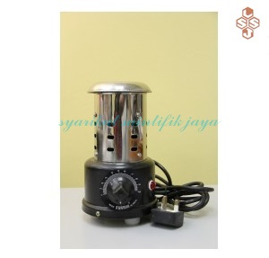  - ELECTRIC BUNSEN BURNER, “AVLAB”  Very useful for heating test tubes, crucibles small flasks, beakers etc.  The heating element is spiraled Nichrome wire enclosed in refractory casing. Works on electricity.  - This is safe compared to the conventional Bunsen Burner  - Can be carried anywhere and connect to the power source  - No fire hazards since it gives no flame unlike the conventional  Bunsen Burner  - No smoke, clean atmosphere  - Works on electricity, no gas required.  - Produces radiant heat.   |  |   electric bunsen burner “avlab”  Technical Specifications :  - Stainless steel body  - Aluminium base, powder coated  - Max. temperature 1000 deg C  - Power consumption 350 Watts  - Operates on 220 – 240 V single phase A/C  - Supplied with built – in energy regulator.  - Light weight 1 kg only  SYARIKAT SAINTIFIK JAYA  NO 69 Jalan Penerbit U1/43,  Temasya Industrial Park Glenmarie 40150 Shah Alam  Tel : 603- 5569 0758/0759  HP : 018 274 0955  Fax : 603- 5569 0763  Email : info@saintifikjaya.com  Dates and Times
https://sites.google.com/view/syarikatsaintifikjaya

