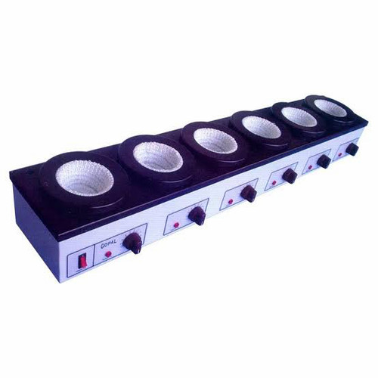

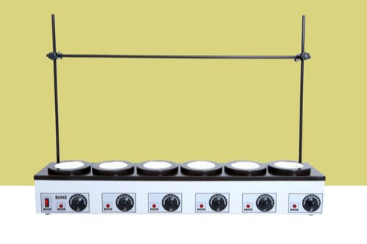

Instruction Manual

AV-SM-01 until AV-SM-06

|  |  |  |
| --- | --- | --- |
|  |  |  |
|  |  |
|  |  |
|  |  |
|  |  |
|  |  |
|  |  |
|  |  |
|  |  |
|  |  |
|  |  |
|  |  |

|  |  |  |
| --- | --- | --- |
| NO | CONTENTS | PAGES |
| 1 | Introduction | 1 |
|  |  |  |
| 2 | General Instructions | 2 |
|  |  |  |
| 3 | Overview of Extraction Mantles | 3 |
|  |  |  |
| 4 | Technical Specifications | 4 |

**INTRODUCTION**

Soxhlet Extraction Apparatus, “AVLAB”

To heat a number of round of bottom flasks simultaneously (for extractions, distillations and digestions) Extraction units may be used. All Extraction Mantles have individual energy regulator with indicator light for each heating surface, allowing liquids with different boiling points to be heated alongside each other. The robust construction permits continuous operation of the units as required by routine extraction tests. Extraction Mantles are available in 2 models, 3 recess and 6 recess. The heating elements are housed in a strong Aluminum housing, powder coated in attractive color.

|  |  |  |  |  |  |  |
| --- | --- | --- | --- | --- | --- | --- |
| Cat. No. | Flask Capacity  in ml | Number of  Recess | Total Watts @  220 – 240 V | Actual Size  L x B x H (mm) | Weight (Kgs) | |
| AV-SM-01 | 250 | 3 | 450 | 525 x 175 x 150 | | 4.5 |
| AV-SM-02 | 500 | 3 | 600 | 645 x 205 x 185 | | 6 |
| AV-SM-03 | 1000 | 3 | 900 | 675 x 215 x 185 | | 6.5 |
| AV-SM-04 | 250 | 6 | 900 | 1025 x 175 x 150 | | 7 |
| AV-SM-05 | 500 | 6 | 1200 | 1225 x 205 x 185 | | 8.3 |
| AV-SM-06 | 1000 | 6 | 1800 | 1300 x 215 x 185 | | 9 |

**GENERAL INSTRUCTIONS**

Please do not operate the equipment before reading the instructions.

1. Do not operate the equipment without load.
2. The equipment is designed for 220/240 V AC only.
3. The outer surface of the flask or the vessel should be completely dried, otherwise the wet surface may damage the heater.
4. The flask/vessel to be heated should be kept in good contact with the heating element
5. In the initial stages of heating, the mantel will give rise to the fumes and some odour because of the organic substance contained in the fiber glass. This will disappear after repeated heating. These fumes will also leave a volatile coating over the flask bottom which can be removed by cleaning with organic solvents. This also turns the color of the fiber glass slightly brownish but will disappear on repeated heating and will regain its whiteness.

**MULTI MANTLES**

The equipment’s can be operated same as heating mantles. Multimantles of bigger capacity are provided with one more than one circuit. This facilitates switching “OFF” of upper circuit when smaller flasks are used. Though the upper circuit can be operated independently the lower circuit should be “ON” while using for heating larger flasks otherwise the element will be damaged.

The Multimantles are provided with a hole at the bottom which facilitates the drying of funnels or heating of flasks with bottom drains off provision. For this purpose the whole mantle can be supported on a stand using the support rod are supplied so that mantle can be made to stand above the bench level with support of these rods.

**OVERVIEW OF EXTRACTION MANTLES**

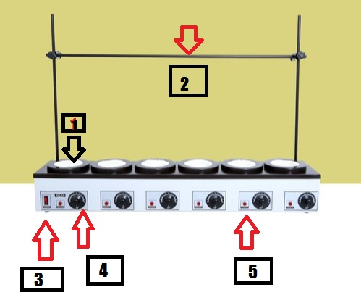

1. Heating Element
2. Support rods
3. Main power “ON & OFF” Indicator
4. Energy regulator control knob
5. Individual recces indicator

**TECHNICAL SPECIFICATION**

Capacity : 3 or 6 recess

|  |  |  |  |
| --- | --- | --- | --- |
| Thermal insulation  Energy Controller |  | :  : | Ceramic fibre (Mineral wool in economy model)  Individual Built-in Simmerstat for each recess |
| Max. Temperature |  | : | Up to 450 deg C |
| Fuses |  | : | Provided |
| Case Construction |  | : | Aluminium powder coated in attractive color |
| Support rods |  | : | Provided 12mm dia. Aluminium rods, |
|  |  |  | 2 nos. Vertical and 1 no Horizontal |
| Connecting Bosses |  | : | Provided |
| Flask fixing Clamps |  | : | Not Provided |
| Mains chord |  | : | 3 core, 2 meter long |
| Mains power |  | : | 220 – 240 V single phase A/C |

Replacement Element : Available