“AVLAB” GLASS BEAD STERILIZER for PLANT TISSUE CULTURE
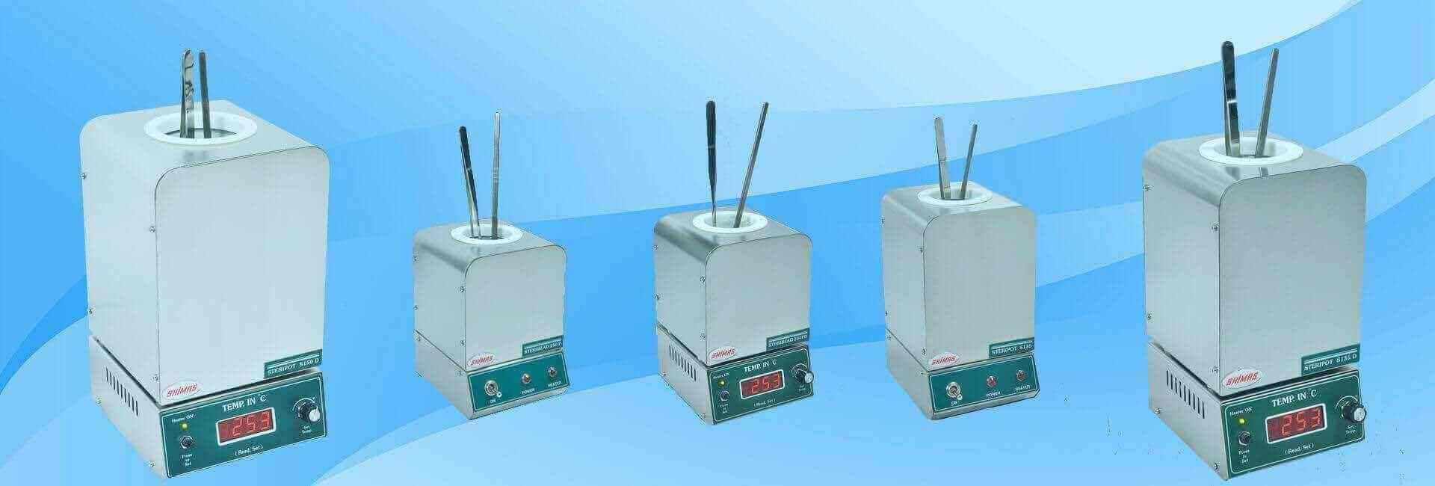
We have with us a range of glass bead sterilizers that are used in various laboratories and research institutes. A glass bead sterilizer is used over alcohol or flame for sterilizing implements in the laboratory. Fabricated using advanced technology, our range of glass bead sterilizer is fully insulated and designed for heavy-duty operational schedules. Provided with easy digital temperature display, this ensure total sterilization by destruction of all micro-organisms in seconds. Available in different specifications, we also provide customization facility to the clients.

Product Features
- Digital temperature display
- Quick, easy, clean, alternative to conventional methods of sterilization, ensure total sterilization by destruction of all micro-organisms in seconds
- Ready to use in 45 minutes from cold start. The GLASS BEAD STERILIZER sets itself to an operating temperature of 250℃ - 265℃.
- The unit is compact and can be placed on any Laminar Air Flow Work benches or any work tables in a clean room atmosphere.
- Fully insulated, designed for heavy – duty operational schedules

Advantages

- GLASS BEAD STERILIZER is very convenient to use over alcohol / flame for sterilizing implements (e.g. forceps, scalpels etc.) in the laboratory. It takes just 10 seconds to sterilize an instruments.
- Absolutely safe, effective and no mess-ups. No need of fire extinguishers near the hood. Can avoid flamed finger, no burning of hood surfaces nor burn of hairs on forearms
(Inherent danger with flames and alcohol)
- No bacterial carryover problems. Can avoid spores in alcohol and spreading of some bacteria that appear to be alcohol resistant.
- Especially good to use the GLASS BEAD STERILIZER in laboratories where you have a lot of students or trainees who may not have the practical manual dexterity to keep from flaming themselves and / or the alcohol.

Product Range

Various models of Glass Bead Sterilizers have been manufactured and our units are being used by Medical, Dental, Laboratory, Biotechnology/Tissue Culture, Podiatry, and Veterinary Professionals all over the world.
Three Models of Glass Bead Sterilizers are listed below. These units have a stainless steel body and are compact enough to be placed on any laminar air flow work benches or other work tables in a clear room atmosphere.

- STERIPOT S135D, STERIPOT S150D have been popular as it is easy to log sterilization temperature for quality control.

Other models of Glass Bead Sterilizers with crucible size 50mm dia / 50mm depth, 50mm dia / 75mm depth, 70mm dia / 150mm depth having Aluminium / Steel body (epoxy coated) are also available.

Specifications | STERIBEAD 250PD | STERIPOT S135D | STERIPOT S150D
Size  (W x D x H ) mm | 125 x 145 x 190mm | 125 x 145 x 220mm | 150 x 165 x 250mm
Crucible Size | 50mm ∅ x 90mm depth | 50mm ∅ x 137mm depth | 70mm ∅ x 150mm depth
Unit Construction | Stainless Steel | Stainless Steel | Stainless Steel
Pre-Set Temperature | 245℃ - 265℃ | 245℃ - 265℃ | 245℃ - 265℃
Initial Stabilization Time | 45 minutes | 45 minutes | 45 minutes
Weight (Including Glass Beads ) | 3kg | 3.5kg | 5.5kg
Input Power | 220-240V, 50 Hz | 220-240V, 50 Hz | 220-240V, 50 Hz

