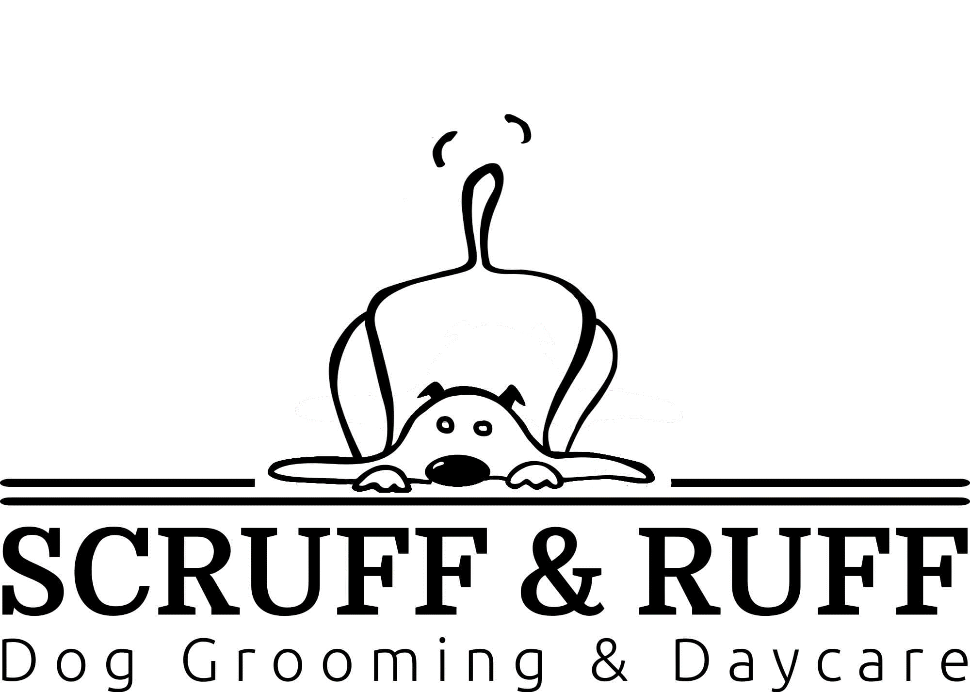

Scruff & Ruff has a goal to provide the safest, most enjoyable grooming experience for you and your pets. We strive to maintain a clean grooming salon and provide the highest standards possible with our grooming and the products we use. Below are some policies we have developed to ensure the safety and happiness of your pets while in our care.
Please bring your pet on and leash or in a carrier for their safety.
PLEASE READ AND INITIAL THE FOLLOWING:

HEALTH OR MEDICAL PROBLEMS
Your pet is our number one concern. If you suspect they are feeling under the weather, please notify us in advance. Grooming can be physically demanding and can aggravate pre-existing health problems. It is our policy to refuse entry to any dog or cat who is displaying symptoms of any contagious condition. If you have a concern about an issue that arises after a grooming appointment, we request that you bring it to our attention within 24-48 hours so it can be addressed immediately. All medical expenses for veterinary care will be covered by the pet’s owner upon signing this contract/agreement.
Initials _________________
ACCIDENTS
Although accidents are exceedingly rare, there is a risk when dealing with animals. Grooming equipment is sharp, and although we use extreme caution and care in all situations, possible problems could occur including cuts, nicks, scratches, quacking of nails, etc. In most cases this can happen when an animal is wiggling or moving around. Your pet’s safety and comfort is our number one priority. In the event an accident does occur, you will be notified of the accidents. If Scruff & Ruff feels it is serious, and the owner is not on-site, The Scruff & Ruff will seek immediate veterinary care for your pet.
Initials _________________
AGGRESSIVE BEHAVIOUR
Grooming can be stressful for sensitive pets and some tolerate it better than others. Our professionally trained staff uses proper handling techniques and equipment to deal with most dispositions. Please ensure to inform our staff at time of booking if your pet requires special handling so we can book accordingly.
Initials _________________
VETERINARIAN AUTHORIZATION-MEDICAL EMERGENCIES
This release gives Scruff & Ruff full authorization to seek medical treatment from our neighbour, Veterinary Hospital, in the case of any medical emergencies while in the care of Scruff & Ruff.
Initials _________________
CURRENT VACCINATIONS
We recommend that you follow your veterinarian’s protocol for vaccination to protect your pet from communicable diseases. As a result, Dogs should be vaccinated for DA2PP (distemper, Adenovirus-2, parvovirus & parainfluenza), Rabies and Bordetella. Cats should be vaccinated for FVRCP (Feline Viral Rhinotracheitis, Calicivirus & Panleukopenia) and Rabies.
Initials _________________
FLEAS/TICKS
The Scruff & Ruff strives to be a flea-free salon. Any dog or cat that we discover to have fleas is immediately given a flea bath to reduce the risk of parasite transmission to the other pets in our care. The salon is thoroughly treated with a flea premise spray after every case of fleas is discovered to protect the other pets that visit us. An extra fee of $20.00 or more is always applied to the grooming bill to cover the cost of the extra labour associated with the flea bath as well as the shampoo and fumigation products. There are currently many flea control products on the market, but in order to find one that is safe for your pet, you need to discuss all products with your veterinarian. Many of the monthly treatments available can be used topically or orally and are highly successful in repelling fleas from your dog or cat's skin and fur.
Initials _________________
MATTED COATS/STRIPPING COATS
There are many reasons a pet can get matted. When the dog or cat’s hair becomes tangled or clumped close to the skin, it can pose a health risk for the dog/cat and increases the chance of skin irritation or injury during the grooming process. There are only 2 options when a pet’s coat is deemed matted – shave under the matted portion of hair, leaving the hair shorter but greatly reducing stress on the dog or cat. The other option that is available to some pet owner’s (providing the pet is not too far gone) is dematting. This service is only available for pets’ who can both tolerate it and when the matting is not so severe that dematting poses a high risk of injury or stress. Both the dematting process and stripping off matted coat can be a slow process that takes skill and extra care from our groomers. It is also demanding on our bodies, equipment and often requires extra sharpening of blades and scissors. Because of these reasons, there are extra fees associated with both the dematting and clipping of matted coat. Prevention is the best defense by scheduling regular grooming appointments, every 6-8 weeks.
Initials _________________
STAFF
At times, additional staff members are needed to aid in the grooming process as a safety precaution. Such instances would include an older pet unable to stand, squirmy pets and various behavioural attitudes etc. Therefore, the grooming process takes longer and additional staff as a result costs can accrue when necessary.
Initials _________________
SCHEDULES APPOINTMENTS & CANCELLATIONS
Scheduling is important to maintain the flow of the shop. We strive to book appointments so we can keep our appointment times short and accommodate our client’s schedules. If unable to make a scheduled appointment we would appreciate advanced notification.
Initials _________________
PAYMENT
Payment is due when services are rendered. We accept Visa, MasterCard, debit, are preferred. We do not accept cash payments.
Initials _________________
CLIENT REQUESTS & SATISFACTION
Customer service is especially important to all our staff. We do our absolute best to accommodate all customer requests, however if a pet’s temperament or health condition prevents us from fulfilling a clients’ wishes we will communicate our concerns beforehand whenever possible. Your satisfaction is important to us. If you are unhappy for any reason, and would like something adjusted, we will be happy to make any adjustments when you pickup your pet from his/her appointment. Once, however, you take your pet home from the appointment, any return visits will be treated as a new appointment and client will be charged a grooming fee or some kind.
Initials _________________

PHOTOGRAPHS & SOCIAL MEDIA
This release form authorizes Scruff & Ruff to take photos of your pet for client file and for company website, Facebook, and Instagram pages. All photos taken are the property of Scruff & Ruff.
Initials _________________

I have reviewed this Service Contract for accuracy and understand the contents of this contract. I affirm that I am the rightful legal owner of the pet(s) for which services are being rendered. I am 18 years of age or older and have the authority, as pet’s owner, to enter into this agreement. I authorize this signed contract to be valid approval for future grooming services, permitting Scruff & Ruff to accept telephone reservations for service without additional signed contracts or written authorization. I understand that pricing is subject to change. This agreement is valid for all pets that I currently own or will own in the future. I have read, signed, and agreed to the above

Name (print): ________________________________________________
Signature: ___________________________ Date:___________________

