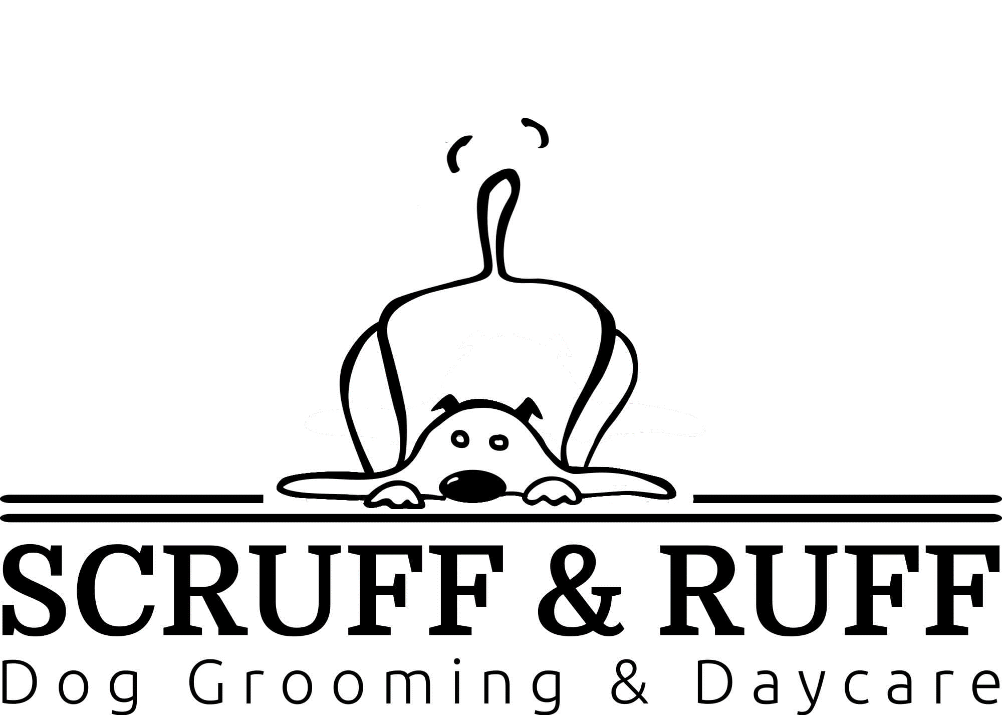
WAIVER, RELEASE, AND INDEMNITY
General Terms:
By voluntarily participating in any of the services offered by Scruff and Ruff, both paid and complimentary, you are confirming that you agree to the following terms:
It is my understanding that notwithstanding the exercise of due care and control of the attending dogs, whether on my part, those of the other owner/handlers, employees, volunteers, and independent contractors (including without limitation all instructors and/ or assistants) (collectively and individually the “Releasees”) of Scruff and Ruff are not without risk, not only to myself, but also to family or guests or others who may attend, as well as to my dog.
I will not hold Scruff and Ruff or the Releasees responsible for any damage, loss, injury, illness or parasitic infestation to me, my dog, my agent, or anyone under my control. I agree to free the Releasees from any and all manners of action, causes of action, claims, demands and liability of any nature or kind whatsoever whether arising from negligence or any other reason or cause whatsoever.
I expressly assume the risk of any such damage, loss or injury while participating in any of the services provided or on any grounds that the daycare occurs in. With the acceptance of my application for any services with Scruff and Ruff, or participation in Scruff and Ruff organized events, I hereby agree to indemnify and hold harmless Scruff and Ruff and Releasees from any and all claims, suits, injuries, debts, demands, costs, damages, actions or proceedings or charges of any nature whatsoever.
Communications:
I acknowledge and agree that from time-to-time Scruff and Ruff may send communication via email, text, or other means with offers or information that I may find valuable regarding events that I have registered for and events or offers that I may like to register for in the future. You may opt out of future communications at any time by selecting the 'unsubscribe' option if you are contacted.

Media Release:
I acknowledge and agree that all media including photographs, video, live stream, and audio recordings are the sole property of Scruff and Ruff and may be distributed and used for, but not limited to, and at the sole discretion of Scruff and Ruff resale, advertising materials, marketing and/or promotional materials without any prior or future written and/or verbal consent.

Pricing:
Conditions and pricing may vary without notice and all services are subject to availability. Client's on a recurring monthly program will be notified via email a minimum of 60 days prior to the price adjustment; special sale and/or promotional prices will adjust back to their standard amounts without notice and as scheduled. Refunds: All customers are subjected to a full refund for unused services if needed.

Termination of Service:
Scruff and Ruff reserves the right to remove, at any time, and without notice, any pup that is deemed to be a risk to other pups, staff, or itself for any reason and at their sole discretion and without limitation. A refund will be issued for any remaining, unused, services. I acknowledge that I have read and fully understand the terms and conditions of this waiver/ release form and that I freely, voluntarily have printed and signed a hard copy to bring to Scruff and Ruff for submission.

Name (print): ____________________________________________________
Signature: __________________________________ Date ________________

REGISTRATION FORM
OWNER’S INFORMATION
OWNER FIRST & LAST NAME:________________________________________________________________
CO-OWNER FIRST & LAST NAME:_____________________________________________________________
FULL ADDRESS:___________________________________________________________________________
HOME PHONE:____________________________________________________________________________
BUSINESS PHONE:_________________________________________________________________________
CELL:____________________________________________________________________________________
EMAIL ADDRESS:_____________________________________________________________________
EMERGENCY CONTACT NAME:______________________________________________________________

INFORMATION REGARDING YOUR PET
NAME: ___________________________________________________________________________________
BIRTHDAY:________________________________________________________________________________ BREED:____________________________________________________________________________________ MALE/FEMALE:______________________________________________________________________________ SPAYED/NEUTER:____________________________________________________________________________ COLOUR:__________________________________________________________________________________ MICROCHIP/ TATTOO:________________________________________________________________________

VETERINARIAN INFORMATION
PRACTICE NAME VETERINARIAN: ______________________________________________________________
FULL ADDRESS______________________________________________________________________________ PHONE:___________________________________________________________________________________
FAX:______________________________________________________________________________________ EMAIL:____________________________________________________________________________________

Note: All dogs must have all vaccinations up to date. Owners must submit proof of all vaccinations including Kennel Cough and Revolution when returning forms to be reviewed. Flea, Tick and Lice prevention treatments are highly recommended for ultimate protection.
REQUIRED VACCINES
RABIES: Yes / No DHLPP: Yes / No BORDETELLA: Yes / No

Please state if there are any of the following:
Health issues Allergies/ Sensitivities (i.e., food, seasonal etc.) _____________________________________________________________________________________
Physical limitations/ Injuries (i.e. previous surgeries or medical conditions)
____________________________________________________________________________________
Medications or treatments needed to be given daily
_____________________________________________________________________________________
GENERAL INFORMATION
How long have you had your dog? _____________________________________________________________________________________
Has your dog ever participated in a day care program? _____________________________________________________________________________________
Is your dog house trained? _____________________________________________________________________________________
How often do you socialize your dog and where? (i.e., parks, walks etc.) _____________________________________________________________________________________
Familiar with basic commands (circle all that apply): -
Heal - Sit - Down (lie down) – Stay - Off (no jumping) - Come (recall)

Aggression towards people: never/ very rare/ sometimes/ often
Aggression towards animals: never/ very rare/ sometimes/ often
Dominance towards food, toys, etc.: never/ very rare/ sometimes/ often

I have reviewed this Service Contract for accuracy and understand the contents of this contract. I affirm that I am the rightful legal owner of the pet(s) for which services are being rendered. I am 18 years of age or older and have the authority, as pet’s owner, to enter into this agreement. I authorize this signed contract to be valid approval for future daycare services, permitting Scruff and Ruff to accept telephone reservations for service without additional signed contracts or written authorization. I understand that pricing is subject to change. This agreement is valid for all pets that I currently own or will own in the future. I have read, signed, and agreed to the above.

Signature __________________________________ Date _________________

