Alcohol and Drug Use Overview

In 2020, there were an estimated 91,799 drug overdose deaths in the United States. The age-
adjusted rate of overdose deaths increased by 31% from 2019 (21.6 per 100,000) to 2020 (28.3
per 100,000). Age-adjusting the rates ensures that differences in deaths from one year to the next are not due to differences in the age distribution of the populations being compared.
Opioids, mainly synthetic opioids (other than methadone), are currently the largest driver of
drug overdose deaths (82.3% of all drug overdose deaths). Opioids were involved in 68,630 overdose deaths in 2020 (74.8% of all drug overdose deaths).

In Arizona, the number and age-adjusted rate of drug overdose deaths increased from 2018,
[1,766 (25.0 per 100,000)] to 2019 [2,000 (39.8 per 100,000)]. Rates of overdose deaths in 2019 varied by county. Relative to other states, Arizona ranked 17th highest in 2019 for the rate of drug overdose deaths. The current report provides an update on current trends of opioid-related overdoses from 2020-2021.
https://www.azdhs.gov/opioid/documents/opioid-surveillance-report-2020-2021.pdf

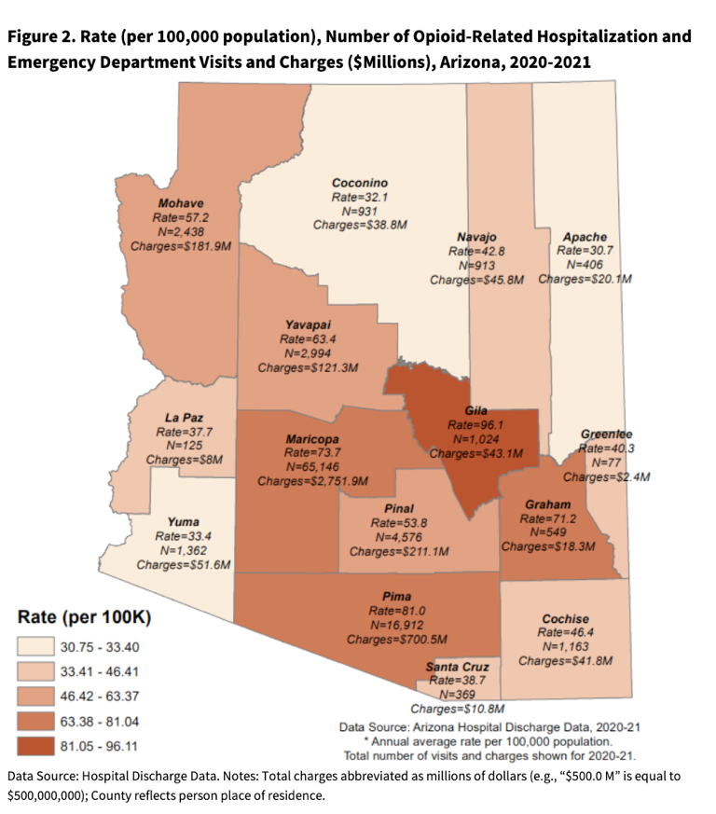
Alcohol Abuse Statistics

Arizona has a high number of alcohol-related deaths compared to its population. The rate of chronic causes is well above average.

- 16.7% of Arizona adults over 18 binge drink at least once per month.
- The median number of drinks per binge is 5.5; the 25% most active drinkers consume a median 7.9 drinks per binge.
- Binge drinking adults in Arizona binge a median 1.5 times monthly; the 25% most active drinkers’ binge 3.8 times per month.
- An average of 3,670 annual deaths in Arizona are attributable to excessive alcohol use.
- The 5-year average annual rate of excessive alcohol deaths per capita in Arizona increased by as much as 40.9% from 2015 to 2019.
- Arizona averages one (1) death from excessive alcohol use for every 1,949 people aged 18 and older or 6.62 deaths for every 10,000 adults.
- 68.3% of people who die from excessive alcohol use in Arizona are male.
- 59.2% of excessive alcohol use deaths are from chronic causes, such as Alcohol Use Disorder.
- 84.1% of deaths in Arizona from excessive alcohol use are adults aged 35 years and older.
- 2.75% of people in Arizona who die from excessive alcohol use are under the age of 21.
- The CDC estimates 7,151,502 years of potential life are lost to excessive alcohol use each year.
- Arizona taxpayers spent $5.946 billion as a result of excessive alcohol use in 2010; adjusted for inflation, this is equivalent to $8.028 billion or $2.27 per drink in 2022 US$ (https://drugabusestatistics.org/alcohol-abuse-statistics/#arizona).

