Arizona’s Unhoused Population Overview

[PDF] Homelessness in Arizona Annual Report 2022

December 31, 2022 · The Homeless population has steadily risen in Arizona since 2017, with Unsheltered homelessness increasing by 62% since 2012—housing insecurity.

See: State of Homelessness, Homelessness in Arizona Annual Report 2022, Arizona Department of Economic Security, December 31, 2022 (https://des.az.gov/sites/default/files/dl/2022-Homelessness-Annual-Report.pdf.)

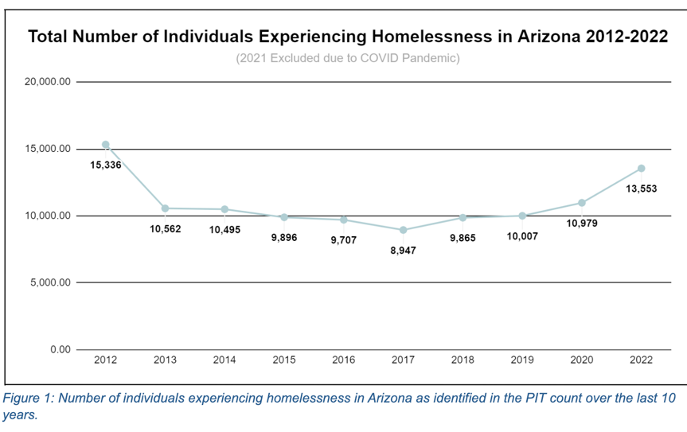
As of January 2022, the number of people experiencing homelessness in Arizona was 13,553, an increase of nearly 25% since 2020. The Homeless population has steadily risen in Arizona since 2017, with Unsheltered homelessness increasing by 62% since 2012. In State Fiscal Year (SFY) 2022, more than 90,000 individuals at risk of or experiencing homelessness received preventative rental assistance and homeless intervention services.

In Arizona and across the nation, affordable housing remains scarce. According to The National Low Income Housing Coalition (NLIHC), there is a national shortage of 7 million affordable
rental homes available to extremely low-income renters whose household incomes are below
the federal poverty level or 30 percent of their area median income. Evictions and foreclosures
have increased across the state of Arizona and nationwide. NLIHC now places Arizona as the
18th highest housing wage in the United States. Housing wage is the hourly wage required to
afford a one-bedroom rental home. Currently, 193,961 renter households have meager incomes and a rental shortage of 143,998 units. Seventy-six percent of extremely low-income renter households are also severely cost-burdened, which means they spend more than half of their income on housing. This can cause unstable housing situations and lead to evictions, which have also increased in Arizona. In 2022, working at a minimum wage of $12.80 per hour, an individual would need to work 60 hours to afford a one-bedroom rental home at Fair.

SHPEV functions as a support housing program, which means that staff will advocate and provide the necessary services to safely and responsibly help to maintain the clients at our program as well as in their future independent homes.

