Suicide and Murder Overview

“Suicide rates increased approximately 36% between 2000–2021. Suicide was responsible for 48,183 deaths in 2021, which is about one death every 11 minutes (related data from a CDC report is at the end of this section). The number of people who think about or attempt suicide is even higher. In 2021, an estimated 12.3 million American adults seriously thought about suicide, 3.5 million planned a suicide attempt, and 1.7 million attempted suicides.

“By race/ethnicity, the groups with the highest rates are non-Hispanic American Indian/Alaska Native people followed by non-Hispanic White people.³ Other Americans with higher-than-average rates of suicide are veterans, people who live in rural areas, and workers in certain industries and occupations like mining and construction.^{5,6} Young people who identify as lesbian, gay, or bisexual have higher prevalence of suicidal thoughts and behavior compared to their peers who identify as heterosexual (https://www.cdc.gov/suicide/facts/index.html).
“Last year, a team of researchers primarily based out of the University of Texas delved into the data on suicide in the hopes of identifying trends that could lead to useful interventions to save lives. The researchers made use of the National Violent Death Reporting System, specifically looking at data on 94,454 U.S. adult suicides between 2017 and 2019.
“They found that 54.7% of men and 30% of women who died by suicide used firearms, 28.4% of men and 28.5% of women hanged themselves, and 9% of men and 32.1% of women died by poisoning. Other methods like cutting, jumping from heights, running in front of a vehicle, drowning, and electrocution were used in the remaining cases (https://bigthink.com/health/3-most-common-suicide-methods/).
“The U.S. murder rate in 2020 was 42% lower than the suicide rate (13.5 deaths per 100,000 people) and 71% below the mortality rate for drug overdose (27.1 deaths per 100,000 people, as of the third quarter of 2020), the CDC data shows.
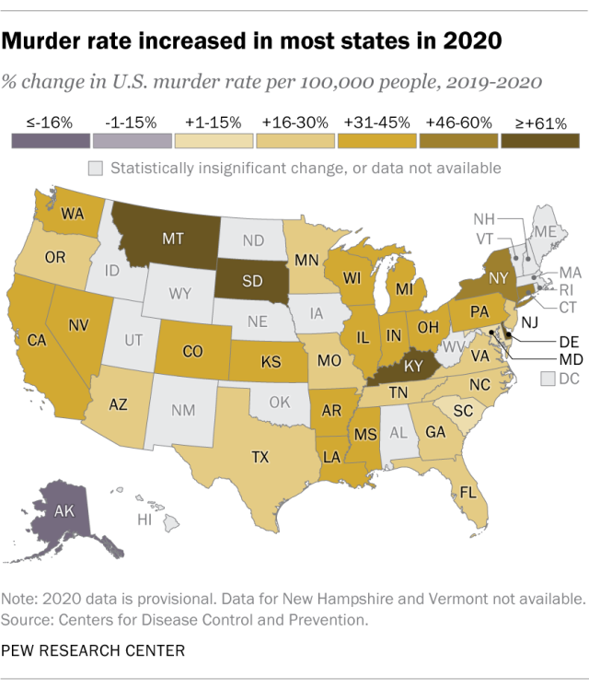
“At least eight states saw their murder rates rise by 40% or more last year, with the largest percentage increases in Montana (+84%), South Dakota (+81%), Delaware (+62%) and Kentucky (+61%), according to the CDC. Higher-than-average increases also occurred in several heavily populated states, including New York (+47%), Pennsylvania (+39%), Illinois (+38%), Ohio (+38%) and California (+36%) (Please note that Arizona is excluded in this count of eight states (https://www.pewresearch.org/short-reads/2021/10/27/what-we-know-about-the-increase-in-u-s-murders-in-2020/).

Children Living in Poverty Overview

Some states address the problems of underprivileged children better than others. To determine where children are most disadvantaged, WalletHub compared the 50 states and the District of Columbia across

Arizona is ranked number nine with the worst child poverty based on 27 key indicators of neediness. It is ranked ninth as having the most children living in poverty, according to Wallethub's comprehensive analysis.

This vulnerability is acute among rural Native American and Hispanic populations. And it is exacerbated by these populations living under impoverished conditions, having limited access to vital and emergency resources, and often living with physical challenges, such as disabilities and chronic diseases, all of which are disproportionately prevalent among non-White rural populations (Arizona's Vulnerable Populations).

Arizona’s Unhoused Population Overview

[PDF] Homelessness in Arizona Annual Report 2022

December 31, 2022 · The Homeless population has steadily risen in Arizona since 2017, with Unsheltered homelessness increasing by 62% since 2012—housing insecurity.

See: State of Homelessness, Homelessness in Arizona Annual Report 2022, Arizona Department of Economic Security, December 31, 2022 (https://des.az.gov/sites/default/files/dl/2022-Homelessness-Annual-Report.pdf.)

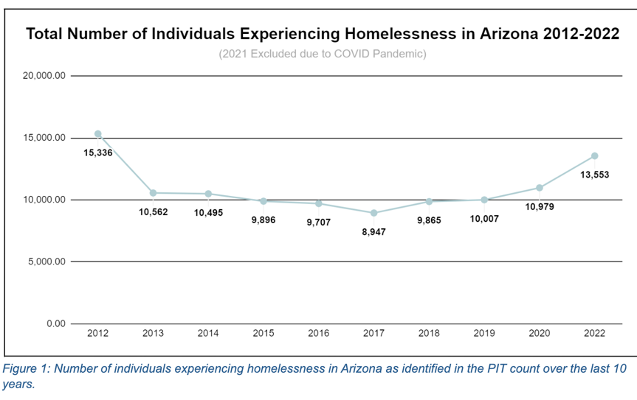
As of January 2022, the number of people experiencing homelessness in Arizona was 13,553, an increase of nearly 25% since 2020. The Homeless population has steadily risen in Arizona since 2017, with Unsheltered homelessness increasing by 62% since 2012. In State Fiscal Year (SFY) 2022, more than 90,000 individuals at risk of or experiencing homelessness received preventative rental assistance and homeless intervention services.

In Arizona and across the nation, affordable housing remains scarce. According to The National Low Income Housing Coalition (NLIHC), there is a national shortage of 7 million affordable
rental homes available to extremely low-income renters whose household incomes are below
the federal poverty level or 30 percent of their area median income. Evictions and foreclosures
have increased across the state of Arizona and nationwide. NLIHC now places Arizona as the
18th highest housing wage in the United States. Housing wage is the hourly wage required to
afford a one-bedroom rental home. Currently, 193,961 renter households have meager incomes and a rental shortage of 143,998 units. Seventy-six percent of extremely low-income renter households are also severely cost-burdened, which means they spend more than half of their income on housing. This can cause unstable housing situations and lead to evictions, which have also increased in Arizona. In 2022, working at a minimum wage of $12.80 per hour, an individual would need to work 60 hours to afford a one-bedroom rental home at Fair.

SHPEV functions as a support housing program, which means that staff will advocate and provide the necessary services to safely and responsibly help to maintain the clients at our program as well as in their future independent homes.

