2020 Northwest guilford baseball skills camp
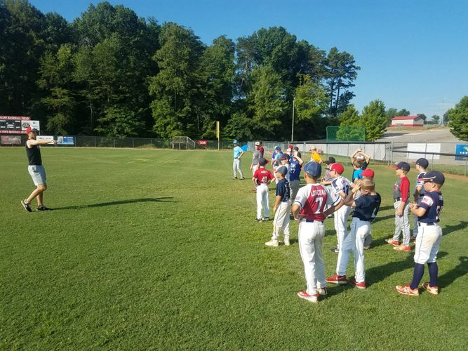June 29th –July 2nd 8:30am-12:30
For rising 2nd to 8th graders
Cost $100.00- cost includes camp fee, tee shirt, and daily snack
Camp will be held at NW Guilford High School Baseball field
Email coach Maness to reserve your spot @ manessc2@gcsnc.com
Mail Payment to: NW Baseball Boosters 7613 Charles Place Drive Kernersville, NC27284

