Carbon And Its Compounds

Soaps and Detergents

Cleansing Action of Soap
When soap is added to water, the soap molecules uniquely orient themselves to form spherical shape micelles.
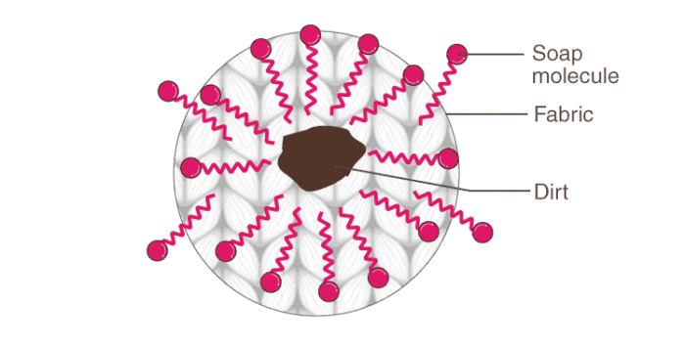
The non-polar hydrophobic part or tail of the soap molecules attracts the dirt or oil part of the fabric, while the polar hydrophilic part or head,(−COO⁻Na⁺, remains attracted to water molecules.
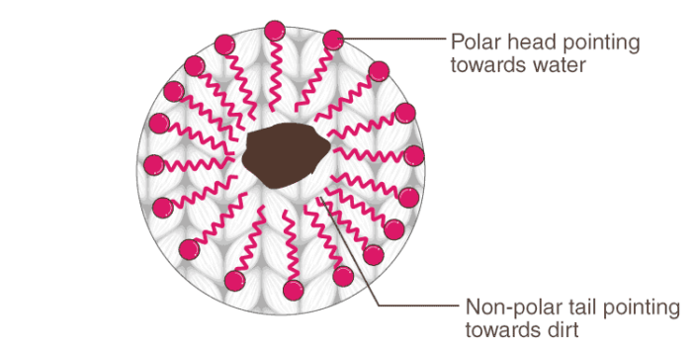

The agitation or scrubbing of the fabric helps the micelles to carry the oil or dirt particles and detach them from the fibres of the fabric.
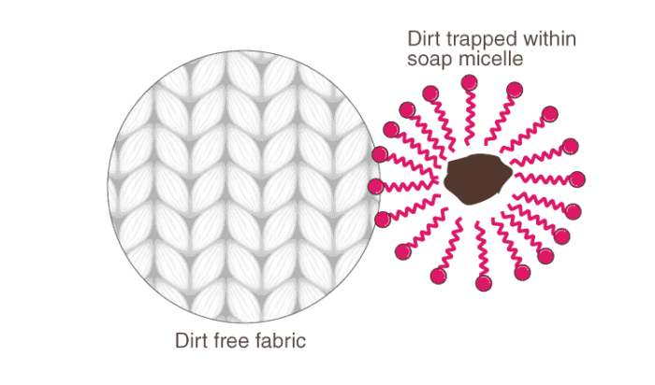

Hard Water
Hard water contains salts of calcium and magnesium, principally as bicarbonates, chlorides, and sulphates. When soap is added to hard water, calcium and magnesium ions of hard water react with soap forming insoluble curdy white precipitates of calcium and magnesium salts of fatty acids.
2C₁₇H₃₅COONa+MgCl₂ → (C₁₇H₃₅COO)₂Mg+2NaCl
2C₁₇H₃₅COONa+CaCl₂ → (C₁₇H₃₅COO)₂Ca+2NaCl
These precipitates stick to the fabric being washed and hence, interfere with the cleaning ability of the soap. Therefore, a lot of soap is wasted if the water is hard.

Covalent Bonds

Difficulty of Carbon to Form a Stable Ion
To achieve the electronic configuration of the nearest noble gas, He, if the carbon atom loses four of its valence electrons, a huge amount of energy is involved. C⁴⁺ ion hence formed will be highly unstable due to the presence of six protons and two electrons.
If the carbon atom gains four electrons to achieve the nearest electronic configuration of the noble gas, Ne, C⁴⁻ ion will be formed. But again, a huge amount of energy is required. Moreover, in C⁴⁺ ion it is difficult for 6 protons to hold 10 electrons. Hence, to satisfy its tetravalency, carbon shares all four of its valence electrons and forms covalent bonds.

Ionic Bond
Ionic bonding involves the transfer of valence electron/s, primarily between a metal and a nonmetal. The electrostatic attractions between the oppositely charged ions hold the compound together.
Ionic compounds:
- Are usually crystalline solids (made of ions)
- Have high melting and boiling points
- Conduct electricity when melted
- Are mostly soluble in water and polar solvents
To know more about Ionic Bond, visit here.

Covalent Bond
A covalent bond is formed when pairs of electrons are shared between two atoms. It is primarily formed between two same nonmetallic atoms or between nonmetallic atoms with similar electronegativity.
To know more about Covalent Bonds, visit here.

Lewis Dot Structure
Lewis structures are also known as Lewis dot structures or electron dot structures.
These are basically diagrams with the element’s symbol in the centre. The dots around it represent the valence electrons of the element.
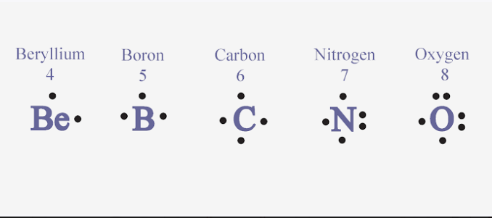

Covalent Bonding in H₂, N₂ and O₂
Formation of a single bond in a hydrogen molecule:
Each hydrogen atom has a single electron in the valence shell. It requires one more to acquire the nearest noble gas configuration (He).
Therefore, both the atoms share one electron each and form a single bond.


Formation of a double bond in an oxygen molecule:
Each oxygen atom has six electrons in the valence shell (2, 6). It requires two electrons to acquire the nearest noble gas configuration (Ne).
Therefore, both the atoms share two electrons each and form a double bond.


Formation of a triple bond in a nitrogen molecule:
Each nitrogen atom has five electrons in the valence shell (2, 5). It requires three electrons to acquire the nearest noble gas configuration (Ne).
Therefore, both atoms share three electrons each and form a triple bond.


Single, Double and Triple Bonds and Their Strengths
A single bond is formed between two atoms when two electrons are shared between them, i.e., one electron from each participating atom.
It is depicted by a single line between the two atoms.
A double bond is formed between two atoms when four electrons are shared between them, i.e., one pair of electrons from each participating atom. It is depicted by double lines between the two atoms.
A triple bond is formed between two atoms when six electrons are shared between them, i.e., two pairs of electrons from each participating atom. It is depicted by triple lines between the two atoms.
Bond strength:
– The bond strength of a bond is determined by the amount of energy required to break a bond.
– The order of bond strengths when it comes to multiple bonds is: Triple bond>double bond>single bond
– This is to signify that the energy required to break three bonds is higher than that for two bonds or a single bond.
Bond length:
– Bond length is determined by the distance between nuclei of the two atoms in a bond.
– The order of bond length for multiple bonds is: Triple bond<double bond<single bond
The distance between the nuclei of two atoms is least when they are triple bonded.

Covalent Bonding of N, O with H and Polarity
In ammonia (NH3), the three hydrogen atoms share one electron each with the nitrogen atom and form three covalent bonds.


- Ammonia has one lone pair.
- All three N-H covalent bonds are polar in nature.
- N atom is more electronegative than the H atom. Thus, the shared pair of electrons lies more towards N atom.
- This causes the N atom to acquire a slight negative charge and H atom a slight positive charge.


In water (H₂O), the two hydrogen atoms share one electron each with the oxygen atom and form two covalent bonds.


- Water has two lone pairs. ​
- The two O-H covalent bonds are polar in nature.
- ​​​​​​O atom is more electronegative than the H atom. Thus, the shared pair of electrons lies more towards O atom.
- This causes the O atom to acquire a slight negative charge and H atom a slight positive charge.

​​​​​​​​​​​​​​​​​​​​​​​​​

Covalent Bonding in Carbon
A methane molecule (CH₄) is formed when four electrons of carbon are shared with four hydrogen atoms as shown below.
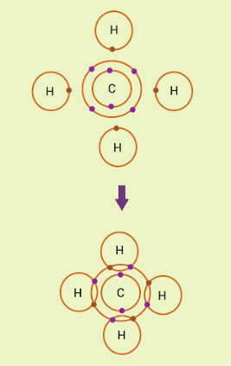

Mp, Bp and Electrical Conductivity
Covalent compounds:
- Are molecular compounds
- Are gases, liquids or solids
- Have weak intermolecular forces
- Have low melting and boiling points
- Are poor electrical conductors in all phases
- Are mostly soluble in nonpolar liquids

Allotropes of Carbon
– The phenomenon of the existence of the same element in different physical forms with similar chemical properties is known as allotropy.
– Some elements like carbon, sulphur, phosphorus, etc., exhibit this phenomenon.
– Crystalline allotropes of carbon include diamond, graphite and, fullerene.
– Amorphous allotropes of carbon include coal, coke, charcoal, lamp black and gas carbon.

Diamond
Diamond has a regular tetrahedral geometry. This is because each carbon is connected to four neighbouring carbon atoms via single covalent bonds, resulting in a single unit of a crystal. These crystal units lie in different planes and are connected to each other, resulting in a rigid three-dimensional cubic pattern of the diamond.
Diamond:
- Has a high density of 3.5g/cc.
- Has a very high refractive index of 2.5.
- Is a good conductor of heat.
- Is a poor conductor of electricity.
To know more about Diamond, visit here.

Graphite
In graphite, each carbon atom is bonded covalently to three other carbon atoms, leaving each carbon atom with one free valency. This arrangement results in hexagonal rings in a single plane and such rings are stacked over each other through weak Van der Waals forces.
Graphite:
- Has a density of 2.25 g/cc.
- Has a soft and slippery feel.
- Is a good conductor of electricity.

C₆₀
C₆₀, also known as Buckminsterfullerene, is the very popular and stable form of the known fullerenes.
It is the most common naturally occurring fullerene and can be found in small quantities in soot.
It consists of 60 carbon atoms arranged in 12 pentagons and 20 hexagons, like in a soccer ball.

Chains, Branches and Rings

Saturated and Unsaturated Hydrocarbons
Saturated hydrocarbons: These hydrocarbons have all carbon-carbon single bonds. These are known as alkanes. General formula = C_{n}H_{2n+2} where n = 1,2,3,4…..
Unsaturated hydrocarbons: These hydrocarbons have at least one carbon-carbon double or triple bond.
Hydrocarbons with at least one carbon-carbon double bond are called alkenes. General formula = C_{n}H₂n where n = 2,3,4…..
Hydrocarbons with at least one carbon-carbon triple bond are called alkynes. General formula = C_{n}H_{2n−2} where n = 2,3,4…..

Chains, Rings and Branches
Carbon chains may be in the form of straight chains, branched chains or rings.
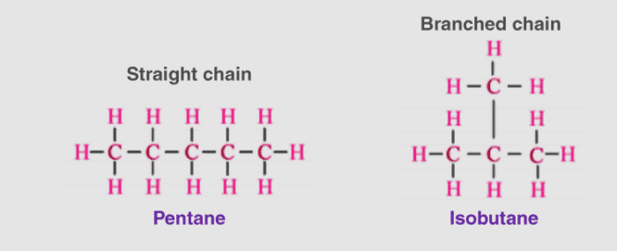

In cyclic compounds, atoms are connected to form a ring.
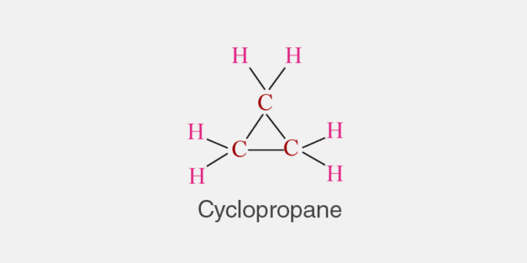

Structural Isomers
The compounds with the same molecular formula and different physical or chemical properties are known as isomers and the phenomenon is known as isomerism.
The isomers that differ in the structural arrangement of atoms in their molecules are called structural isomers and the phenomenon is known as structural isomerism.
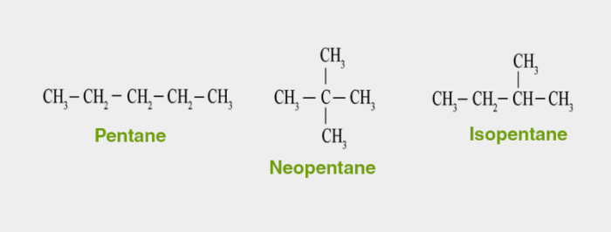

Benzene
Benzene is the simplest organic, aromatic hydrocarbon.
Physical properties: colourless liquid, pungent odour, flammable, volatile.
Structure:
Cyclic in nature with chemical formula, C₆H₆, i.e., each carbon atom in benzene is arranged in a six-membered ring and is bonded to only one hydrogen atom.
It includes 3-double bonds which are separated by a single bond.
Hence, this arrangement is recognized to have conjugated double bonds and two stable resonance structures exist for the ring.
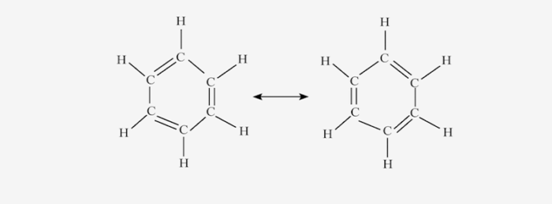

Functional Groups and Nomenclature

Functional Groups
An atom or a group of atoms which when present in a compound gives specific physical and chemical properties to it regardless of the length and nature of the carbon chain is called a functional group

Classification of Functional Groups
Main Functional Groups:
(i) Hydroxyl group (-OH): All organic compounds containing – OH group are known as alcohols. For example, Methanol (CH₃OH), Ethanol (CH₃−CH₂−OH), etc.
(ii) Aldehyde group (-CHO): All organic compounds containing -CHO group are known as aldehydes. For example, Methanal (HCHO), Ethanal (CH₃CHO), etc.
(iii) Ketone group (-C=O): All organic compounds containing (-C=O) group flanked by two alkyl groups are known as ketones. For example, Propanone (CH₃COCH₃), Butanone (CH₃COCH₂CH₃), etc.
(iv) Carboxyl group (-COOH): All organic acids contain a carboxyl group (-COOH). Hence, they are also called carboxylic acids.
For example, Ethanoic acid (CH₃COOH), Propanoic acid (CH₃CH₂COOH), etc.
(v) Halogen group (F, CI, Br, I): The alkanes in which one or more than one hydrogen atom is substituted by- X (F, CI, Br or I) are known as haloalkanes. For example, Chloromethane (CH₃Cl), Bromomethane (CH₃Br), etc.
To know more about Functional Groups, visit here.

Homologous Series
Homologous series constitutes organic compounds with the same general formula, similar chemical characteristics but different physical properties. The adjacent members differ in their molecular formula by −CH₂.

Physical Properties
The members of any particular family have almost identical chemical properties due to the same functional group. Their physical properties such as melting point, boiling point, density, etc., show a regular gradation with the increase in the molecular mass.

Chemical Properties

Combustion Reactions
Combustion means burning of carbon or carbon-containing compounds in the presence of air or oxygen to produce carbon dioxide, heat and light.

Flame Characteristics
Saturated hydrocarbons give clean flame while unsaturated hydrocarbons give smoky flame. In the presence of limited oxygen, even saturated hydrocarbons give smoky flame.

Oxidation
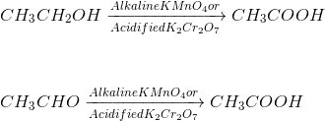

Addition
The reactions in which two molecules react to form a single product having all the atoms of the combining molecules are called addition reactions.
The hydrogenation reaction is an example of the addition reaction. In this reaction, hydrogen is added to a double bond or a triple bond in the presence of a catalyst like nickel, palladium or platinum.

Substitution
The reaction in which an atom or group of atoms in a molecule is replaced or substituted by different atoms or group of atoms is called substitution reaction. In alkanes, hydrogen atoms are replaced by other elements.
CH₄+Cl₂+Sunlight → CH₃Cl+HCl

Ethanol and Ethanoic Acid

Ethanol
(i) Ethanol, C₂H₅OH is a colourless liquid having a pleasant smell.
(ii) It boils at 351 K.
(iii) It is miscible with water in all proportions.
(iv) It is a nonconductor of electricity (it does not contain ions)
(v) It is neutral to litmus.
Uses:
- As an antifreeze in radiators of vehicles in cold countries.
2. As a solvent in the manufacture of paints, dyes, medicines, soaps and synthetic rubber.
3. As a solvent to prepare the tincture of iodine.

How Do Alcohols Affect Human Beings?
(i) If ethanol is mixed with CH₃OH and consumed, it causes serious poisoning and loss of eyesight.
(ii) It causes addiction, damages the liver if taken in excess.
(iii) High consumption of ethanol may even cause death.

Reactions of Ethanol with Sodium
Ethanol reacts with sodium to produce hydrogen gas and sodium ethoxide. This reaction supports the acidic character of ethanol.
2C₂H₅OH+2Na → 2C₂H₅ONa+H₂(↑)

Elimination Reaction
An elimination reaction is a type of reaction in which two substituents are removed from a molecule. These reactions play an important role in the preparation of alkenes.

Dehydration Reaction
Ethanol reacts with concentrated sulphuric acid at 443 K to produce ethylene. This reaction is known as dehydration of ethanol because, in this reaction, a water molecule is removed from the ethanol molecule.
CH₃CH₂OH → CH₂=CH₂+H₂O
(reaction taking place in presence of Conc.H₂SO₄)

Ethanoic Acid or Acetic Acid
(i) Molecular formula: CH₃COOH
(ii) It dissolves in water, alcohol and ether.
(iii) It often freezes during winter in cold climate and therefore it is named as glacial acetic acid.

Esterification
When a carboxylic acid is refluxed with alcohol in the presence of a small quantity of conc.H₂SO₄, a sweet-smelling ester is formed. This reaction of ester formation is called esterification.
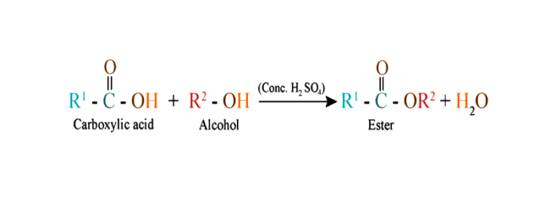

When ethanol reacts with ethanoic acid in presence of conc.H2SO4, ethyl ethanoate and water are formed.
CH₃COOH+C₂H₅OH → CH₃COOC₂H₅+H₂O
(reaction taking place in presence of Conc.H₂SO₄)

Saponification
A soap is a sodium or potassium salt of long-chain carboxylic acids (fatty acid). The soap molecule is generally represented as RCOONa, where R = non-ionic hydrocarbon group and −COO⁻Na⁺ ionic group. When oil or fat of vegetable or animal origin is treated with a concentrated sodium or potassium hydroxide solution, hydrolysis of fat takes place; soap and glycerol are formed. This alkaline hydrolysis of oils and fats is commonly known as saponification.
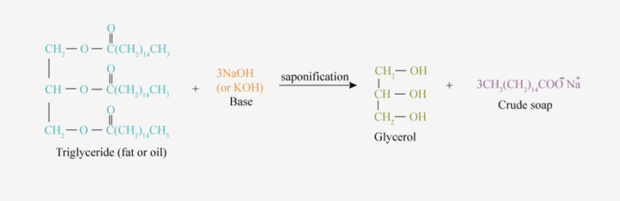

Reaction of Ethanoic Acid with Metals and Bases
Ethanoic acid (Acetic acid) reacts with metals like sodium, zinc and magnesium to liberate hydrogen gas.
2CH₃COOH+2Na→2CH₃COONa+H₂(↑)
It reacts with a solution of sodium hydroxide to form sodium ethanoate and water.
CH₃COOH+NaOH→CH₃COONa+H₂O

Reaction of Ethanoic Acid with Carbonates and Bicarbonates
Carboxylic acids react with carbonates and bicarbonates with the evolution of CO₂ gas. For example, when ethanoic acid (acetic acid) reacts with sodium carbonate and sodium bicarbonate, CO₂ gas is evolved.
2CH₃COOH+Na₂CO₃→2CH₃COONa+H₂O+CO₂
CH₃COOH+NaHCO₃→CH₃COONa+H₂O+CO₂

Friendly Carbon

Why Carbon Can Form so Many Compounds
Catenation occurs most readily with carbon due to its small size, electronic configuration and unique strength of carbon-carbon bonds. Tetravalency, catenation and tendency to form multiple bonds with other atoms account for the formation of innumerable carbon compounds.

Catenation
Catenation is the self-linking property of an element by which an atom forms covalent bonds with the other atoms of the same element to form straight or branched chains and rings of different sizes. It is shown by carbon, sulphur and silicon.

S₈
In its native state, sulphur show catenation up to 8 atoms in the form of S₈ molecule. It has a puckered ring structure.
