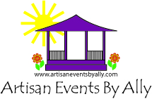
EVENT SPONSORSHIP FORM
EVENT NAME: _Milford Artisan Market
EVENT DATE: May 9, 2026 & May 10, 2026
Company Name:________________________________________________________________
Contact:_______________________________________________________________________
Address:_______________________________________________________________________
______________________________________________________________________________
Phone:________________________________________________________________________
Email:_________________________________________________________________________
Website:_______________________________________________________________________
Facebook:_____________________________________________________________________
Sponsorship cost is $1600
Thank you for your sponsorship! You will receive the following:
- Company/ name logo on all promotional materials, to include signage, flyers, etc…
- Company/ name logo listing on Facebook page.
- Company / name logo listing on event website.
- Company booth at the above noted market.
- Company/ name logo on all media releases.
We accept company check, all major credit cards, Paypal (allyfand@gmail.com) and Venmo (@Alison-Kosakowski). Please visit ArtisanEventsByAlly.com to access our Credit Card Authorization Form if needed.
Please feel free to contact Alison Kosakowski at 203-824-8293 or at allyfand@gmail.com with any questions.

