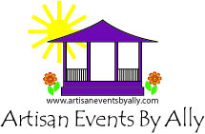

EVENT SPONSORSHIP FORM

EVENT NAME: _Milford Artisan Market

EVENT DATE: 0ctober 18, 2025 & October 19, 2025

Company Name:________________________________________________________________

Contact:_______________________________________________________________________

Address:_______________________________________________________________________

______________________________________________________________________________

Phone:________________________________________________________________________

Email:_________________________________________________________________________

Website:_______________________________________________________________________

Facebook:_____________________________________________________________________

Sponsorship cost is $1600

Thank you for your sponsorship! You will receive the following:

1. Company/ name logo on all promotional materials, to include signage, flyers, etc…
2. Company/ name logo listing on Facebook page.
3. Company / name logo listing on event website.
4. Company booth at the above noted market.
5. Company/ name logo on all media releases.

We accept company check, all major credit cards, PayPal (allyfand@gmail.com) and Venmo (@Alison-Kosakowski). Please visit ArtisanEventsByAlly.com to access our Credit Card Authorization Form if needed.

Please feel free to contact Alison Kosakowski at 203-824-8293 or at allyfand@gmail.com with any questions.