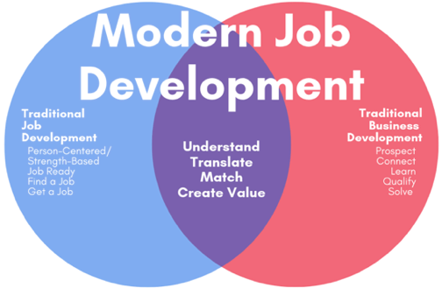

MODULE 4, CHAPTER 3, LESSON 2
Job GOAL SELECTION

Links

https://www.themuse.com/advice/the-11-best-career-quizzes-to-help-you-find-your-dream-job

https://www.thebalancecareers.com/free-career-aptitude-tests-2059813
Personality/values

http://www.colorquiz.com/

http://www.humanmetrics.com/cgi-win/jtypes2.asp#questionnaire

https://www.16personalities.com/Interests/Career identification

https://www.mynextmove.org/explore/ip

https://www.123test.com/career-test/

https://www.careeronestop.org/Toolkit/Skills/skills-matcher.aspx

https://tallo.com/blog/how-to-choose-career/

https://www.princetonreview.com/quiz/career-quiz

