**Pros & Peasants – Which One Are You?**

**Canada – June 2025**

The “Pros & Peasants” portion of our golf adventure tees off Saturday, June 21st, however, I’m sharing highlights of the area and my itinerary in the event any of you are looking to mirror it, wish to tag along or just searching for some ideas.

I’m arriving early Thursday, June 19th with plans to pack in what I can – golf at Stewart Creek and Banff Springs plus sightseeing - prior to the official start of our golf adventure. I’m also taking an extra day on the back end, returning Friday, June 27th, to catch a few more sights or squeeze in another round someplace.

Share your plans and we can coordinate as much or as little as you’d like.

**Highlights -** I’ve been to this area on two prior occasions, September 2015 and June 2017 (PnP), and there’s so much scenic beauty to marvel at. Travels included stops in Banff, Lake Louise, Panorama Mountain Resort and the Icefields Parkway. At the Columbia Icefield Discovery Center – halfway to Jasper - we took a [tour](http://www.brewster.ca/attractions-sightseeing/columbia-icefield-glacier-adventure/) out onto the glacier and took in the views from the ‘skywalk’ high above the valley floor below. Along the way there and back were many stops for photos of glaciers, waterfalls and stunning turquoise-colored glacial lakes such as Moraine Lake, Peyto Lake and Lake Louise. This area is so incredibly beautiful!

**Routing** – here’s the route from Calgary AB to Invermere BC (central to the PnP courses we will be playing). Lake Louise, in the northwest corner of the map, is the gateway to the Icefields Parkway… one of the most scenic drives in the world.

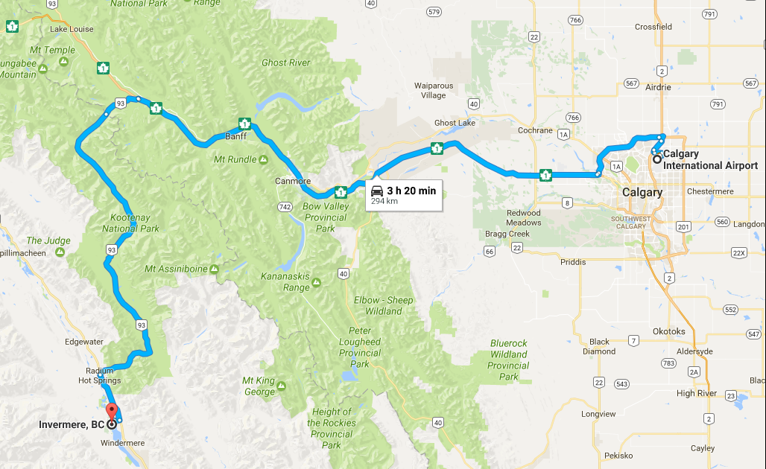

**Daylight** - the days are long this time of year with 5:30 am sunrises and 10:00 pm sunsets.

**Flights** – the majority of you have direct flight and/or morning arrival options into Calgary. Plan accordingly if you would like to play either of the optional pre-PnP rounds keeping in mind you’ll need to get through customs and travel time to the course. If you do not have this option, you might consider arriving the night prior. Same for those only playing PnP rounds.

**Lodging** – if arriving in the evening, I’d suggest booking an airport near the hotel. If you need a room in Banff for one or both nights, I can help with suggestions or include you in our room count. I’m looking at “budget” options, nothing fancy.

**Canadian Dollas (CAD) to US Dollar (USD) Exchange Rate** – near 20-year lows, the USD goes farther than ever. At the time of this writing, $100 CAD = $69.67 USD.

**Significant Others** – while PnP is for the guys only, several of you have shared your significant other may join you prior to or following PnP. If you get the “when are you done?” or “what is there to see and do?” line of questioning, I hope you find this guide, particularly the last section, useful.

**PnP Notes:**

* most tee times are now booked; Copper Point is TBD (tee sheet opens February)
* All PnP rounds, with the exception of Saturday, are planned for the mornings.
* Afternoons are open / free time. Options include:
  + Replay rounds or other area courses
  + Explore the area
  + Whitewater rafting / kayaking
  + Soak in the hot springs
  + Hiking

**------------------------------------------------------------------------------------------------------------------------------------------**

**Itinerary:**

**Thursday, June 19th**

* Arriving Calgary (YYC) at 10:43 am
* PM: 3:30’ish golf at [Stewart Creek](https://stewartcreekgolf.com/) ($185 CAD); #12 on Scoregolf’s Top 59
* Overnight in Banff area.

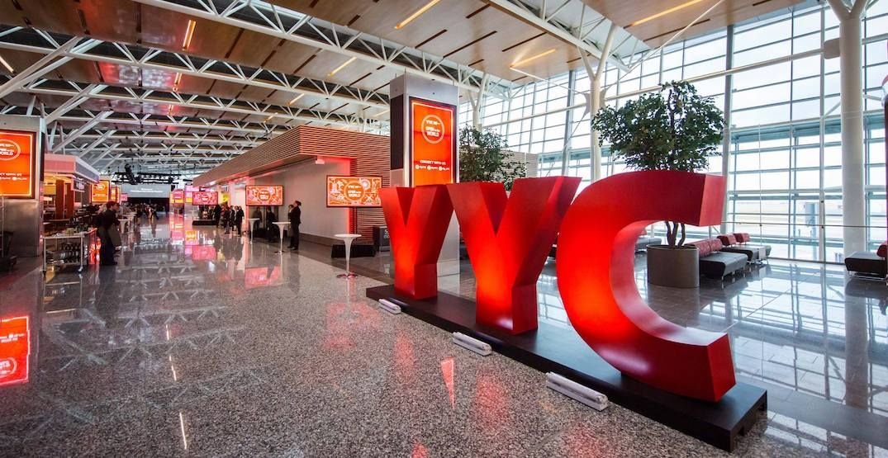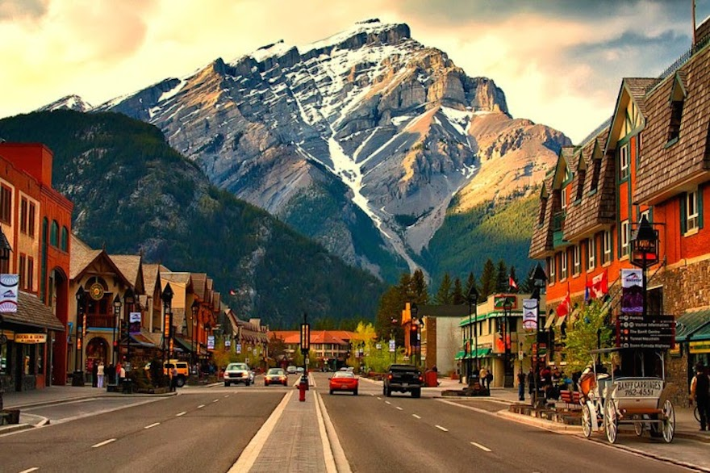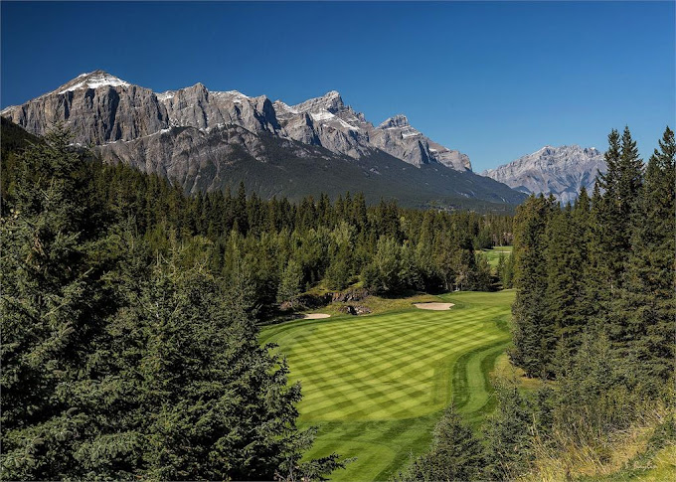 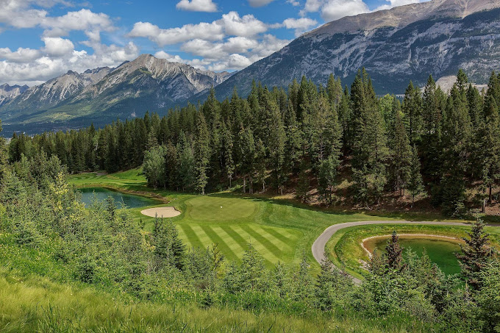

**Friday, June 20th**

* AM: 8 am shotgun start at [Banff Springs](https://www.banffmountaingolf.com/) ($339 CAD); # 4 on Scoregolf’s Top 59
* PM: take in the sights / explore the area; options include: Lake Louise and / or Moraine Lake, short hike along Johnston Canyon, visit Bow Falls, take the Banff Gondola to the summit, enjoy lunch / drinks from the Fairmont Banff Springs outdoor patio overlooking the Bow River and Banff Springs golf course.

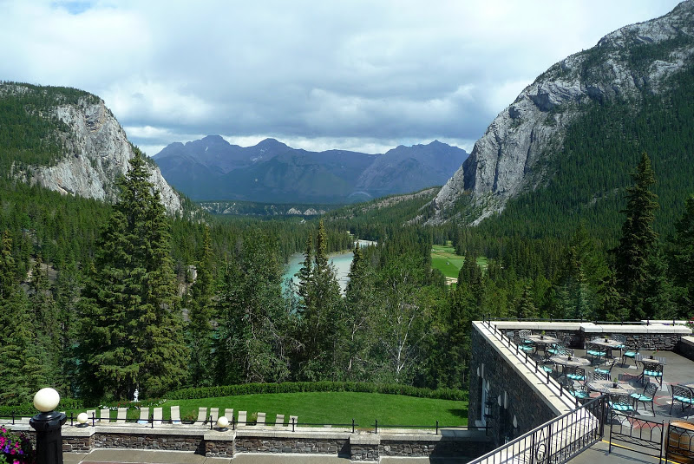 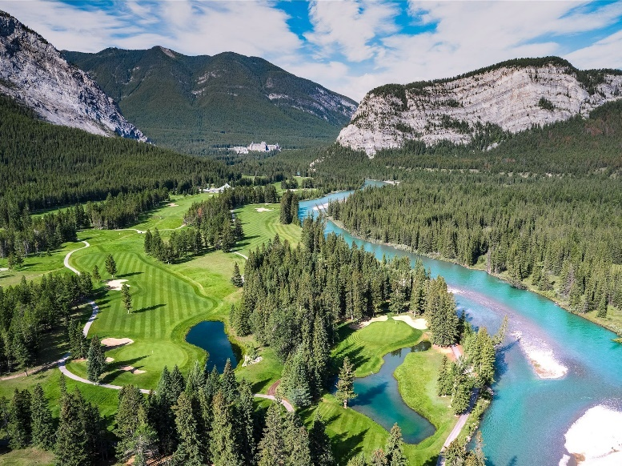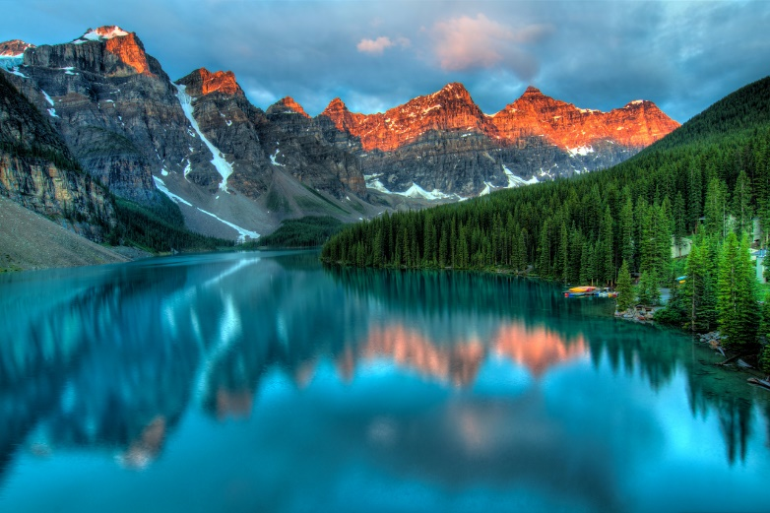 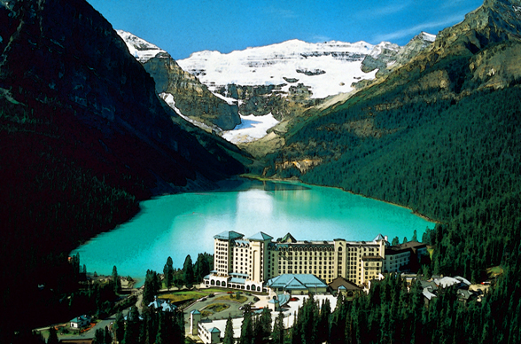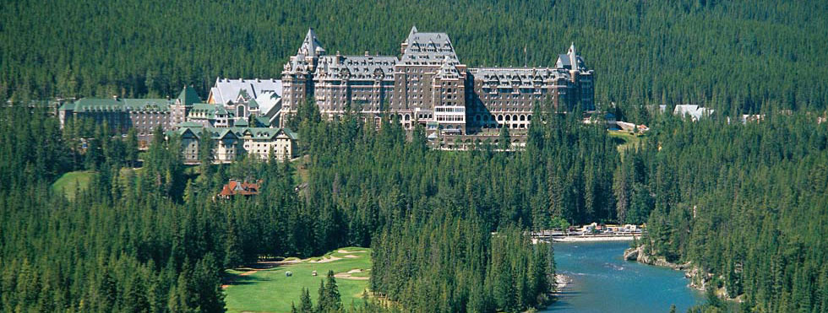 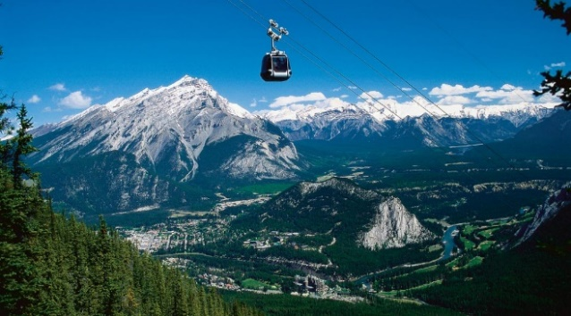 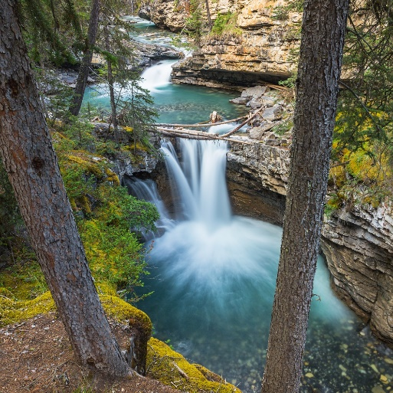 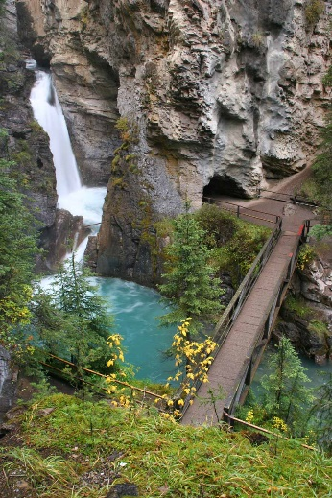 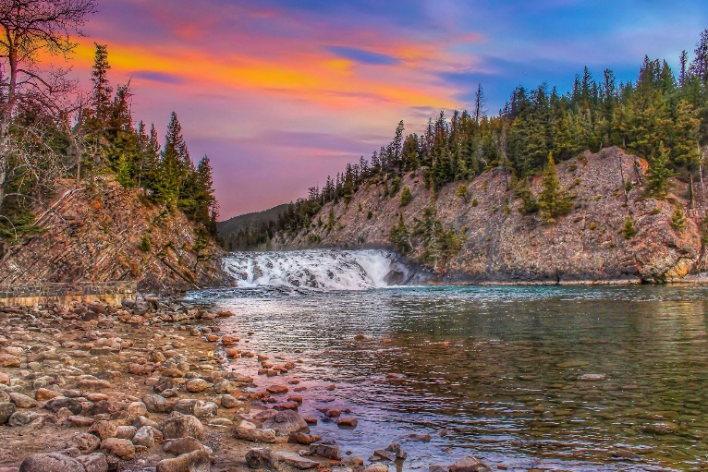

**Saturday, June 21**

* AM - visit Moraine Lake or other area attractions that may have been missed. Or stop for a short scenic hike (Marble Canyon) along the way to [Panorama Mountain Resort](https://www.panoramaresort.com/) where PnP 26 will officially begin with a Welcome Reception.
* [Greywolf](https://www.greywolfgolf.com/) (PnP – round 1) @ 2:40 pm
* Lodging for the next 5 nights will be here at Panorama.

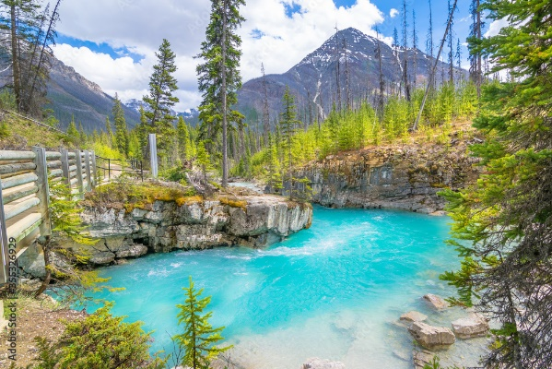 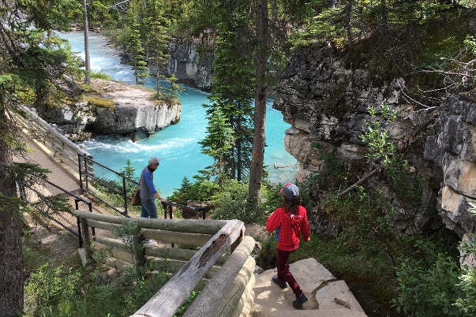 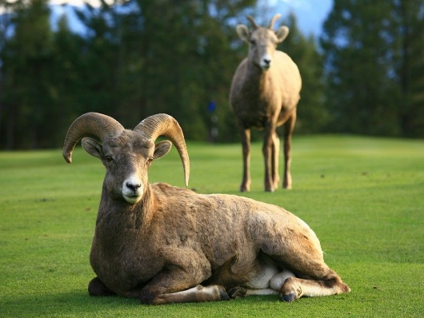

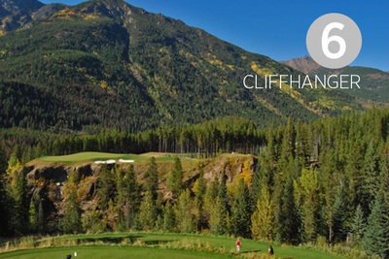 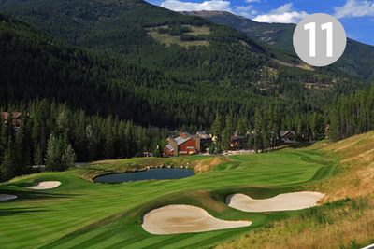 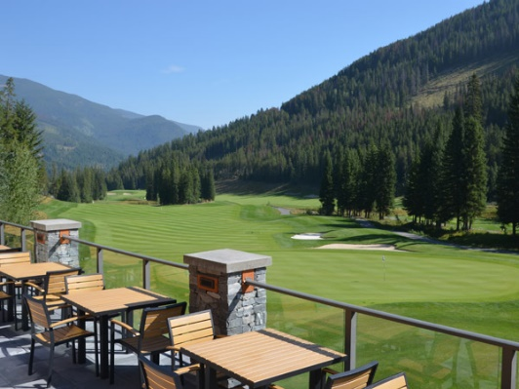 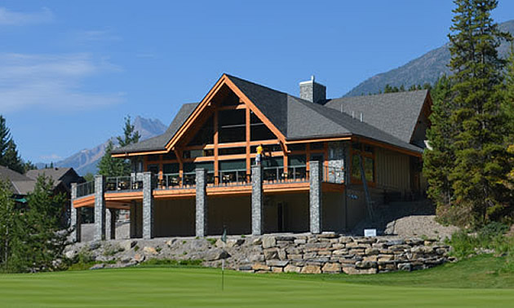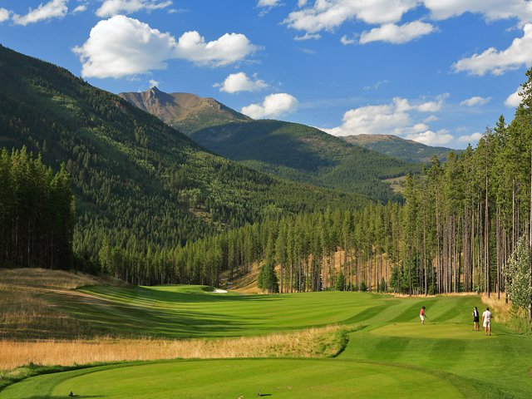

**Sunday, June 22**

* [The Point at Copper Point](https://copperpointgolf.com/) (PnP – round 2) – tee time TBD

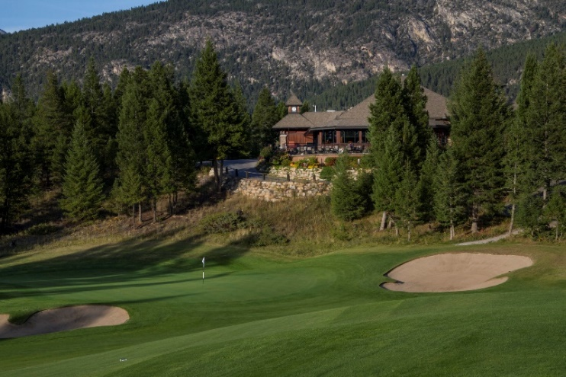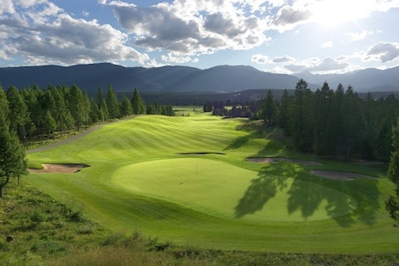

**Monday, June 23**

* [Greywolf](https://www.greywolfgolf.com/) (PnP – round 3) @ 8:20 am; optional replay @ 2:30 pm

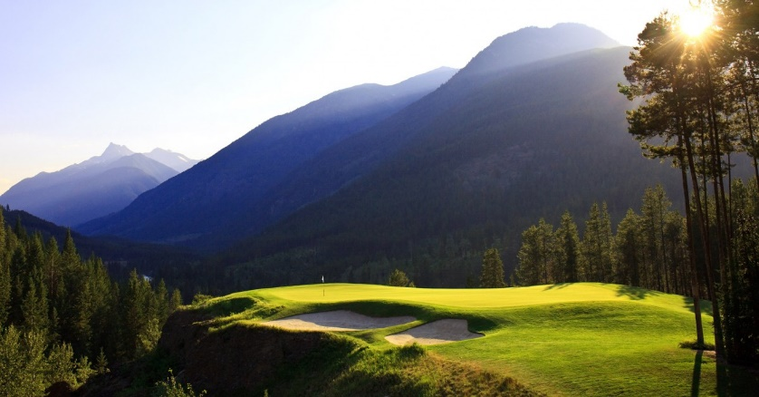 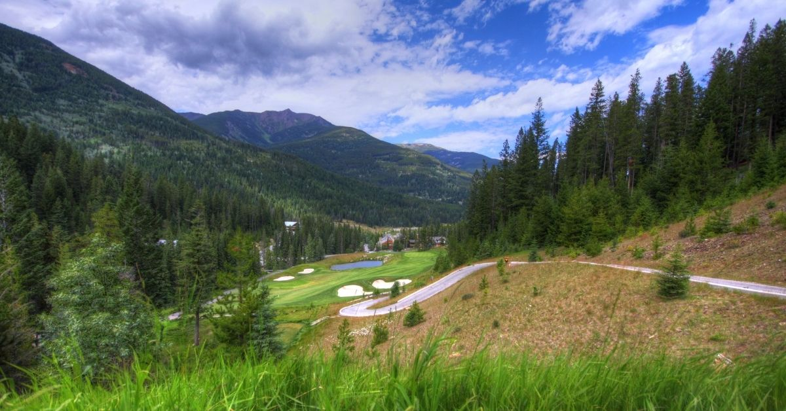

**Tuesday, June 24**

* [Eagle Ranch Resort](http://eagleranchresort.com/) (PnP – round 4) @ 9 am; optional replay @ 2:30 pm

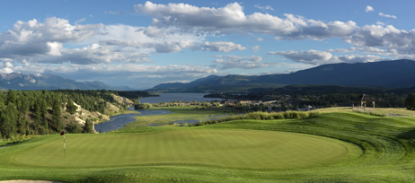 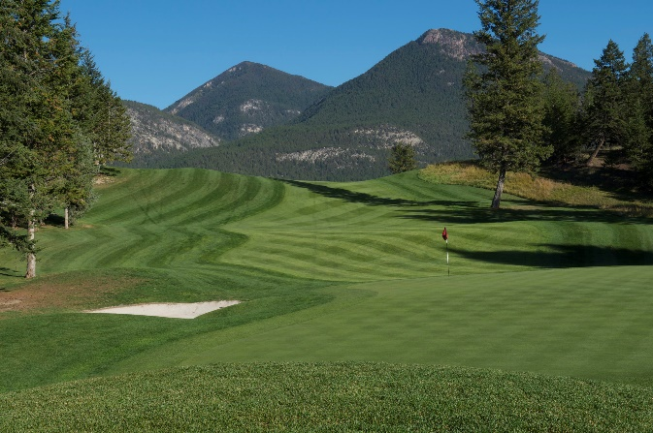

**Wednesday, June 25**

* [Greywolf](https://www.greywolfgolf.com/) (PnP – round 5) @ 8:20 am; optional replay @ 2 pm
* Plans are to cap off the week with a final night dinner at the [Cliffhanger Restaurant](https://www.facebook.com/pages/Cliffhanger-Restaurant-Greywolf-Golf-Course/1634124843467990).

**Thursday, June 26**

* Pack-up and head out
* The day is yours to do as you please whether that’s heading home, touring more of Canada, taking in another activity or squeezing in another 18…. the choice is yours.
* I’m taking the day to do whatever …. another hike, another round of golf, spot wildlife or take in additional sights as I return to Calgary.
* Overnight at an airport hotel

**Friday, June 27**

* My return flight departs at noon

**Optional Afternoon Activities**

* [Springs at Radium](http://www.radiumgolf.ca/the-courses/the-springs-course/) – set high along the banks of the might Columbia River just 20 minutes north of Eagle Ranch, it is also rated in SCOREGolf’s list of top 59 public courses in Canada
* Following your round on the Springs course, you might consider relaxing in the [Radium Hot Springs](http://www.hotsprings.ca/radium-hot-springs) pool just 5 minutes away.

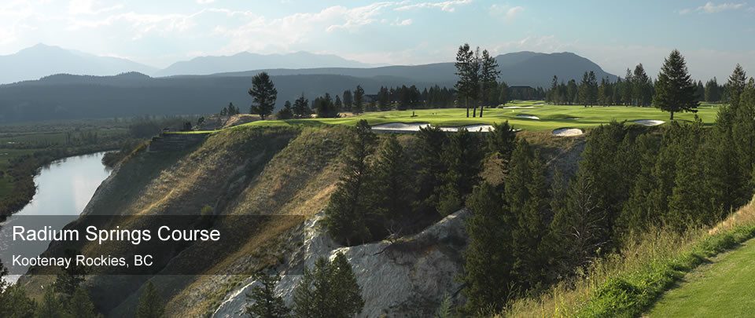 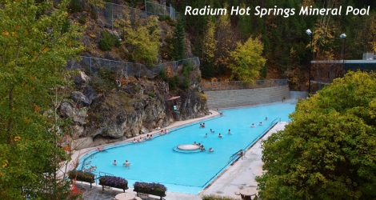

* Kick back and relax, soak in one of the warm water pools at Panorama, get a thrill [whitewater rafting](http://raftingtherockies.com/) the Toby Creek (on property) or Kicking Horse River (1 hour), kayak on Lake Windermere, go biking, hiking, shopping or add another round of golf....the choice is yours!

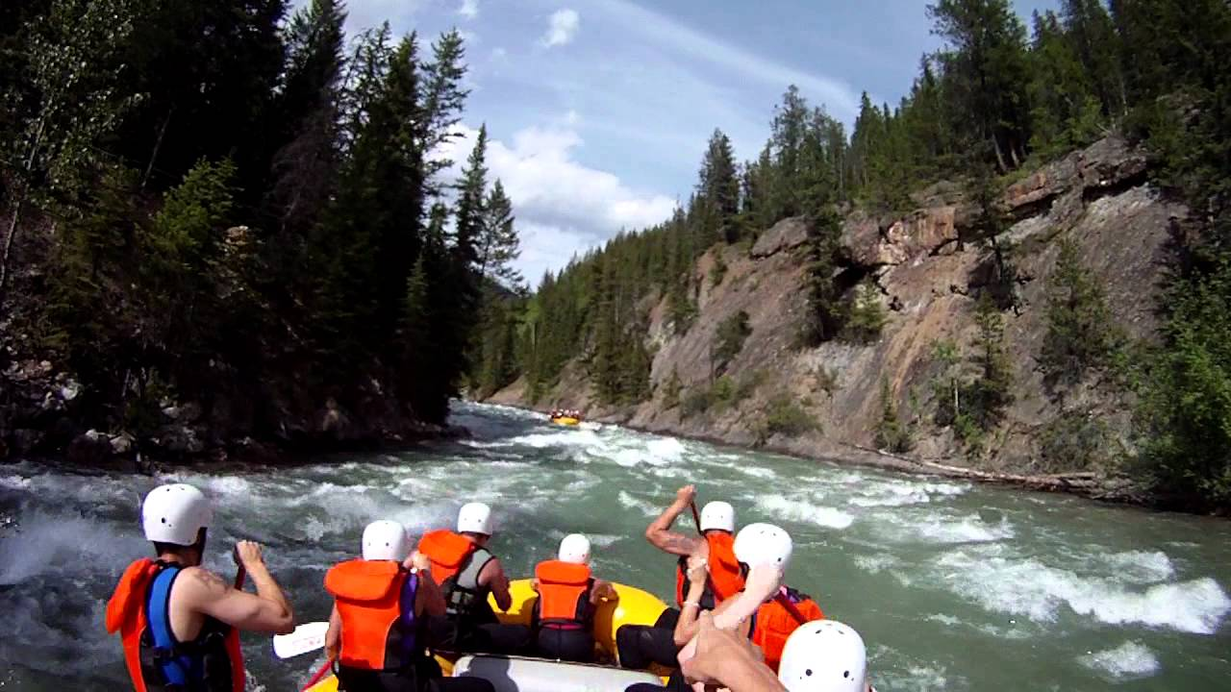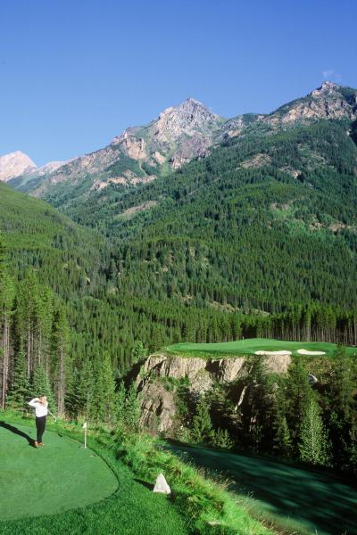 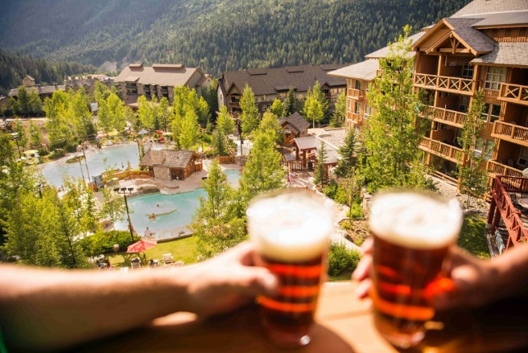

**Sightseeing**

* [Banff and Lake Louise](https://www.banfflakelouise.com/) –
  + Banff: Bow River, Bow Falls, Banff Fairmont Springs Hotel, Banff Gondola, Lake Minnewanka
  + Lake Louise – Moraine Lake, Fairmont Chateau Lake Louise overlooking Lake Louise, hiking to the Tea Houses, Lake Louise Gondola
* [Jasper](https://www.jasper.travel/) – Jasper National Park, Fairmont Jasper Park Lodge, hiking
* [Icefields Parkway](http://icefieldsparkway.com/) – grab your camera and prepare for a full day of incredible views from Lake Louise to the Columbia Icefield (largest south of the Arctic Circle) and beyond if you so choose. Attractions along the parkway include: Peyto Lake, Bow Lake, Crowfoot Glacier, Columbia Icefield, Glacier Skywalk, Sunwapta Falls, Athabasca Falls

