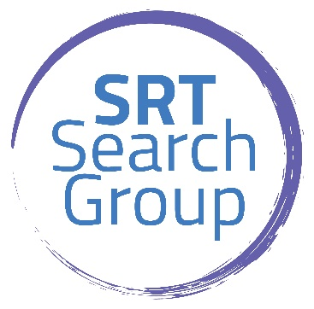

Audit Manager

Our client is a growing, full-service accounting firm in Willoughby. It has become one of the leading firms in the area by combining expertise, experience, and the energy of its staff. Each client receives close personal and professional attention. Most importantly this firm has 3 Partners with a combined 60 years of experience that genuinely care about their employees, offer a flexible, family-oriented work environment, manage the workload so they can keep hours to 55 during busy season and offer great pay and benefits. In addition to a base salary comparable to larger firms, the firm also offers an income sharing plan, commissions for bringing on new clients, great 401K plan and a contribution of $600 per month for medical insurance.

We are currently seeking an Audit Manager with strong client contact skills and the ability and desire to manage and review audit and accounting engagements. This opportunity requires someone that enjoys meeting and working closely with our business clients on quarterly or annual closings with Peachtree and QuickBooks software, preparing and reviewing audit/review engagements; serving as a resource to other staff accountants through training and mentoring along with growing and developing their own skills.

Excellent benefits including medical, dental, vision, 401K profit sharing plan, life insurance, STD/LTD, continuing education, team outings, business casual dress and more.

A Bachelor's degree in Accounting, Finance or related subject is required and a minimum of 7 years public accounting experience. CPA is preferred but not required.