Completed Applications to be sent to Management Agent;

Sage Management Corporation of Western New York

Address: 916 Upper Mountain Road, Lewiston, NY 14092

Phone: 716-298-4966

Fax: 716-298-4489   
TDD: 1-800-662-1220

[www.sagemanagementcorp.com](http://www.sagemanagementcorp.com)

Pages 1 – 6 for your records

**Four Locations to Apply**

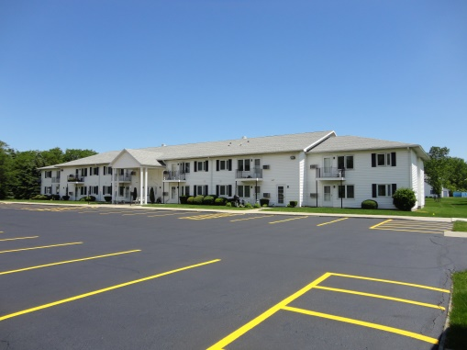 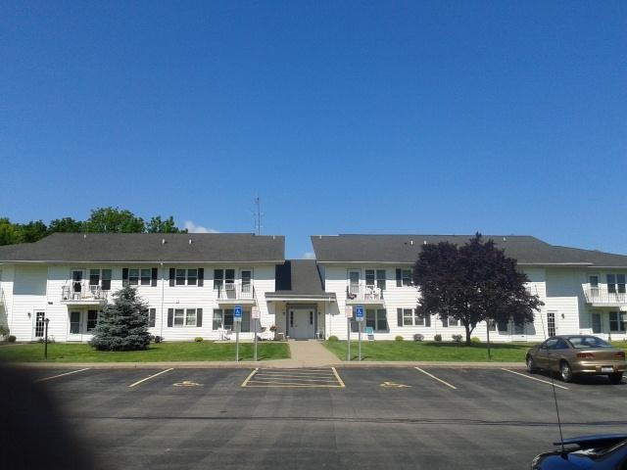

Lewiston Country Estates

916 Upper Mountain Road

Lewiston NY 14092

24 one bedroom, 1 two bedroom apartments

Middleport Country Estates

89 Telegraph Road

Middleport NY 14105

24 one bedroom apartments

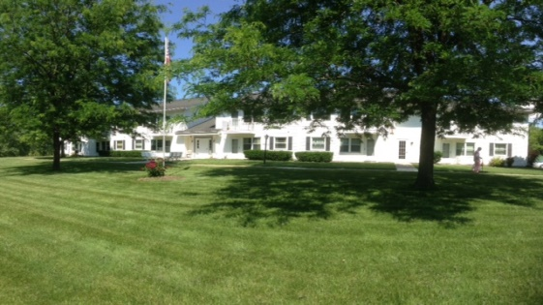 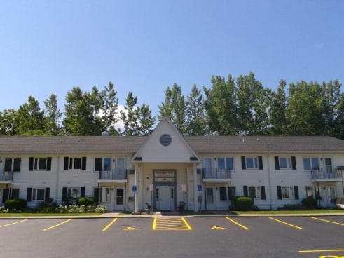

Middleport Villa

89B Telegraph Road

Middleport NY 14105

24 one bedroom, 1 two bedroom apartments aaaapartments

24 one bedroom apartments, 1 two bbebedrrobedroom

Wilson Country Estates

250 Autumnview Drive

Wilson NY 14172

24 one bedroom apartments

**To Qualify You Must**

* Be 62 years of age or older, or disabled of any age.
* Meet the income qualifications listed below
* Meet Screening Criteria Listed In Tenant Selection Plan (available upon request or found on our website)

|  |  |  |  |
| --- | --- | --- | --- |
| Max Income Level | 1 PERSON | 2 PERSON | 3 PERSON |
| **Very Low Income** | **$33,950** | **$38,800** | **$43,650** |
| **Low Income** | **$54,250** | **$62,000** | **$69,750** |

Priority is given to those applicants with very low income.

Revised: 07/12/2024

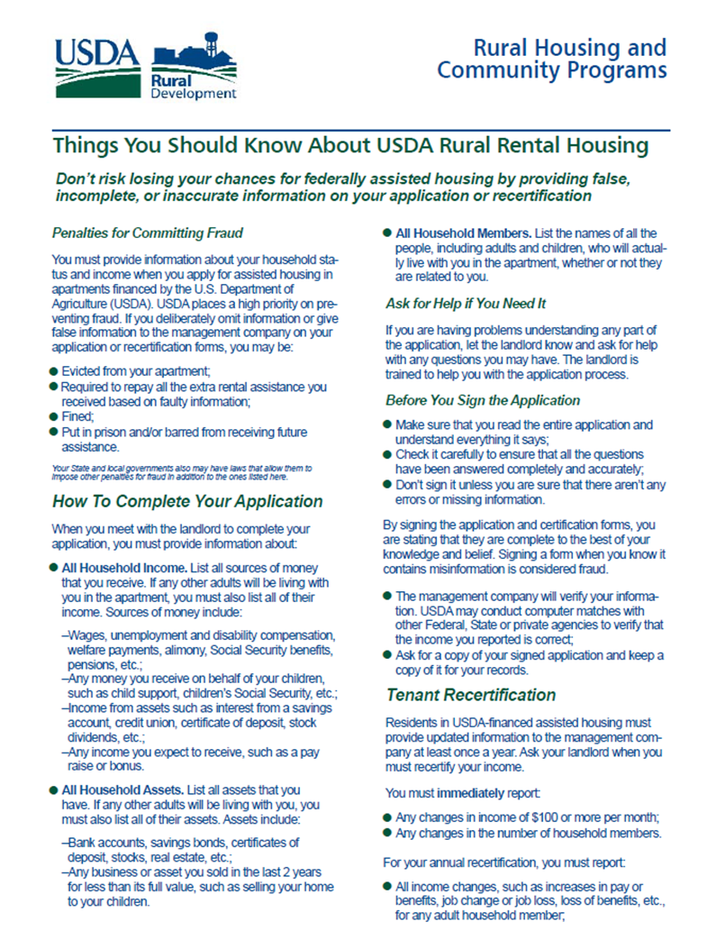

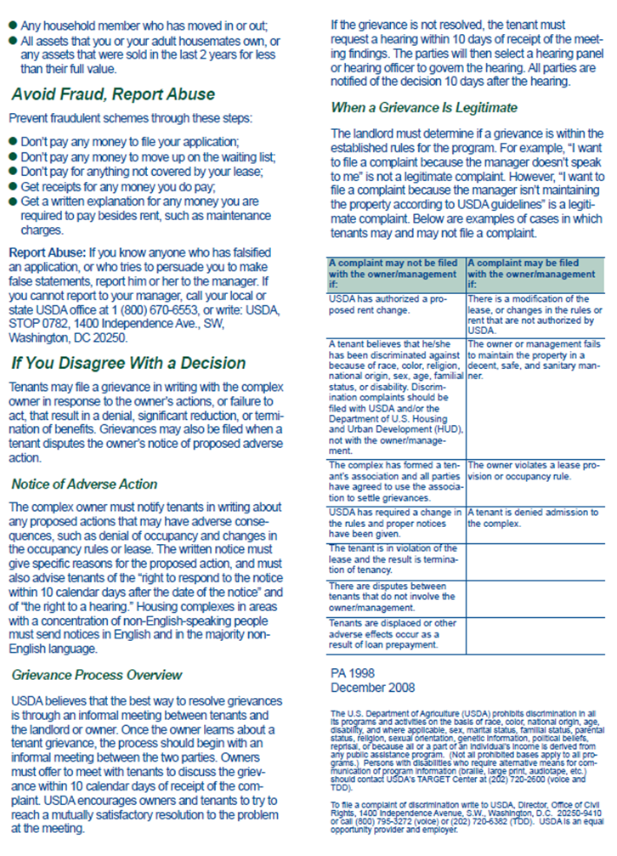

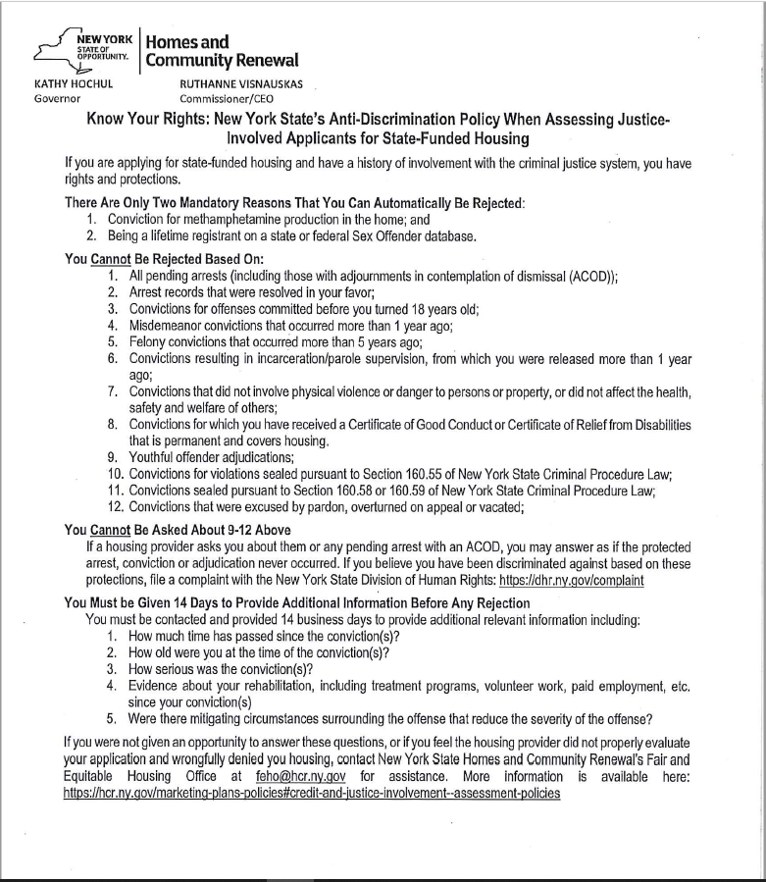

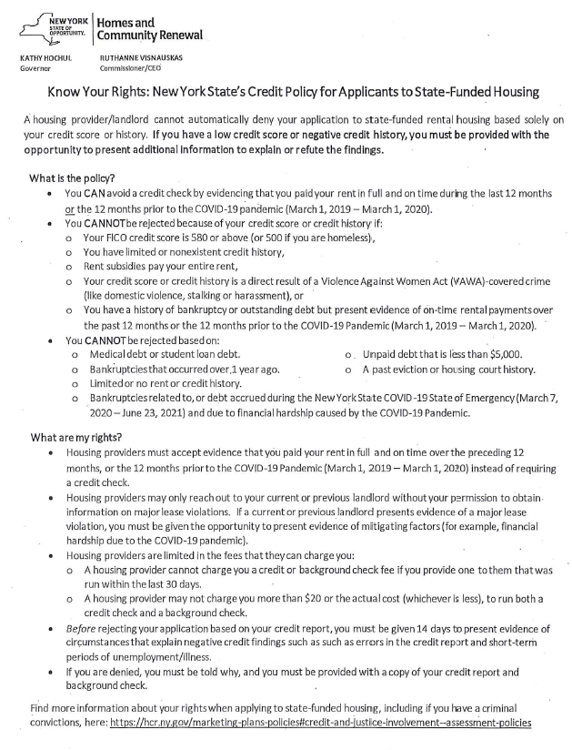

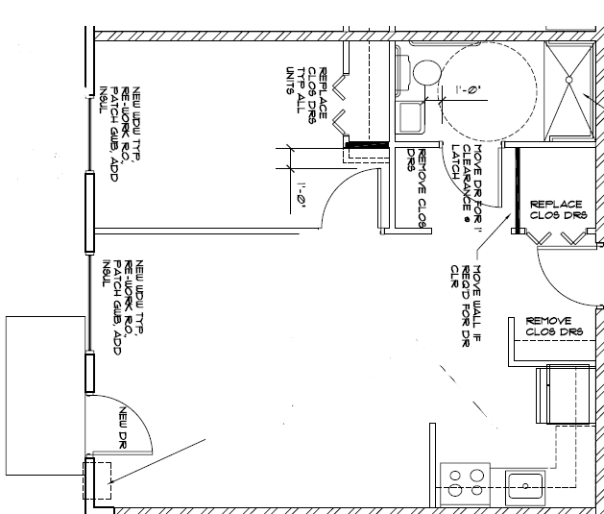**Typical One-Bedroom Apartment**

**Typical Two-Bedroom Apartment**

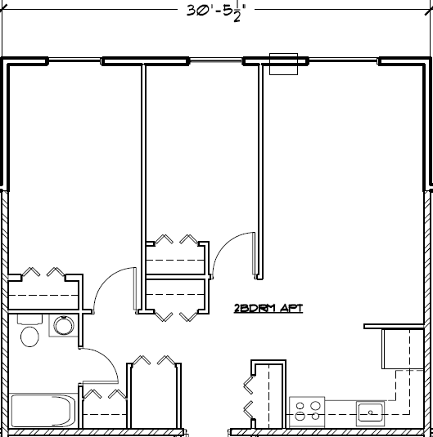

**Wait List Application**

**Please return this portion (pages 7-11) to 916 Upper Mountain Road, Lewiston NY 14092**

**Please put N/A if something doesn’t apply, blank responses will be view as unanswered, and application could be rejected. Acceptance of application does not guarantee an apartment.**

**House Hold Information**

**Which Apartment Complex are you applying too? (You may request more than one).**

Lewiston Country Estates,  Middleport Country Estates,  Middleport Villa  Wilson Country Estates

**Type of Unit Requested: (You may request more than one type of unit).**

One Bedroom,  Two Bedroom,  Handicapped (If checked yes, please complete Special Unit Questionnaire)

Head of Household:

Date of Birth:

Social Security#:

Phone:

The information regarding race, ethnicity and sex designation solicited on this application is requested in order to assure the Federal Government, acting through the Rural Housing Service that the Federal laws prohibiting discrimination against tenant applications on the basis of race, color, national origin, religion, sex, familial status, age and disability are complied with. You are not required to furnish this information but are encouraged to do so. This information will not be used in evaluation of your application or to discriminate against you in any way. However, if you choose not to furnish it, the owner is required to note the race, ethnicity and sex of individual applicants on the basis of visual observation or surname.

Address:

Email:

License info:

I do not wish to furnish the information about race, gender or ethnicity.

**Race:**   
 White  American Indian or Alaskan Native

Asian  Native Hawaiian or Other Pacific Islander

Black/African American  Other (Specify)  **Gender:**

Male  Female  **Ethnicity:**

Hispanic or Latino  Not Hispanic or Latino

**List ALL persons who will live in the apartment.**If you do not wish to furnish information about race, gender or ethnicity, please put **RF**

AS: **Asian,** AI/AN: **American Indian or Alaskan Native,** B/AF: **Black/African American,**

WH: **White,** NH/PI: **Native Hawaiian or Other Pacific Islander, For Student, put yes or no**

|  |  |  |  |  |  |  |  |  |
| --- | --- | --- | --- | --- | --- | --- | --- | --- |
| Name | Relation | Date of Birth | SSN# | Phone# | Race | Gender | Ethnicity | Student |
|  | **SELF** |  |  |  |  |  |  |  |
|  |  |  |  |  |  |  |  |  |
|  |  |  |  |  |  |  |  |  |
|  |  |  |  |  |  |  |  |  |

**Do you have a vehicle?** ☐ YES (please complete the chart below) ☐ NO

|  |  |  |  |  |
| --- | --- | --- | --- | --- |
| **Year** | **Make** | **Model** | **Plate# & State** | **Color** |
|  |  |  |  |  |

**Income**

Please check all that apply to your household.

☐ I have no income sources

☐ Social Security

☐ SSI/SSD

☐ State Disability

☐ Retirement/Pension

☐ Veterans Benefit

☐ Unemployment Benefits

☐ Alimony /Child Support

☐ Annuity/IRA Payments

☐ Employment

☐ Stock Market Returns

☐ Monthly Monetary Gift(s)

☐ Lottery Winnings

☐ Rental Income

|  |  |  |  |
| --- | --- | --- | --- |
| **Name** | **Income Source** | **Dollar Amount** | **Frequency-Per** |
|  |  |  | Week ­ Month ­ Year |
|  |  |  | Week ­ Month ­ Year |
|  |  |  | Week ­ Month ­ Year |
|  |  |  | Week ­ Month ­ Year |
|  |  |  | Week ­ Month ­ Year |
|  |  |  | Week ­ Month ­ Year |

**Any household members receive, or attempting to receive child support or alimony?** ☐ YES ☐ NO

If yes, please explain: _____________________________________________

###### **Do you anticipate changes to this income in next 12 months?** YES NO

###### Yes, explain:____________________________________________________

**Any household members receive income from any source not listed above?** ☐ YES ☐ NO

If yes, please explain: _____________________________________________

A**ny household members a student?** ☐ YES ☐ NO

If yes, name of Educational Institution:

Address:

Phone:

Fax & Email:

**Do you wish to provide a copy of a recent credit check you had completed?**

YES (if selected please attach credit check)  NO (we will run a credit check)

**Do you wish to provide evidence that you paid your rent in full on time during the last 12 months or the 12 months prior to COVID-19.** (March 1, 2019 – March 1, 2020)  YES (if yes, please attach evidence)  NO

**Do you have a Pet?** ☐ YES ☐ NO If yes, please describe:__________________________________________

**Assets**

Please check all that apply to your household.

☐ Checking Account

☐ Savings Account

☐ IRA,

☐Annuities

☐Money Markets

☐ Whole Life Insurance

☐ Stocks, Bonds & Treasures Funds

☐ Trust Funds

☐ Certificates of deposit

☐ 401K

|  |  |  |
| --- | --- | --- |
| **Name** | **Asset Type** | **Cash Value** |
|  |  |  |
|  |  |  |
|  |  |  |
|  |  |  |
|  |  |  |
|  |  |  |

**Declaration of NO assets**

I hereby declare that I do not have any assets in any form which I have access, ownership or entitlement to. \

Signature: _____________________________

**Real Property: Do you own any property?**  Yes

If Yes: Type of Property ___________________________________________________

Location _______________________________________________________

Appraised Market Value $______________Mortgage Balance_______________

**Have you disposed of any assets below market value in the last two years?**  Yes  No

If Yes: Type of Asset _______________________­_________________________

Market Value When Sold/Disposed $_________ Transaction Date ___________

Amount Sold/Disposed For $__________________________________________

**Do you jointly own any assets?**  Yes  No

If Yes: Type of Asset _______________________­_________________________

Percentage owned:

**Do you have other asset not listed above (excluding personal property)?**  Yes  No

If yes, explain __________________________________________

**Any household members have whole or term life insurance?** ☐ YES ☐ NO

If yes, please list cash value:

# Medical Expenses

Please check all that apply to your household.

☐ I have No Medical Expenses

☐ Co-pay for Physician Visits

☐ Medical Insurance Premiums

☐ Prescription Drug Coverage Premiums

☐ Medical Spenddowns

☐ Prescription Out Of Pocket

☐ Audiology Expenses

☐ Optical expenses

☐ Dental Expenses

☐ Hospital, Lab & Therapy

☐ Medical Mileage

☐ Over the Counter Items

(Requires Physician’s prescription)

|  |  |  |
| --- | --- | --- |
| **Medical Provider with Address** | **Round Trip Mileage** | **Visits Per Year** |
|  |  |  |
|  |  |  |
|  |  |  |

**Do you require a reasonable accommodation?** ☐ YES ☐ NO   
If yes, please explain accommodation

*A reasonable accommodation is a change, exception, or adjustment to a program, service, building, dwelling unit or workplace that will allow a qualified person with a disability.*

**Do you have an Assistance Animal?** ☐ YES ☐ NO

Is the assistance animal trained in any actions other that emotional support? ☐ YES ☐ NO

If yes, please provide at least one action: ­­

**Do you or household members meet the eligibility requirements listed on Page 1?** ☐ YES ☐ NO

**Will you or any member of your family require any of the following?**

Unit for Visually-Impaired

Unit for Hearing-Impaired

First Floor Unit

Wheelchair accessible shower

Lowered Kitchen Shelves

Live In Attendant

**Justice Involvement Check**

Have you, or a household member been arrested or convicted of a Misdemeanor?  Yes  No

Have you, or a household member been arrested or convicted of a Felony?  Yes  No

Have you, or a household member been arrested or convicted for production of methamphetamine?  Yes  No

Have you, or a household member on a Federal or State Sex Offender database?  Yes  No

**Landlord Reference**

**Have you rented in the last 10 year?** ☐ YES, ☐ NO, Own My House ☐ NO, living with family

Last Landlord Name: Phone No:

Address:

Email: Monthly Rent Amount:

Move In: Move Out:

**---------------------------------------------------------------------------------------------------------------------------------------------------**

**Emergency Contact**

Name: Phone No:

Relation: Email:

Address:

**Permission for Emergency Contact (Check all that would apply)**  
☐Management can discuss and release any information to the above person/organization.

☐ Call if Management is unable to contact you.

☐ Management can allow person/organization access to your apartment if requested.

☐ Person/Organization has ability to allow Management into the unit if requested. (Wellness Check)

---------------------------------------------------------------------------------------------------------------------------------------------------

**How did you hear about us?**

Online Search  Paper Advertisement

Department of Social Services  City / Township

Referral by friend  Other:

---------------------------------------------------------------------------------------------------------------------------------------------------

**CERTIFICATION**

I hereby certify that I will not maintain a separate subsidized rental unit in another location. I certify that this will be my permanent residence. I certify that I am a U.S. citizen or a qualified alien (a legal or qualified alien refers to any person lawfully admitted to the country who meets the criteria in Section 214 of the Housing and Community Development Act of 1980, 42 USC 1436a.). I understand I must pay a security deposit for this apartment prior to occupancy. I understand that my eligibility for housing will be based on the USDA Rural Development and NYS Housing and Community Renewal income and occupancy limits and selection criteria. I certify that all information contained in this application is true to the best of my knowledge and that false statements and/or information are punishable by law and will lead to cancellation of this application and/or termination of tenancy after occupancy.

**__________________________________________ ____________________________________________**

**Head of Household Date Co-Head Date**

**Adult Household Member Date Adult Household Member Date**

**RELEASE OF INFORMATION AUTHORIZATION**

I do hereby authorize Sage Management and any authorized representative to contact any agencies, offices, groups or organizations to obtain and verify any information or materials which are deemed necessary to complete my application for housing. This could include police/background checks and credit checks.

**Head of Household Date**

**Co-Head Date**

**Adult Household Member Date**

**Adult Household Member Date**

Sage Management Corporation of Western New York, Lewiston Country Estates, Middleport Country Estates, Middleport Villa and Wilson Country Estates do not discriminate on the basis of race, color, religion, sex, national origin, age, marital status, disability, handicap, sexual orientation, gender identity, or familial status.

