
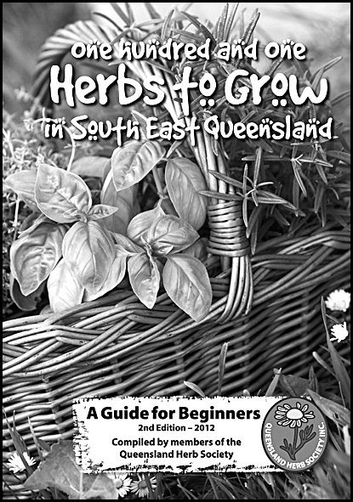
QUEENSLAND HERB SOCIETY INC.
102 McDonald Road, Windsor Qld 4030
Email: qhs@live.com.au Tel: 07 3279 6037
BOOK ORDER FORM
Book Cost = $15 each OR 2 for $25
(can be two of the same book or one of each)
+ Postage of $5 for 1 book or $10 for 2 books.
To order these books complete the details below.
----------------------------------------------------------------------------
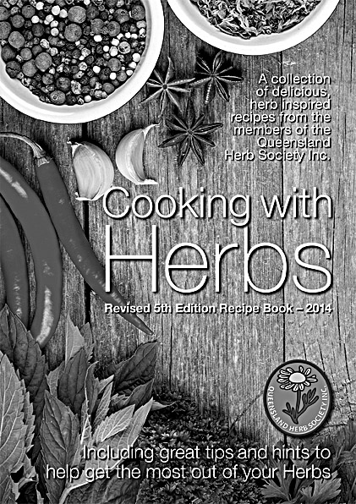
Yes please I wish to order the following book/s…
QUANTITY OF BOOKS ORDERED:
101 Herbs to Grow in South-East Queensland
(A guide for beginners)

Cooking with Herbs – Recipe Book

TOTAL PAYMENT DUE:
1 book + postage ($15 + $5) = $20

2 books + postage ($25 + $10) = $35

NOTE: For prices to order more than 2 books, please contact the Queensland Herb Society.
PAYMENT OPTIONS: Choose one (1) of the following payment options. Please make cheque or money order payable to “The Queensland Herb Society Inc.”:

IN PERSON: Fill out this form and bring along to one of our meetings with your cash, cheque or money order.
POST: Fill out this form and along with your cheque or money order (do not send cash) post to: Queensland Herb Society Inc., 102 McDonald Road,
Windsor Qld 4030.

ELECTRONIC TRANSFER: Fill out this form and along with your confirmation of deposit, scan and email to qhs@live.com.au or post to address above.

• EFT Bank Account Details BSB: 124011 Account Number 10020707 Account Name: Qld Herb Society Inc.
• Please include the prefix “BOO” then your “surname” in the description for the electronic transfer to help clarify payment.
CONTACT & DELIVERY DETAILS:
Name: _____________________________________________________________

Delivery address: ____________________________________________________

______________________________________________ Postcode: __________

Phone: ______________________ Email: ________________________________

