Royal Oaks Tennis Reservations
- Login to your account- royaloaksestates.frontsteps.com
- My Reservations & Requests >
- Community Reservations>
- +Community Reservations

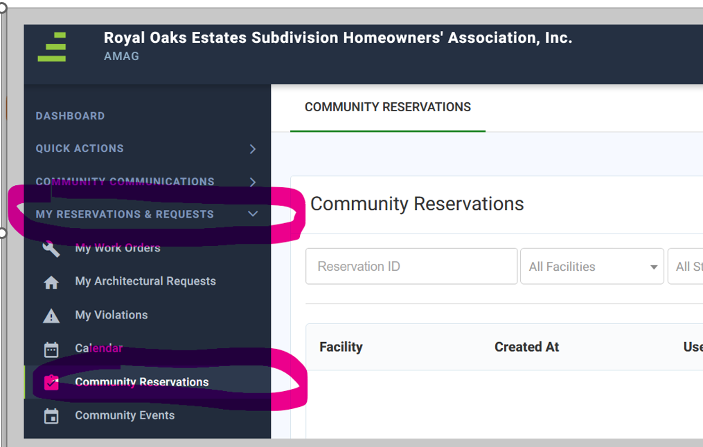
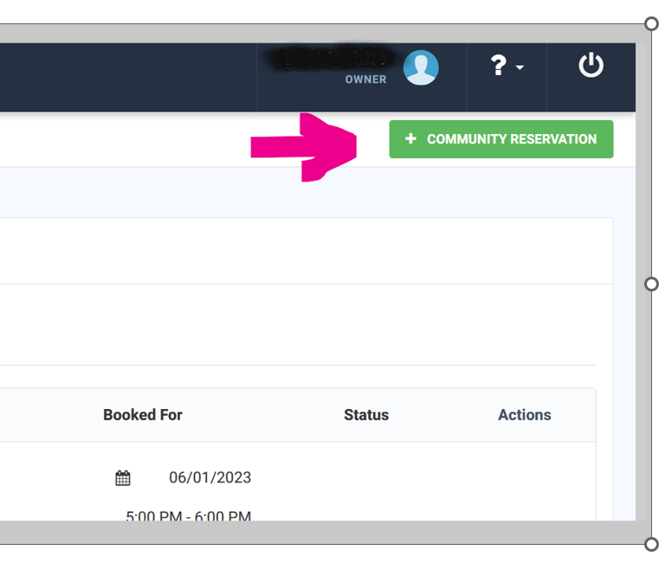

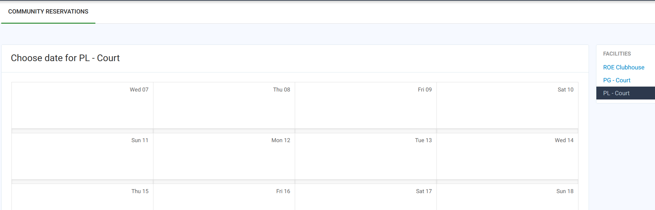
- ROE Clubhouse

- Select time and submit.
- For approval you will need to : email Clubhouse Form to Admin@AssociationMgt.com and Pay fee.

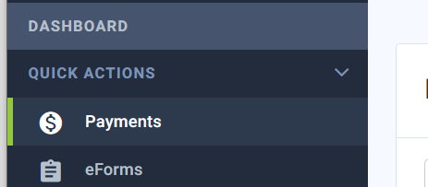
Pay fee $75.00 :
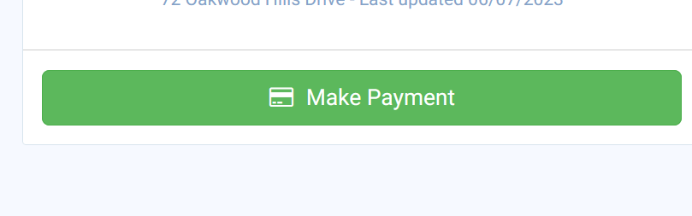

You can check the status of reservations.

