Royal Oaks Tennis Reservations
- Login to Front Steps: royaloaksestates.frontsteps.com
- My Reservations & Requests >
- Community Reservations>
- +Community Reservations

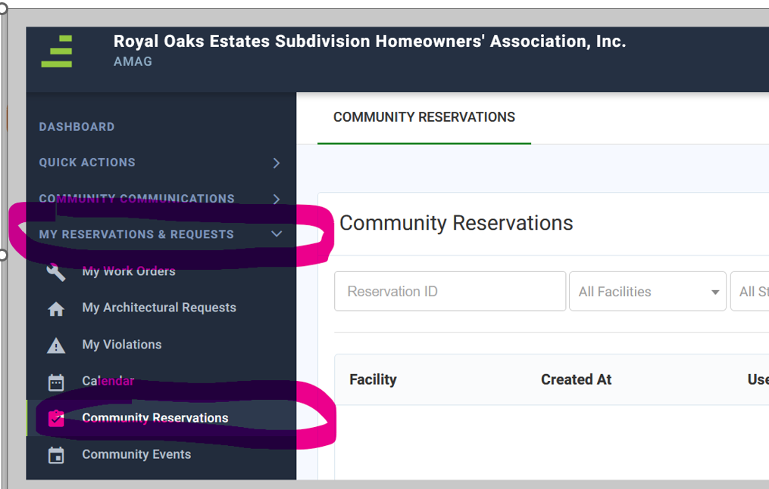
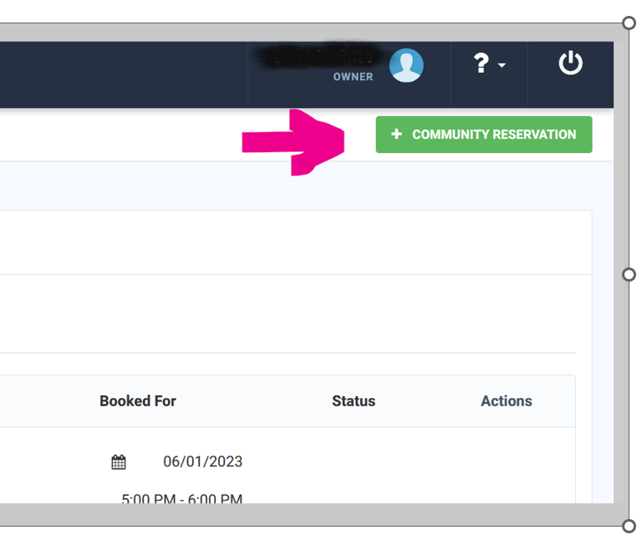

- PG Court – Play Ground tennis court
- PL Court - Parking Lot tennis court

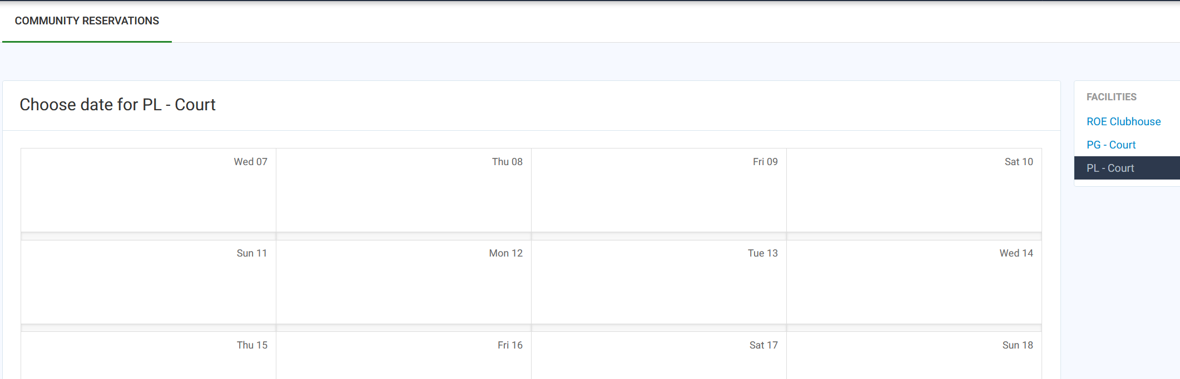
For Tennis – select Court & time and submit, then wait for approval
You can check status of reservations.
