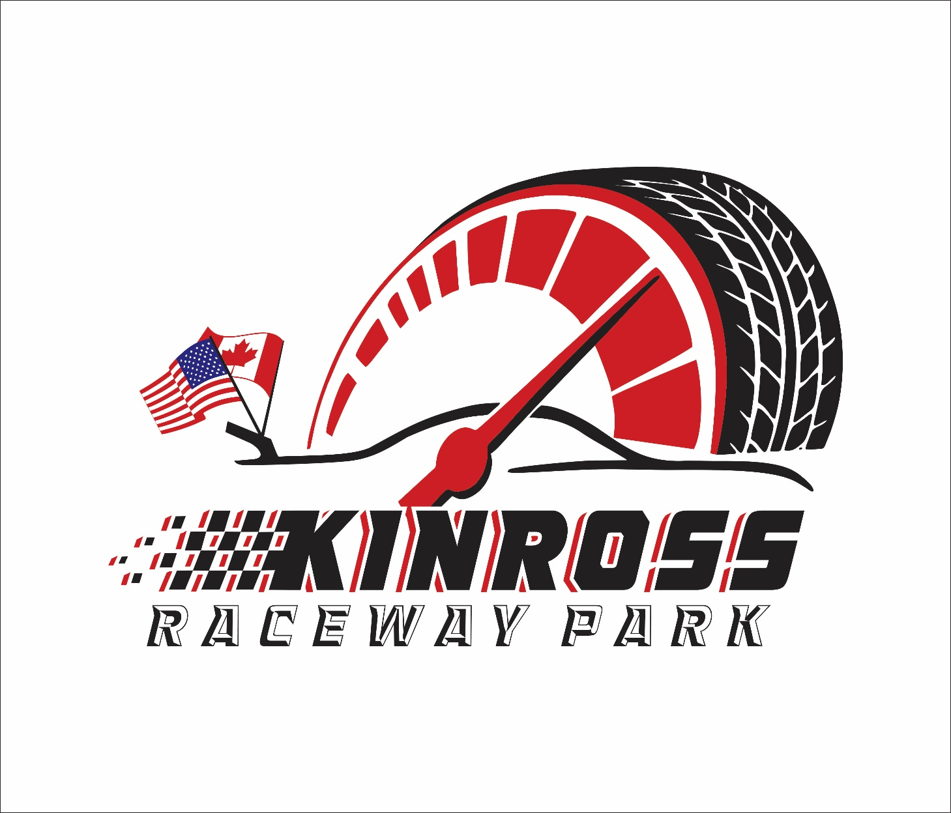

2026 ABC STOCKCAR RULES
RULES QUESTIONS? Please e-mail the track by sending your e-mail to kinrossracewaypark@gmail.com
Please also read and understand the General Rules, (published separately) they apply to all classes / competitors. Kinross Raceway Park/Kinross Raceway Park Racing officials decision is FINAL!

The ABC Stock Car Division is designed to allow the competition of many different variations of stock cars which are currently racing at most local short tracks in Michigan and surrounding areas or have raced in the past. The most common classes of cars are typically known as Sportsman, Street/Factory Stock, Stock, and Sands Fuel Injected Mustang. Other names for allowable classes to compete in this series might be Pro Stock, Super Stock, Factory Stock and Lead Sled. This division is designed for current up to date race cars as well as what many consider to be old and outdated race cars. The basic ABC Stock Car is V8 powered and rear wheel drive. Teching in this division is very easy since all areas of enforcement are clearly visible. Teardowns are not needed in this division. In addition to the requirement of V8 and RWD, there are some ultimate limits to what is allowed. Those limits are covered in these rules. Even though there is a very wide range of cars allowed in the ABC Division, the basic concept allows everyone to be competitive because of the feature race format. The generic ABC name is derived from the features that will be run, A-main, B-main, and C-main. The format allows for an unlimited number of cars to race since additional features can be added. The ABC concept allows everyone to be able to compete in a feature along with other drivers and cars of similar speed. There are no races or semi features. Everyone qualifies for a feature, the A-main, B-main, or C-main, depending on the qualifying times. (Or D-main, E-main, etc)
.

NOTE: RACECEIVERS AND TRANSPONDERS ARE MANDATORY!
All drivers will be required to operate a raceceiver during all hot lap sessions, qualifying and race events. These devices will be used for on-track safety notice, disciplinary action and line-up procedures.
Raceceiver is to be tuned to 454.0000. Any driver who does not have a THE MOST IMPORANT RULE IS THIS: Any car that is deemed too radical and too much outside of the rules of
typical stock car classes (by components or speed) that can be found competing at various other area tracks will not be allowed. With that said, the rules for this series are fairly open, but will be controlled by Kinross Raceway Park officials if necessary. Interpretation of these rules is for the
track officials and their decision is FINAL! Track officials reserve the right to determine the division classification of any car. Their decision is finalRaceceiver on, or operational, will be instructed to leave the track. NO EXCEPTIONS!
Westhold transponders are used for scoring purposes at Kinross Raceway Park. Drivers can purchase these units independently or can contact the track for pricing. Compatible units are orange or yellow (green does not work) Radios and mirrors ARE NOT permitted for regular events.

ELIGIBLE CHASSIS
- Factory production unibody cars
- Factory stock full frame cars.
- Stock front sub frames from front of forward steering box mount rearward to 2” past rear lower
control arm mount must remain stock with tubed center and rear sections.
Must have stock crossmember. Crossmember may be altered for fuel pump location. ABSOLUTELY NO FABRICATED FRONT CLIPS.
- Minimum wheelbase is 102 inches.
- AFCO 1968-1972 Chevelle Replacement Frame (Part #40000) and components (Part #’s 40013, 40014,
40015, 40016, 40017 and 40018) are permitted.
Howe Camaro clip allowed with stock steering. (Weight added per track discretion)
- Factory Fuel injected are allowed to run in this Division.

BODIES
ACCEPTABLE body styles and UNACCEEPTABLE body style images can be found on following pages.
- The most important rule here is that bodies MUST REMAIN AS STOCK APPEARING AS POSSIBLE. This means that cars must have all body panels (hood, roof, deck lid, fenders, doors, quarter panels, nose, and tail) that would be seen on any street legal production car/truck. Any cars that do not look like a stock car/truck will not be legal.
- Rear panels must be fully enclosed from top of rear deck to bumper and from left quarter panel to right quarter panel.
- Maximum overall width of any part of the car is 82 inches
- Bodies may be factory stock production, fabricated stock appearing, or template style. Again, the key point is to keep its stock appearing.
- Bodies may be constructed of sheet metal, aluminum, or fiberglass, Plastic nose/tail bumper covers OK.
- There shall be no roll cage or support extensions protruding past, or outside of the front body contour of any car/truck. Cover it up!
- Nose Rule: Noses must be stock appearing or ABC template style. NO outlaw asphalt or dirt late model noses. Noses must be vertical, not laid back.
- Tail Panel Rule: Tails must be stock appearing or ABC template style. Tails must match nose and roof. IE: truck to truck, car to car.
- Roof must include A and B pillars of original type design for that roof and must be centered on the body. IE: Monte to Monte, Camaro to Camaro. No Outlaw teardrop roof with A or B pillar added.
To view acceptable/unacceptable roof examples see following pages.
- Cars must have full windshields in good condition (glass or lexan). Three minimum 1/8-inch steel bars required with
4-inch spacing with lexan.
- Bodies are to be kept neat and intact. Any sharp or protruding edges (fender lips, bumpers, rub rails, body panels
etc) that can be deemed unsafe must be fixed before entering race surface. Track official’s discretion!

BRAKES
- Must have working brakes at all four wheels
- In-cockpit brake adjusters are permitted

ENGINES/TRANSMISSIONS
- Must be production style cast iron block with cast iron heads. NO ALUMINUM HEADS.
- GM Crate engine option for 350/350 hp. P.N.88958602 including spec. carburetor allowed.

- Wet sump with internal oil pump only. NO DRY SUMP ENGINES
- Any intake with any single 2bbl or 4bbl carburetor.
- Engine setback to be measured at balljoint centerline closest to foreward most spark plug on engine. set back is not to exceed 4" rearward from the foreward most spark plug. engines in the 2.01" range to 4" range are to carry an additional 25# of ballast anchored with 1/2" bolts. chassis with more than 4" of setback are ineligible for competition.
- No magneto ignitions.
- Any stock manual or automatic transmission. Must have working reverse gear.
- Bert/Brinn/other racing transmissions OK

EXHAUST
- Headers allowed
- Single or dual exhaust OK.
- Mufflers are mandatory
- Exhaust must exit behind driver and may not pass-through driver compartment
- Must be able to pass 100 decibel test.

SAFETY
- Four post roll cage of quality construction/welding is required. Cage must be constructed of round tubing and may
not be black pipe material. Must be welded, not bolted together
- Center section of cage must have at least 4 door bars on left side and at least 3 on right side.
- Left side of cage must have 1/8 inch minimum steel plate welded on. Plate must extend front upright to rear upright
and from top door bar to frame rail
- All bars within reach of any part of the driver’s body must be padded with approved roll bar padding
- Steering shafts must have a minimum of 2 U-Joints or collapsible steering column.
- Aluminum racing seat properly mounted to roll cage is required
- Properly mounted five-point racing/safety harness is required. BELTS ARE TO BE NO MORE THAN FIVE YEARS OLD
- Properly mounted window net with quick release is required on the driver’s side
- A racing fuel cell is mandatory; stock gas tanks are not allowed. If the bottom of the fuel cell is located below the bottom of the frame rails, it must be protected with a steel hoop properly welded to the frame behind the cell
- Front and rear firewalls must be completely sealed from the driver's compartment
- Battery must not be in the driver's compartment
- Master shut off switch to main battery cable must be placed near driver, preferably on the A pillar, for easy access by driver and safety crew is mandatory
- Dbl layer fire suit or sgl layer fire suit and helmet required (see general rules)
- Gloves, race shoes, Neck brace/Hans device highly recommended.
- Fully charged and properly mounted fire extinguisher is mandatory; 2.5 lbs. minimum. NO duct tape or zip ties will be allowed.

SPOILER
- Maximum spoiler dimensions are 6 ½” X 60”
- Spoiler must be centered on rear deck.
- Supports made of small tube or bar material ok but must be no higher than the top of the spoiler.
- No verticals allowed on spoilers, strut or strap style supports only. To view acceptable spoiler examples see following pages. SUSPENSION (FRONT)
- Tubular upper control arms allowed.

- Stock steel lower non-adjustable control arms only.
- Screw jacks allowed.
- No Coil over shocks allowed.
- Rack and pinion steering allowed.
- NO bumps Allowed in ABC Class

SUSPENSION (REAR)
- Upper and lower control arms may be adjustable.
- Coil over shocks allowed. Shocks must be fully contained with no external components, lines, canisters, etc.
- Screw jacks allowed.
- Stock four link OK
- Three link ok.
- Quick change, ford 9 inch OK

TIRES
1.Kinross Raceway Park ‘home track’ tires are the Hoosier D810. 8in Radial Tires will be allowed.

- Tires you qualify on must be ran in the feature event. Tires will be marked prior to qualifying and monitored by track officials. In the event of a flat or replacement tire needed, must be approved by official.
- ABSOLUTELY NO TIRE SOAKING OR ALTERING OF THE TIRE OF ANY KIND ALLOWED AT Kinross Raceway Park.This does not mean you can go down to a certain softness or Durometer number … it states
NO SOAKING OR TIRE ALTERING PERIOD.
At any time track officials may take a tire sample from any tire(s) to be submitted to laboratory for testing. If the tire sample sent in is found to have been altered, the driver will forfeit their earned money and points from that night of racing and receive a 2 race day suspension.
If the tire sample is found to be clean, all points and money will be administered.
When a tire sample are taken for laboratory testing, the drivers pay will be withheld until results are returned to the track determining if there was soaking, altering etc.

WEIGHT
- Minimum weight, with driver in race trim, is 3100lbs for all cars prior to racing 60% left side weight rule.
- Any added weight must be secured with two ½ inch bolts and may not extend below the bottom of the frame rails at
any point. All weight must be painted white and have car number clearly marked on it

WHEELS/HUBS
- Steel made for racing wheels with a maximum width of 8 inches.
- Wide 5 hubs OK.
- One inch minimum lug nuts, studs must be flush with outer edge of lug nut
- Car will be deemed unsafe for racing if more than one stud on any wheel is broken

OTHER
- Feature winners will be placed at the back of the field upon their next appearance at the Speedpark.
These driver’s position will be behind ALL cars, including Fast Qualifier, at the discretion of track officials

