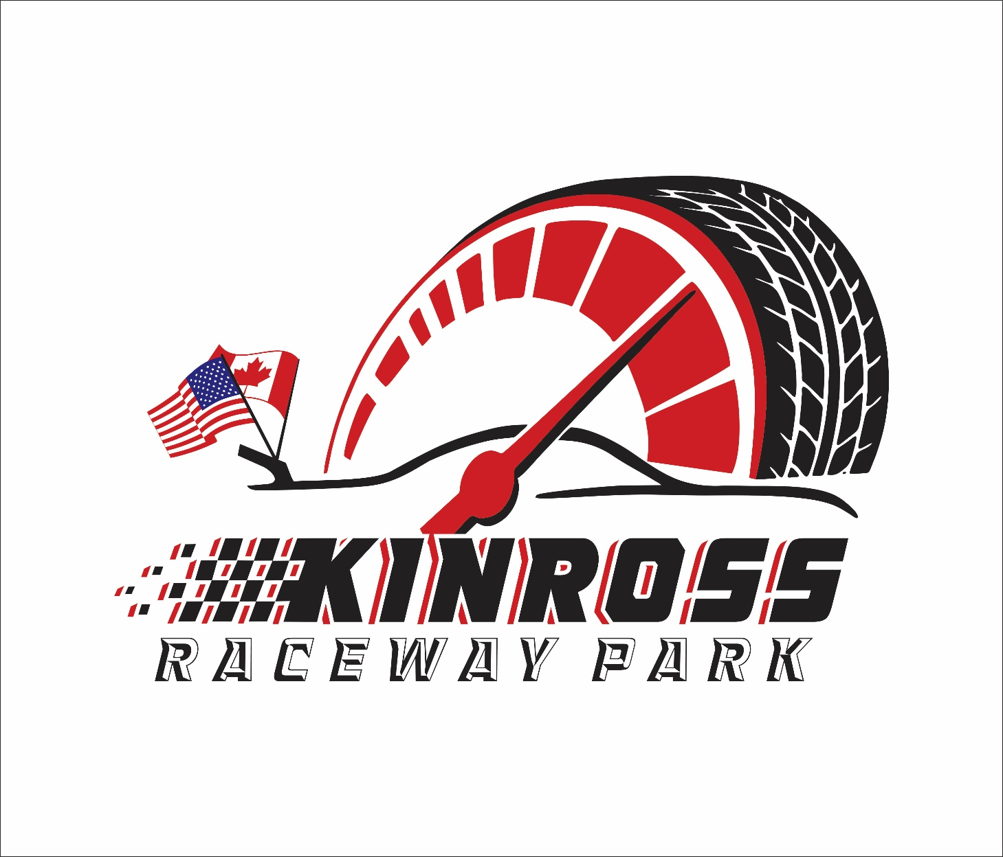

2026 MODIFIED DIVISION

RULES QUESTIONS? Please e-mail the track by sending your e-mail to kinrossracewaypark@gmail.com

Please also read and understand the General Rules, (published separately) they apply to all classes / competitors. Kinross Raceway Park/Kinross Raceway ParkRacing officials decision is FINAL!.

NOTE: RACECEIVERS AND TRANSPONDERS ARE MANDATORY!
All drivers will be required to operate a Raceceiver during all hot lap sessions, qualifying and race events. The devices will be used for on-track safety notice, disciplinary action and line-up procedures.
Raceceiver is to be tuned to 454. 0000.Any driver who does not have a Raceceiver on, or operational, will be instructed to leave the track. NO EXCEPTIONS! Westhold transponders are used for scoring purposes at Kinross Raceway Park. Drivers can purchase these units independently or can contact the track for pricing. Compatible units are orange or yellow (green does not work) Radios and mirrors ARE NOT permitted for regular events.

BRAKES
MUST be cast steel OEM type ONLY, operative on all 4 wheels, drum or disc. Must maintain minimum OEM dimensions for hub/rotor and calipers, cannot be drilled or lightened. Bolt pattern may be changed. Larger studs allowed. Front brake rotors MUST be stock type. Rear rotors may be aftermarket, minimum .810 inch thick, vented rotors only. No scalloped or drilled rotors.

BODY
- Roof height to be 46” Max. – 42” Min.
- Outside of tires must be the widest part of car. Maximum overall width, front and rear, shall not exceed 78 inches from outside of tire, to outside of tire

DRIVE SHAFT
Minimum 2.5 inch diameter, steel drive shaft, painted white. Steel slip-yokes only. 360 degree drive shaft loop required and must be constructed of at least .25 inch by 2 inch steel or equivalent, mounted 6 inches back from front u-joint.

ENGINE
Any American make engine allowed. Steel block. No machine work to the outside of block (lightening). Wet sump oiling system only.
**SINGLE STAGE EXTERNAL PUMP ALLOWED AS LONG AS OIL REMAINS IN PAN (NO EXTERNAL TANKS).
One (1) naturally aspirated two- or four-barrel carburetor only. (No fuel injection) No magnetos. Oil pump must be in front of engine.

FRAMES
1964 or newer OEM perimeter American made rear wheel drive passenger car frame only. Reproduction 68-72 Chevelle frames are approved - AFCO 1968-1972 Chevelle Replacement Frame (Part #40000) and components (Part#’s 40013, 40014, 40015, 40016, 40017 and 40018) are permitted. Howe OEM replacement fabricated Impala Type Front Frame (Part #35809) and Chevelle Type Front Frame (Part #35810) will be allowed but must add 60 lbs total, 30 lbs. to each frame rail at built in ballast mounts (Tech officials discretion). Howe frames must have CNC cut part number tag along with trademarked
Howe ‘H’ logo on each frame rail. Must be original and from factory, no altering.
No sports car frames. 2002 & up Ford Crown Vic or similar frames are allowed. Strut front suspension of any kind allowed must add 50 lbs. No tube clips allowed. Frame must be full and complete, cannot be widened or narrowed, and must be able to support roll cage on both sides. Minimum wheelbase 108 inches, maximum 112 inches, both sides.
Maximum overall width, front and rear, shall not exceed 78 inches from outside of tire, to outside of tire. Exceptions: Weight jack in original center line of spring tower; frame may be cut a maximum 36 inches forward from center of rear housing: horns may be removed in front of steering box; front cross member may be notched and boxed for radiator and/or steering clearance; maximum 7 inch wide opening in side of spring tower for spring removal. OEM upper A mounts may be replaced with aftermarket mounts. Maximum 4 inch wide by 4-inch-tall frame stiffener may be welded
directly to outside of left OEM frame rail. Left side OEM frame rail may be notched for seat and foot clearance. Rightside frame must have top and bottom of frame no holes in rails.

ROLL CAGE
Maximum 4 inch wide by 4 inch tall frame stiffener may be welded directly to outside of left OEM frame rail. Left side OEM frame rail may be notched for seat and foot clearance Must consist of continuous hoops, minimum 1.75 inch O.D.
tubing, with a minimum wall thickness of .095 inch for the main cage. Frame mounted in at least 6 places, low carbon or mild steel recommended. Must consist of a configuration of front, rear, and top hoops connected by tubing on the sides or side hoops. Driver’s head must not protrude outside cage with helmet on. Roll cage must be securely supported and braced with minimum 1 cross bar in top halo. Foot protection bar(s) required. Main cage no further forward than rear of engine. All bars forward of the cage must be lower than the hood. “X” OR “Z” BAR BEHINDDRIVERS HEAD .
DOOR BARS; All driver side door bars and uprights must be a minimum 1.75 inch and .095 inch wall thickness. Minimum 4 driver side door bars, parallel to the ground and perpendicular to the driver, and welded to the front and rear roll cage. Passenger side must have at least 1 cross door bar, horizontal or angled, and 1 top door bar, minimum 1.5-inch O.D. Steel door plate, 16 gauge (.065) minimum thickness, must be securely welded to outside of the driver side door bars and cover the area from top door bar to bottom door bar and from rear hoop down post to front cage down post.

REAR END
All steel. Closed, steel tube Quick changes allowed. Safety hubs (floater) mandatory. Steel axles only. No cambered rear ends. One (1) piece drive flange only. All components must be steel. Exceptions: lowering blocks, axle caps, rotor plates, and drive flanges. NO COVER ON REAR END OF BODY. . ALL CAR RUNNING A BIRD CAGE TYPE REAR END MUST HAVE A 1/16 STEEL PLATE or 1/8 alum plate behind the seat From the top bar to bottom to and from the left side to right 3 inches pass seat . THIS WILL BE IN place or you don’t race.

REAR SUSPENSION

No independent rear suspension. All components must be steel. No covers allowed. All trailing arms/link bars must be made of steel tubing (aluminum hex tube will be acceptable) Rear of frame may be altered to accept leaf or coil springs. Steel coil-over eliminators, and steel or aluminum (5”) coil-over kits, allowed on the rear only. Must conform to shock and spring rules. No rear sway bars.

SPOILER
A 4 inch by 66-inch spoiler 45 deg to the deck is allowed, with all braces to the rear of the spoiler. Spoiler must be 1 piece.

SHOCKS
NO EXTERNAL CANISTERS (SHRADER VALVES PERMITTED) 1 SHOCK PER WHEEL, 1 ADDITIONAL SHOCK ALLOWED IN THE LIFT/PULL BAR AREA. ALL SHOCKS MUST BE EASILY REMOVED (NO COVERS ALLOWED)
You can run single adjustable shocks no double adjustable, no blow off shafts.

SPRINGS
Steel coil and leaf springs allowed. Coil springs must be at least 4.5 inches O.D. No torsion bars or air bags. Exception: Pull bar may utilize smaller O.D. springs.it

WEIGHT RULE
All modifieds must weigh 2450lbs with 1,000lbs right side weight.

TIRES
- Hoosier D810.
- Tires you qualify on must be ran in the feature event. Tires will marked prior to qualifying and monitored by track officials. In the event of a flat or replacement tire needed, must be approved by official.
- All Tires must have tethers.

Additional Safety Item: All cars will be equipped with automatic fuel Valve shutoff must be installed.

