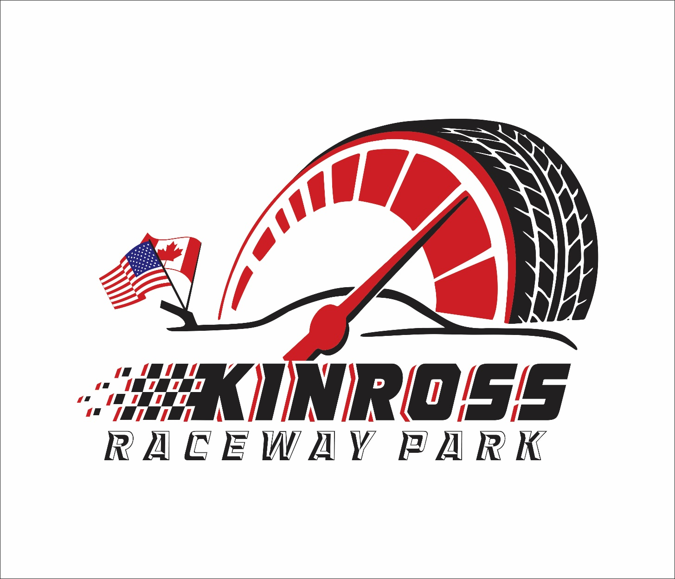

2026 Four Cylinder Division
RULES QUESTIONS? Please e-mail the track by sending your e-mail to kinrossracewaypark@gmail.com
Please also read and understand the General Rules, (published separately) they apply to all classes / competitors.
Kinross Raceway Park/Kinross Raceway Park Racing officials’ decision is FINAL. THE MOST IMPORANT RULE IS THIS:
Any car that is deemed too radical and too much outside of the rules of this class (by components or speed) that can be found competing at various other area tracks will not be allowed. The rules for this class will be controlled by Kinross Raceway Park officials if necessary. Interpretation of these rules is for the track officials, and they have the FINAL decision.

NOTE: RACECEIVERS AND TRANSPONDERS ARE MANDATORY!
All drivers will be required to operate a raceceiver during all hotlap sessions, qualifying and race events. These devices will be used for on-track safety notice, disciplinary action and line-up procedures.
Raceceiver is to be tuned to 454.0000. Any driver who does not have a Raceceiver on, or operational, will be instructed to leave the track. NO EXCEPTIONS!
Westhold transponders are used for scoring purposes at Kinross Raceway Park. Drivers can purchase these units independently or can contact the track for pricing. Compatible units are orange or yellow (green does not work) Radios and mirrors ARE NOT permitted for regular events.

CAR ELIGIBILITY
- 1966 and newer, American or Foreign, front wheel and rear wheel, three- or four-cylinder, non-turbo charged, single or daul overhead cam, passenger cars, station wagons, and compact trucks. Four-wheel drive trucks are allowed if one drive shaft is disconnected (either front or rear). MINI-VANS ARE LEGAL. No 2- seats (e.g., Fiero’s, Honda CRX), no convertibles allowed.
- Maximum wheelbase is 104 inches, with the exception of station wagons and pickups.

BATTERY
- The battery may remain in the original factory location provided it is in a safe location and securely mounted. If the batter is relocated, it may only be relocated to the trunk, or trunk area. Batteries mounted in the trunk area must be secured by two 1” metal straps. No batteries mounted in driver’s compartment.
- Master shut off switch to main battery cable must be placed near driver, preferably on the A pillar, for easy access by driver and safety crew is mandatory.

BODY/CHASSIS
- Body and frame must match the same make and model.
- Front and rear firewalls must be original and in stock locations.
- All holes and openings in the firewalls must be covered in metal
- No pedal extensions that places the driver behind the b-pillar. (tech’s discretion)
- All body panels will remain stock from front to rear with exception of front nose cover Body panels may be made of aluminum.
- All glass, interior and exterior, must be removed.
- Cars must have full windshields in good condition. Approved lexan only if there is a full cage. Three minimum 1/8-inch steel bars required with 4-inch spacing with lexan.
- Doors must be chained or welded shut; WELDING IS HIGHLY RECOMMENDED!!
- Any car with a hatchback can weld or bold the hatchback solid.
- Hood and trunk must be secured with hood pins for easy accessibility; OEM latches must be removed or disabled.
- Fenders may be trimmed (if not excessive) to remove rust out. Excessive cutting and removing of body metal will see the car in question subject to weight penalties as tech/track officials see fit.
- Bumpers may be welded into place. Bumper ends may be capped and have supplemental attachments to the fenders which prevents the hooking of bumpers.
- Non-functional hood scoops are allowed.
- FRONT AND REAR TOW HOOKS OR CHAINS ARE MANDATORY!
- Rub rails allowed. Maximum 1” by 2” rectangle tubing.
- Stock bumper covers or nose cones must be over fabricated bumpers.

BRAKES
  - Must have 4-wheel hydraulic brakes in working order.

COOLING SYSTEMS
- Any stock radiator allowed which will fit in the stock brackets.
- 180-degree fan shroud required.
- An overflow container mounted in engine compartment is required.
- No anti-freeze; water only in radiator.

ENGINE
- Intake, throttle body and carburetor must be factory stock.
- All cars must pull 18” of vacuum at 1000 RPM hot or cold. All cars must have easily accessible vacuum hose located near A-pillar outside of hood. Cars that have a vacuum pump must have access to pull vacuum from the manifold.
- Water pump must remain stock and intact.

FUEL TANKS
- Cars without the fuel pump mounted in the tank must use a cell or marine type tank mounted in the trunk floor with a minimum of two (2), 1 inch by 1/16 inch straps in each direction, bolted through the floor using double plates or installed in a safely constructed manner between the frame rails.
- Trunk mounted tanks must be sealed off from the driver’s compartment by a metal plate.
- No bottom draw tanks.
- Maximum 8 gallons.
- Cell required on wagons.
- Cars equipped with electric fuel pumps must install a toggle type switch, clearly marked in a bright
contrasting color, at the base of the drivers “A” pillar.
- If fuel tank is in front of rear axle you can leave it stock.

MUFFLER
- Removal of catalytic converter allowed.
- Maximum 100 Db at 100 feet.
- Headers are allowed.

ROLL BARS/CAGE
- Minimum 4 point cage is mandatory (full cage recommended), constructed of at least 1.5 inch OD,
.095 inch side wall roll car steel tubing (seam split resistant, cold rolled or seamless; see anyone experienced in building roll cages). No exhaust pipe tubing or water pipe! Cage must be welded or bolted to the floor pan. It is highly recommended that roll cage be welded with 1/8 inch steel plate and bolted to the floor pan using double plate under floor pan. MAKE ROLL CAGE A PART OF YOUR CAR!
- Driver’s door protection will consist of at least three roll bar type bars welded to roll cage and covered with a minimum 18-inch by 24-inch by 1/8-inch thick steel plate or 18-inch by 24-inch by 1/3-inch aluminum plate.
- Footplates are to be 10-inch by 30-inch by 1/3-inch aluminum are required.
- All cages/driver protection devices will be allowed the tech. Officials discretion.
- No offset cages.
- ROLL CAGES ARE SUBJECT TO TECH/TRACK OFFICIALS APPROVAL AND THEIR DECISIONS IS FINAL. CAGES WILL BE TECHED.

SEAT BELTS / SEATS
- Minimum three inch wide, five-point safety belt assembly required, must be mounted securely to the role cage. BELTS ARE TO BE NO MORE THAN FIVE YEARS OLD. TRACK OFFICIALS decision is final)
- Race seats secured with 3/8-inch bolts are mandatory.
- All seats and belts are subject to tech. Officials approval; tech decisions are final!

STEERING AND SUSPENSION
- Must be factory stock or stock replacement, in stock location, with no alternations and must match make and model.
- No adjustable struts/shocks.
- Power steering is optional.
- Maximum 1” rear steer allowed. Measured from front hub center to rear hub center, per side.

TRANSMISSION
- Stock automatic & stick shifts only.
- Stock converter with no alterations for automatics. OEM style clutch for manuals.
- Must have working forward and reverse gears.

WEIGHT
- Minimum 2400 lbs with driver in car, in race trim before the feature.
- Added weight must be securely fastened with minimum 1/2inch bolts, painted white and include the
car’s number on them.
- Weight will be added as deemed necessary by tech officials to maintain parity in the class. Tech officials will determine where and how much weight will be added in these cases
NOTE** Bring extra weight with you to the track. Weight may be added for rules infractions or to maintain parity in the class. Weight will be added to the car based on its last scaled weight NOT minimum weight of the division.

WHEELS/TIRES
- Stock OEM tires.
- 50, 60, 65 or 70 series radial tires allowed.
- Hankook/Falcon tires are allowed.
- All 4 tires must have same size wheel.
- 1” lug nuts recommended.
- No aluminum wheels allowed.
- Off-set racing rims are permitted. (Steel only). Any excessive track widths, as determined by track officials, will not be allowed.

OTHER
  - Feature winners will be placed at the back of the field upon their next appearance at the Speedpark. These drivers’ position will be behind ALL cars, including Fast Qualifier, at the discretion of track officials.
  - Each vehicle must be equipped with a charged 2-pound minimum BC rated steel fire extinguisher with FIRE EXTINGUISHERS gauge; mounted in an approved quick release bracket within reach of driver. NO duct tape or zip ties will be allowed.

