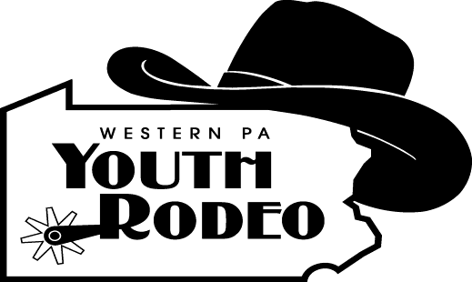

Western Pennsylvania Youth Rodeo Association

Yes! I would like to assist in promoting Youth Rodeo 20222 – 2023 Rodeo Season.
Return with your tax-deductible donation by September 2022
***Please attach a business card with information for us to promote your business.

I/We wish to support
(Cowboy or cowgirl’s name)
Trophy Saddle Sponsor $1,000.00

_______ Buckle Sponsor $150.00

Western Pennsylvania Youth Rodeo Association

Yes! I would like to assist in promoting Youth Rodeo 2022 – 2023 Rodeo Season.
Return with your tax-deductible donation by September 2022
***Please attach a business card with information for us to promote your business.

I/We wish to support
(Cowboy or cowgirl’s name)

_________ Trophy Saddle Sponsor $ 1,000.00

_________ Buckle Sponsor $150.00

Event Award Sponsor $250.00 Event Award Sponsor $250.00

½ Trophy Saddle Sponsor $500.00 _ ½ Trophy Saddle Sponsor $500.00

Company Banner $200.00 (or Renewal $100.00) Company Banner $200.00 Banner (Renewal $100.00)

Cowboy/Cowgirl Sponsor $200.00 Cowboy/Cowgirl Sponsor $200.00

Scholarship Sponsor Scholarship Sponsor

Other Amount
NAME: ADDRESS: CITY, STATE & ZIP PHONE NO.
Please make your generous tax-deductible contribution payable to:

W P Y R A · c/o P.O. Box 1034 Connellsville, Pa 15424
Email your logo/artwork to charlie@decal-kreations.com
Only if you are purchasing a banner

Other Amount
NAME: ADDRESS: CITY, STATE & ZIP PHONE NO.
Please make your generous tax-deductible contribution payable to:

W P Y R A · c/o P.O. Box 1034 Connellsville, Pa 15425

Email your logo/artwork to charlie@decal-kreations.com
Only if you are purchasing a banner

