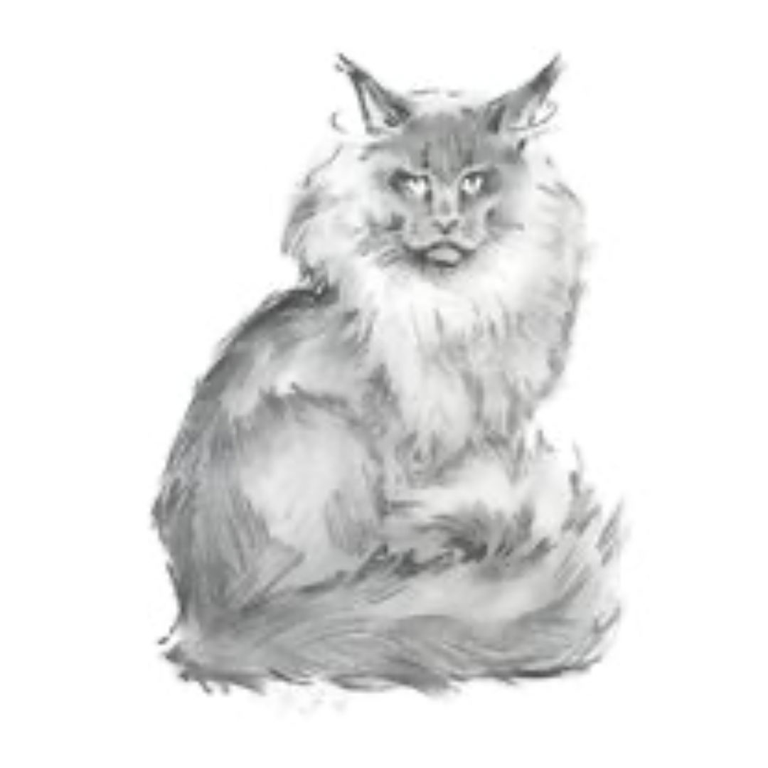

CastleCoons Maine Coons

Specializing in European bloodline Maine Coons

Adoption Application/Cat Questionnaire/Waitlist

CastleCoons Maine Coons

TICA registered cattery (The International Cat Association)

Lily Sevchuk (Owner of CastleCoons, Maine Coon Cat Breeder & Exhibitor)

Facebook:<https://www.facebook.com/CastleCoons/>

**\*Preferred method of contact: by email (✿˶’◡˘)☺️**

E-mail: [CastleCoonsMC@gmail.com](mailto:CastleCoonsMC@gmail.com)

Mobile: (916) 531-7724

Website: [CastleCoons.com](http://castlecoons.com)

First & Last name:_____________________Phone:___________________Date:___________________

Address:________________________City:__________________________State:___________________

Zip:_____________Email:_______________________________________DOB:____________________

Home: (circle one) House Condo Townhouse/Apartment

If you are renting, do you have permission from your landlord to have any pets? (circle one)

Yes No

I live

* Alone
* Spouse/Age________
* Parent/Age(s)_______,_______
* Roommate/Age(s)_______,_______,_______
* Children/age(s) _______,_______,________,________,________

Occupations/employment of the members of your household:

________________________________________________________________________________________________________________________________________________________________________

Reason for wanting a kitten?

* Companion
* Breeding
* For children
* Gift

If other, please explain.

____________________________________________________________________________________________________________________________________________________________________________________________________________________________________________________________

Please circle one of the following:

I am applying for a particular kitten I am interested in

I am joining the waitlist for an upcoming litter

If you are applying for a particular kitten, which kitten are you interested in? ________________________

Do you have a preference on the gender of the kitten? (circle one) No preference Male Female

Do you have a color preference? (circle one) No preference Yes No

If you have a color preference, list your first, second, and third color preferences below.

1.)

2.)

3.)

Ideally, when would you like to add one of our Maine Coon kittens into your household? (Please circle one)

No preference Between now & 3 months 3-6 months 6-9 months In the next year

Will your kitten be: (circle one)

Indoors only Outdoors only Indoor/Outdoor

If outdoors, do you have a catio or an enclosed area? ____________________________________________________________________________________

If outdoors, how long after adoption would you start allowing the kitten to go outside? ____________________________________________________________________________________

Do you or any of the people you live with have allergies to cats? (circle one) Yes No

If yes, how do you plan to manage the allergies? ____________________________________________________________________________________________________________________________________________________________________________________________________________________________________________________________

If you plan to move or go on vacation, what will you do with your kitten? ________________________________________________________________________________________________________________________________________________________________________

Have you ever returned a cat or dog before? (circle one) Yes No

Have you ever given an animal away or relinquished an animal to the pound, animal shelter or rescue group? (circle one) Yes No

If yes, please explain.

________________________________________________________________________________________________________________________________________________________________________________________________________________________________________________________________________________________________________________________________________________

Do you or anyone that lives in your home (or visits frequently) smoke? (circle one)

Yes No

Who will be the primary caregiver for the kitten?______________________________________________

My veterinarian is: _____________________________________________________________________

Location:_____________________________________________________________________________

Would you ever consider declawing your kitten/cat? (circle one) Yes No

If yes, please explain:___________________________________________________________________

Is anyone home during the day? (circle one) Yes No

On average, how many hours per day will this kitten/cat be left alone?

________________________________________________________________________________________________________________________________________________________________________

What circumstances justify giving your pet up?

* Moving
* Change in lifestyle such as roommate or baby
* Not getting along with other pets
* Allergies
* Clawing at furniture
* None of the above
* Other:

____________________________________________________________________________________________________________________________________________________________________________________________________________________________________________________________

Do you have any other pets? If yes, please list their breed(s) and age(s)

____________________________________________________________________________________________________________________________________________________________________________________________________________________________________________________________

If applicable, do you know if your pet(s) will get along with a cat? ________________________________________________________________________________________________________________________________________________________________________

If you have pets, do you take them for annual vaccinations and check-ups? (circle one)

Yes No

What will you do if you are no longer able to care for or keep the kitten/cat for whatever the reason may be, for example: financially unable, job loss, moving, other? Please explain.

____________________________________________________________________________________________________________________________________________________________________________________________________________________________________________________________

All of our kittens and cats come with a contract. Do you agree to sign a contract? (circle one) Yes No

Where did you hear about us? (Please be specific)

________________________________________________________________________________________________________________________________________________________________________

Please tell us anything you would like us to know about you, to help us decide if you are an approved home for one of our fur babies. ________________________________________________________________________________________________________________________________________________________________________________________________________________________________________________________________________________________________________________________________________________

Once your application is approved, we can only reserve your Maine Coon kitten or cat upon receiving a non-refundable deposit of $500, which will be applied toward the final purchase price. Kittens and cats with a deposit are marked as "Reserved" in any of our postings or advertisements. Once a kitten or cat is paid in full, it will be listed as "Sold."

By placing a deposit, you acknowledge and agree to our Non-Refundable Deposit Policy.

**CastleCoons Maine Coons accepts the following forms of Payment as deposit:** Venmo, Apple pay, & Cash app. **No personal checks accepted, no exceptions.** **The remainder balance shall be paid in cash on the date of pickup.**

We do not allow home visits as our cattery is a closed cattery to the public. However, we’re happy to share plenty of photos and videos of your kitten or cat in advance, and we can also arrange a FaceTime or Zoom call to connect with you virtually. We love meeting the future owners of our kittens and often arrange for them to pick up their new kitten or cat in a neutral location, allowing us to meet in person. ☺️

If you are not local and cannot pick up your kitten or cat, please be prepared to organize and cover the cost of transportation through a hand-carry transport service (such as a flight nanny) if the kitten or cat needs to fly. Please note, we **do not** ship cargo.

CastleCoons reserves the right to refuse or cancel a sale (sales contract) at any time and for any reason before the buyer takes possession of the kitten or cat. If CastleCoons cancels the contract prior to the buyer receiving the kitten or cat, all monies paid towards the purchase will be refunded in full.

**Please read and sign**

* I have completed this application truthfully and fully understand the adoption process