PART 3: WHEN JESUS PRAYED ELDER MARY ELLIS - FACILITATOR 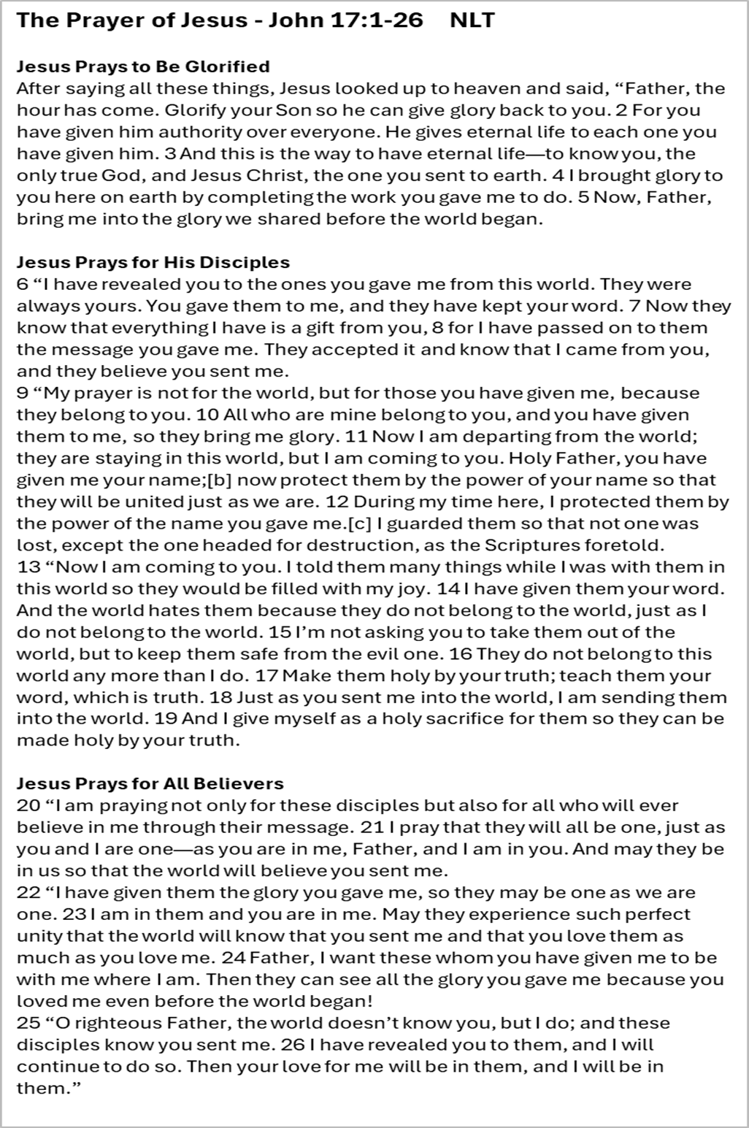
I: When Jesus Prayed
His intercessory prayer for believers in John 17, his agonizing prayers in the Garden of Gethsemane, his prayer for his disciples in the same garden, his prayers on the cross for forgiveness and surrender, show His heartfelt devotion to seeking GOD on behalf of believers. He has compassion for all, and it shows in His prayers. He still prays and intercedes for believers everywhere from His heavenly position.
Romans 8:34 ________________________________________________________________
Hebrews 7:25 ________________________________________________________________
1 John 2:1 ________________________________________________________________
His Intercession gives us:
__________________________________________________________________________
__________________________________________________________________________
__________________________________________________________________________
__________________________________________________________________________
Jesus's "High Priestly Prayer," recorded in John's Gospel, is a powerful intercessory prayer for himself, his disciples, and all future believers. He prays for their unity, protection, and sanctification, that they may be one with him and the Father.
*************
II: When Jesus Prayed
- In the prayer of Jesus recorded in John’s gospel – list the four items that He prays for:
______________________________________________________________________
______________________________________________________________________
- In the first section of the prayer, Jesus prays to be ____________________________
- Jesus begins His prayer by doing what? ____________________________________
- What term does He use that He also instructed to use in the model prayer?
_____________________________________________________________________

- In verse 2 it states that Jesus has _____________________________ over everyone
- What does He give to all that has been given to Him? ___________________________
- How does Jesus say we can receive this gift?__________________________________
- In verse 4 Jesus indicates that He has? ______________________________________
- What important element of Jesus’ life do we see in verse 5? _____________________
___________________________________________________________________
- In the next section, verse 9 tells us that Jesus is praying for His __________________
- What does verse 6 say Jesus did for this group? _______________________________
- In His prayer, He says that the group has ________________, and ________________
______________________, and _________________, and_________________________
- Jesus says that at this time He is not praying for the world, but for this group because they __________________________________________________________________
- Jesus indicates in the next verses that He is ________________________________

- He asks that the group be protected by __________________________________
- This was a reflection of GOD’s ___________________________________________
- Jesus says that He wants them to be filled with ____________________________
- He then begins to pray for all believers who will believe because of their _________
- He prays that we all can be ___________.
- How does Jesus end the prayer – read verse 26: __________________________
_____________________________________________________________________
Reread verses 20-23 of the prayer where Jesus prays for all believers, list three items that you feel the prayer helps you as a believer now.
___________________________________________________________________________
___________________________________________________________________________
____________________________________________________________________________

III: After His Prayer:
John 18:1
“After saying these things, Jesus crossed the Kidron Valley with his disciples and entered a grove of olive trees. 2 Judas, the betrayer, knew this place, because Jesus had often gone there with his disciples. 3 The leading priests and Pharisees had given Judas a contingent of Roman soldiers and Temple guards to accompany him. Now with blazing torches, lanterns, and weapons, they arrived at the olive grove. 4 Jesus fully realized all that was going to happen to him, so he stepped forward to meet them. “Who are you looking for?” he asked.
5 “Jesus the Nazarene,” they replied”.
- This scene is taking place where? _____________________________________________
- In John 17:12 – what reason does Jesus give that Judas is doing this act of betrayal?
________________________________________________________________________
- How does Jesus handle the situation?
_________________________________________________________________________

IV: Poem on Prayer.
Prayer,
It is our power.
It is our strength.
It is our direct connection to the greatest ruler of this earth.
It is our cosmic shift from selfish plans to God’s plans.
It is our ability to be an influencer, a pleader and a worker in a kingdom that counts.
It is our ticket to our greatest needs being met in awe inspiring ways.
It is our hope that confirms to our heart we have a hope.
It is our peace that the Creator is still creating.
It is our power found in uplifted hands and in the quietness of a solitary room.
It is our ability to call the Great Physician to a family member in need.
It is our emergency exit door for what the devil has already cooked up to destroy us.
It is our greatest weapon in a world that is building bigger and bigger weapons.
It is our lifeline when we feel we have lost all life. By Kelly Balarie – Blog post “A Cheerleader of Faith”

Conclusion:
Jesus concludes his prayer by affirming his mission to continue making the Father's name—his entire identity—known to all believers. The ultimate goal is for the love that exists between the Father and the Son to be in his followers, and for Christ himself to be in them.

