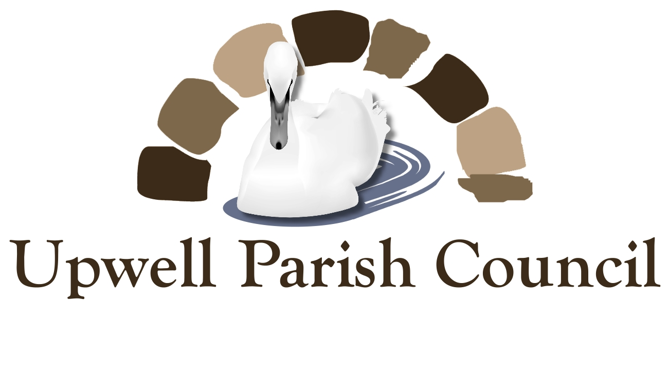
Could You Be A Parish Councillor?

If you live or work in Upwell, Lakes End or Three Holes you could be a parish councillor. We need people who can represent the residents of our villages and make decisions on where local money should be spent.
We are looking for people who have a few hours each month to offer, helping to make decisions about the future of our villages and improve the lives of everyone living here. If you want to see a change for the better and are willing to speak up for local people on important matters then we need your help!

Am I Qualified?

Yes - most people are. However there are a few rules.

You have to be:
- a British subject, or a citizen of the Commonwealth or the European Union
- 18 years old or over
- registered to vote in the parish or work or own land or property in the parish

Contact the Clerk: Kate Cobley on 01945 772260 for more information

