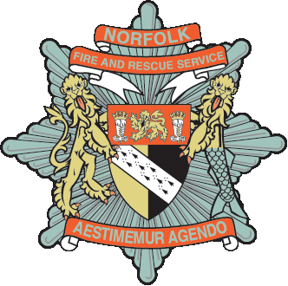
Norfolk Fire and Rescue Service
Free Helpline: 0800 9178137

Norfolk Fire & Rescue Service is committed to keeping you safe from fire. We recognise that only a small minority of people will experience a fire in their home during their lifetime. Unfortunately when fire does occur it can have a devastating effect on all those involved.

We also recognise that in Norfolk people who are more likely to suffer from the effects of fire are over the age of 65. It is for this reason that we would strongly recommend you to take us up on the offer of a Free Home Fire Safety Check and Smoke Detector fit.
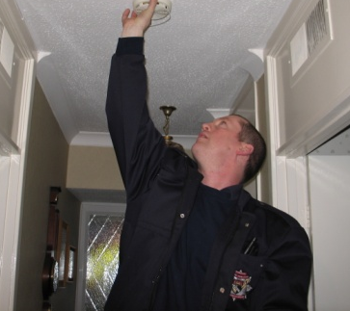
Please allow one of our trained volunteers to talk to you about fire safety in the home and where required our technicians will fit as many smoke detectors as they deem necessary all free of any charge. We also provide specialist Smoke Detectors for the hard of hearing which again will cost you nothing.

For once you will actually get something for nothing and all you have to do is contact the free phone helpline using the number at the top of this article or one of the alternative options at the bottom to make an appointment that is convenient for you.

The visit will only take between 30-60 minutes of your time and remember this service is free and may prevent you from ever having to experience the devastating effects that a house fire can cause. Please also note that all Fire and Rescue Service personnel and our Partners will carry ID with them at all times.

Let us take this opportunity to re-assure you that this is a genuine offer directly from Norfolk Fire and Rescue Service and Norfolk County Council, it is not a scam and nobody will try to sell you anything. Please also be re-assured that whilst this is a golden opportunity to take us up on our offer, if you are unable to do so at present the offer will not expire.

