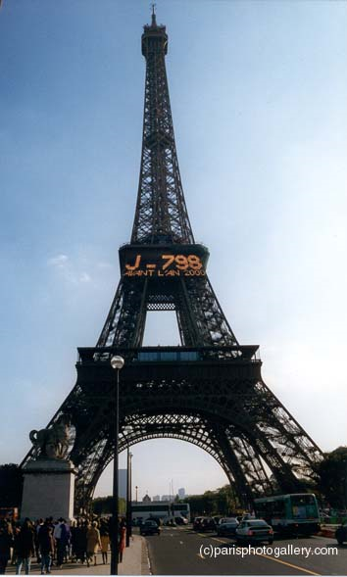
For visiting French students


For more information call Samantha on 01945 774550 or 07765 483167
Wisbech and Downham Market Areas
Students fully occupied during week days
Excellent remuneration
Various Dates in April and August

