THE LOCAL ELECTIONS
(PARISHES & COMMUNITIES)
RULES 2006
CASUAL VACANCY IN THE OFFICE OF

COUNCILLOR
PARISH OF UPWELL

NOTICE IS HEREBY GIVEN that ONE casual vacancy has arisen in the office of Councillor for the above Parish. If, within 14 days of the date of this Notice (see note below) a request, in writing, that an election be held to fill the vacancy, signed by ten local government electors for the Parish is given to:

The Returning Officer
Borough Council of King's Lynn and West Norfolk
King's Court
Chapel Street
King's Lynn
Norfolk PE30 1 EX

an election will be held, and Notice of this will be published in the Parish.

If no such request is received by the Returning Officer, the Parish Council will take the necessary steps to fill the vacancy by co-option.
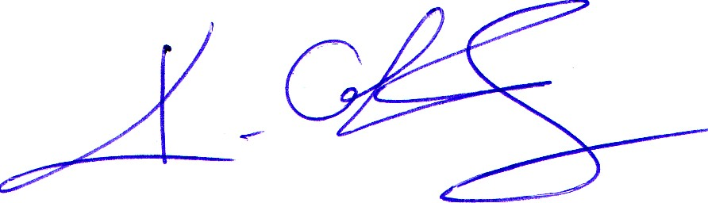
Signed:

Clerk to the Parish Council Dated: 10.03.10

NOTE: In computing this period, the following days are to be disregarded:(a) Saturdays and Sundays (b) Christmas Eve, Christmas Day, Good Friday or a Bank Holiday (c) A day appointed for public thanksgiving or mourning

