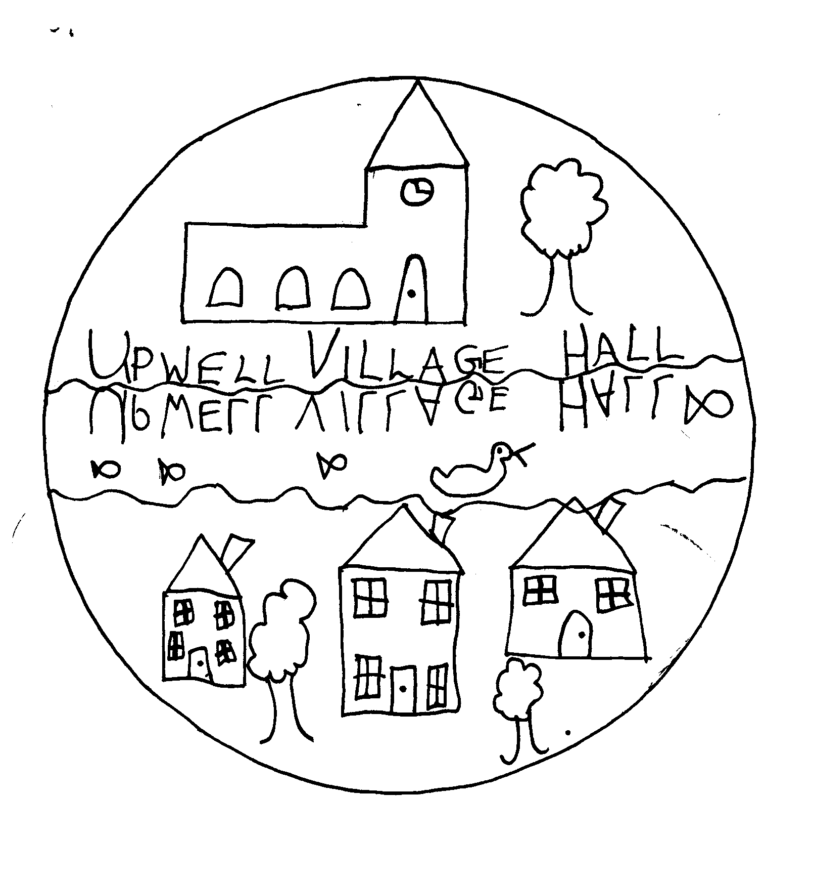

UPWELL HALL – THE FESTIVE SEASON

I am constantly amazed and delighted by the quirkiness and eccentricity of we British. As always at fairs and markets, I headed straight for the home made pickles, jams and chutneys stall where I entered into a deep and meaningful discussion with the stallholder who, displaying hundreds of jars of her wonderful products told me, “I can’t stand the stuff!”

This was, of course, the annual craft fair and if you were not there you are one of the very few who missed a resoundingly successful event. The biggest and best fair yet, organiser and hall committee member Amanda Williams managed to cram in more than thirty stalls presenting a wide range of crafts but, unsurprisingly, with a predominantly Christmas theme. We met friends at the fair buying everything from Christmas table decorations to hand knitted baby wear; festive jewelry to Christmas crackers and cards; spent a few quid ourselves and scoffed the odd slice of gooey cake too. Great effort by prime movers Amanda and husband Paul, not forgetting all of the committee members who helped.

Moving on towards Christmas, the committee will burn the midnight oil at the month’s end to decorate the hall in time for all the parties and seasonal events of which the next is the annual concert of festive music presented by Cantus on the 12th of December. A cash bar and mince pies during the interval will heighten the convivial atmosphere in which we shall listen to and join in with some of our favourite nostalgic Christmas songs and carols. No advance booking is necessary – just turn-up at the door.

Meanwhile, several times a week, members of the cast are meeting in the hall and elsewhere to rehearse for the village pantomime, Aladdin, which is being staged at the end of January. We all know the plot, “Oh yes we do,” but with the usual injection of topicality, local interest and lampooning of ourselves and people we know it will, I am sure, be as refreshing and enjoyable as pantomimes always are. Watch out for posters and buy your tickets as soon as you can because seating is limited for health and safety reasons.

A very merry Christmas and happy and prosperous New Year to you all
from
the Hall Committee


