Tired of losing? Reverse the Trend by Unleashing the Power of Daily Management and Start Winning Again

Published on March 15, 2017
Tell me if this sounds familiar to you...your entire day is consumed by numerous meetings, far from the where the real work happens, covering multiple, disconnected topics, often times completely misaligned from what the goals and objectives of the business happen to be. The agenda and deliverables for these meetings are routinely missing, unorganized, or better yet, useless. Discussions are circular, irrelevant, unproductive, and downright adversarial. People routinely display their passive aggressive side by checking their phones, laptops, having side conversations, or are otherwise uninterested in anything you have to say. Getting people to participate and contribute in a meaningful way is like pulling teeth. You talk about numerous actions, and in "principle" people agree on what you should do next, but inevitably nothing gets done. Does that about sum it up? What if I told you that there is a solution to this madness? You CAN have effective meetings with clear agendas, deliverables, and results. You CAN work on the right stuff that matters to the business. You CAN create a culture of engaged problem solvers who collaborate to get things done. The answer is simple, and it's the most powerful tool in the lean toolbox...Daily Management.
Daily Management is a visual, metrics-driven, collaborative problem solving process that prioritizes the most important process metrics in your company, and helps you to achieve breakthrough results consistently, year-after-year. Quite frankly, as simple as it sounds, this is the "secret sauce" as to why the best lean organizations are significantly outperforming their competition. They create a deliberate, self-driven problem solving culture at all levels and functions of the company, and stay the course over time.
For a transformation like this to occur, values must be changed, adopted, and aligned to the new ways of working in support of a continuous improvement culture. It must be clear how each and every employee contributes towards building this culture, and no function or department should be left off limits. Leadership must at every opportunity reinforce the importance of this culture, and put incentives and structure in place to align the actions and focus of their employees towards supporting the transformation. A key component of this successful cultural transformation resides in the Leadership System, and it is known as the Daily Management Process.
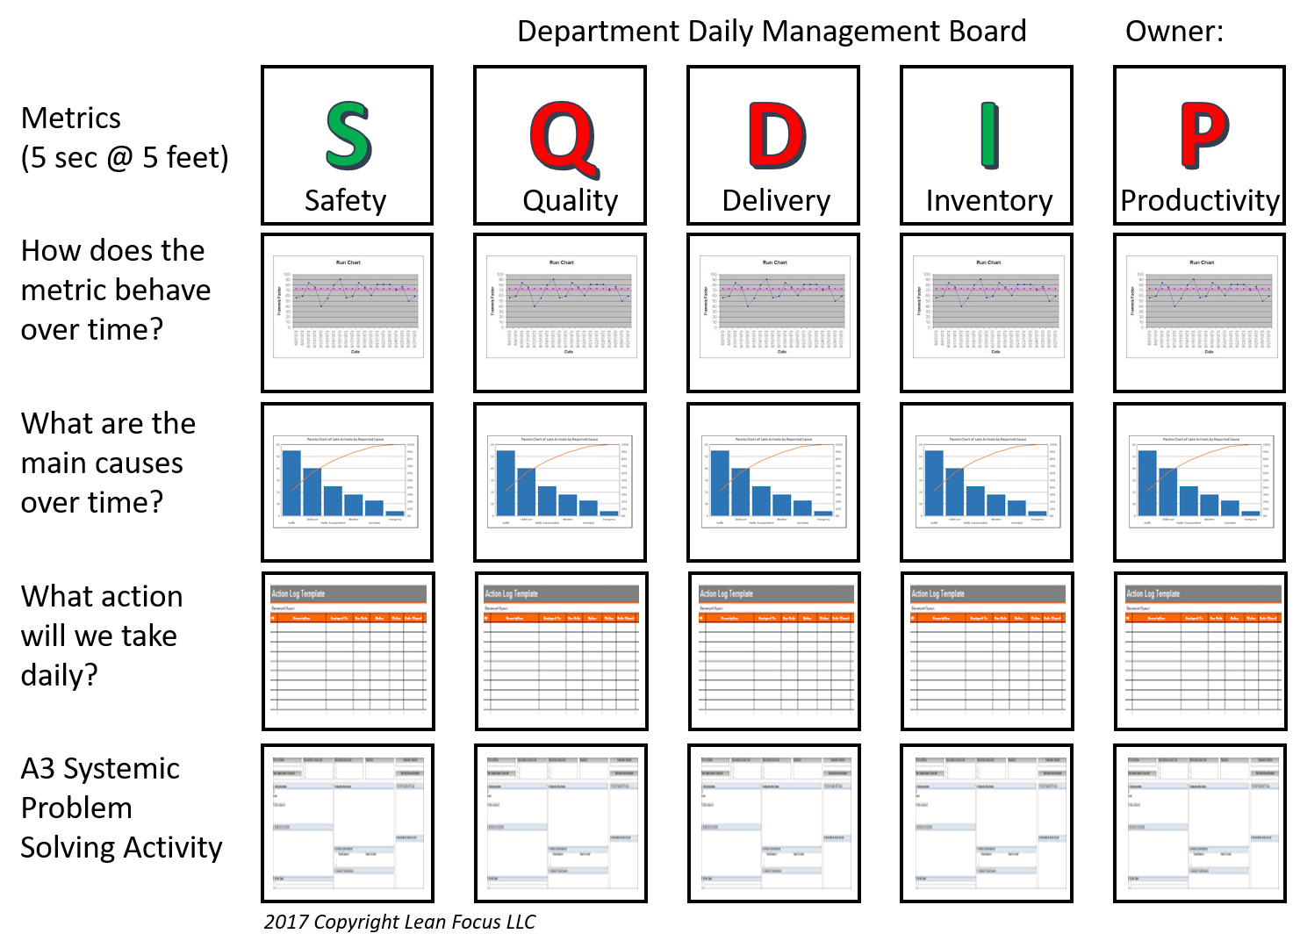
Metrics (KPIs - Key Performance Indicators)
Selecting the right metrics is the key to driving the right behaviors on a daily basis. A good principle to keep in mind when selecting metrics is to understand what your customer's pain points or needs are. By improving these metrics, will your customer (internal or external) derive any tangible benefits? Additionally, when selecting metrics, consider that LESS is MORE and MORE is just MORE. If you are unable to improve one metric, what makes you think measuring five more will make a difference? Below are 10 characteristics of effective metrics:
- Alignment - Metrics are aligned with your business strategy and objectives. A good litmus test, is to have the senior leadership review your metrics and weigh in on their degree of alignment, better yet, work together to create them.
- Ownership and Incentives - Every metric in Daily Management is owned by a named individual, (first and last), who is accountable for its outcome. Additionally, these metrics should be reflected in their annual goals and objectives once they are well understood and stable, a common oversight.
- Predictive - Metrics should be selected that are leading indicators of process performance. Measuring too late in the process minimizes the reaction time afforded in the event of problem solving.
- Actionable - Metrics are populated and updated daily with actionable data so that the team can take action before it is too late.
- Less is More - Metrics should be measured for the critical few, key processes and not dilute the effort of the team.
- Easy to Explain - Metrics should be easy to retrieve, calculate and explain to others. Indices, averages, or other complex metrics distort the importance of what is being measured.
- Balanced and Supportive - In the above example, SQDIP is displayed in this order to indicate the order of importance of the metrics. For example, often times a Quality issue will impact Delivery, and subsequently Inventory and Productivity. Therefore working on the Quality issue first will eliminate the need to focus on the other metrics. Additionally, these metrics should not undermine each other or sub-optimize other processes/departments.
- Instigate Behavior - The old saying, "what gets measured, gets done." You should notice actions being taken and ways of working changing in alignment with the daily management metrics.
- Standardization - Wherever possible and relevant, do not rebuild the wheel. Keep it simple. You'll find that most metrics can be used across departments, functions, and other areas of the company.
- Relevant - Assuming you are driving continuous improvement in a sustainable way, metrics lose their relevance over time. You should update your metrics as you mature on your lean journey to continue to stretch yourself. The point is not to be "green" every day. A great teacher once told me, "no problem is a big problem".
Run Charts: How does the problem behave over time?
With run charts you are trying to visualize how your Daily Management metrics behave over time. Is it getting better or worse? Has some special cause variation been introduced into the process? Knowing when something happened gives you unique insight into where to look in your process with respect to problem solving. Effective run charts have the following characteristics:
- Clearly understood "Standard" or "Goal" line...I like to standardize this in the color "RED".
- Clearly understood "Actual" (data) line...I like to standardize this in the color "BLUE".
- Gap (the amount by which you missed the standard or goal) is clearly understood and visualized...Standard - Actual = Gap.
- Scale resolution - select the right scale for the "Y" axis to visualize the metric appropriately. Large scale might make the problem appear smaller, and a smaller scale may appear larger.
- Measure the appropriate frequency for the process output: weekly, daily, by shift, hourly, etc. If your process does not start and complete at a frequency conducive to building run charts, you might have to extend the period of time between measurements.
Without boring you with too much statistics, for run charts you can use 3 simple rules to understand whether or not your data is random, by comparing it to the median:
- There are no "shifts" (six or more points in a row either above or below the median line).
- There are no "trends" (five or more data points going up or down).
- The number of runs in a chart isn't within the expected lower and upper limits
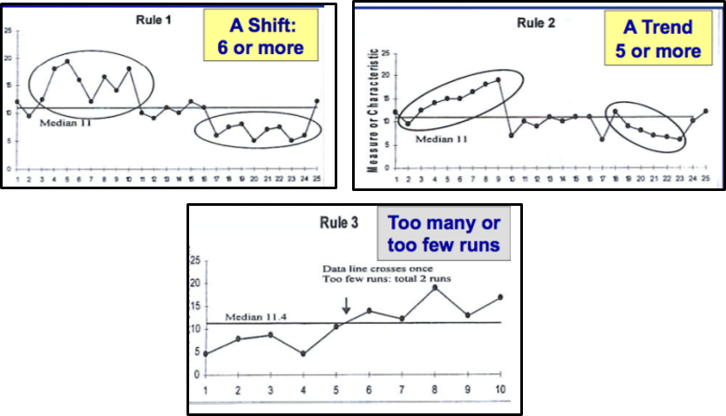
Pareto Charts: What are the main causes over time?
The purpose of the Pareto chart is to highlight the most important contributing factors among a (typically large) set of factors. Effectively, the pareto answers the "What" is the problem question. Each day, as the Daily Management board is updated, the team records the frequency of occurrence for that particular type of issue and reflects this on the updated pareto chart below. People often refer to this as the "80/20" rule, in that typically 20% of the contributing factors represent 80% of the overall impact. As it relates to Daily Management, we use paretos to keep the team focused on solving the largest, recurring issues that are preventing them from hitting their target on a daily basis. Often times, the level of problem solving effort required to get to the root cause of each one of the pareto items, cannot take place in the day in which they occurred, therefore it is necessary to approach these items in a different manner, as I'll explain below with respect to A3 problem solving. Effective pareto charts have the following characteristics:
- Clear title and period time for which the data represents
- Entire population of data is represented (not just the gap)
- Clear, mutually exclusive categories
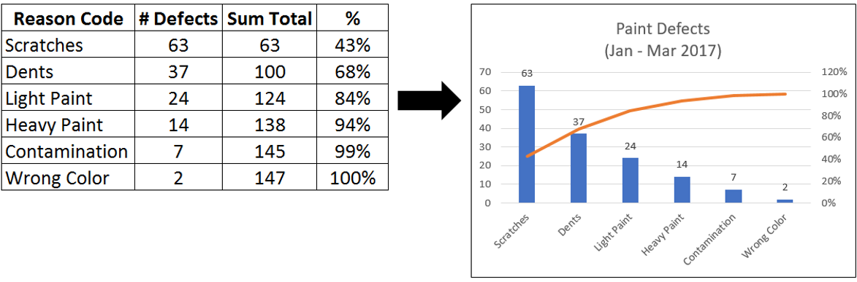
Countermeasures: What action will we take daily to get back on track?
Miriam Webster defines a "countermeasure" as the following: an action or device designed to negate or offset another. In the context of Daily Management, we use this section of the Daily Management board to record the actions the team will take to get the metric back on track as quickly as possible, or avert further pain as result of the problem. This process feels like "firefighting", as the actions we take are just enough to keep the process afloat, while we address the longer-term, systemic problems with dedicated problem solving teams. The following items are typical types of information captured on the daily "Countermeasure" section of the board and reviewed for completion each day by the team until closed:
- Date of Occurrence
- Problem Description
- Root Cause Description
- Countermeasure Identified
- Implementation Date
- Impact on the gap (i.e. # of defects, $, %, or whatever metric you are tracking)
- Owner of the Countermeasure
- Status Completion % (25% - Problem Defined, 50% - Root Cause Verified, 75% - Countermeasure Implemented, 100% - Countermeasure Verified Effective)
A3: Systemic Problem Solving Activity
The last section of the Daily Management board is reserved for systemic problem solving activity. Up until this point, we have been dealing with problems, countermeasures, and metric performance on a daily basis. What do you do when you cannot solve the problem for why you did not hit your KPIs for the day, in one day? One week? One month? Not to mention, a typical Daily Management meeting is 10-15 minutes in length. It is very difficult, if not, next to impossible to discuss these systemic issues in this time-frame or setting. The Countermeasures sheet mentioned above can handle the day-to-day firefighting, but you need a different level of focus and effort to resolve the recurring, systemic issues that hold back performance over time. Therefore, I suggest the weekly systemic A3 review meeting.
The weekly A3 systemic problem review meeting is separate from the Daily Management meeting, and only needs to occur one time per week. This meeting is reserved for the top systemic, pareto items for each one of your metrics, and is represented by the appropriate team, based on expertise and familiarity with the process and metric being improved. Essentially, this is a meeting to review the status of the A3 until closure. The individual team members work together, in their own time to complete the A3 activity, and each week provide updates on where they are at in the process, help they need, where they are stuck, etc. (A3 template example below). A great book on the topic of coaching and mentoring A3 Problem Solving Teams is "Managing to Learn" by John Shook.

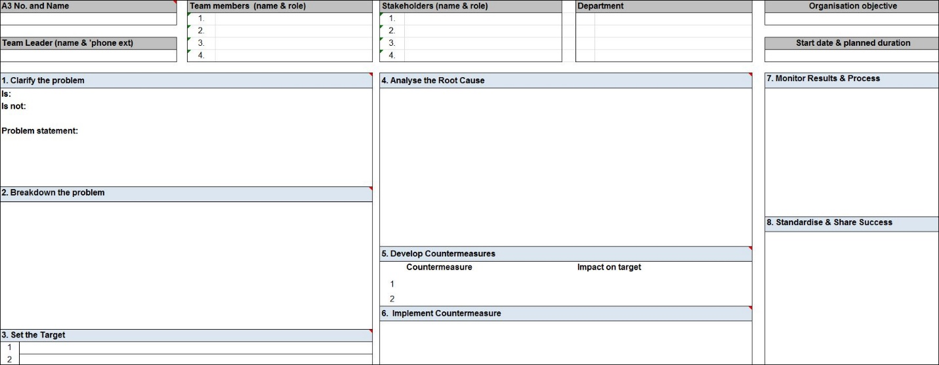
Effective Daily Management: The Sights and Sounds
One of the questions I have been asked more times than I can remember is the following: "So where can I go to see effective Daily Management in practice?" This is a tough one. I have seen literally thousands of Daily Management boards over my career, and led, participated, or observed thousands more. The answer is, the good ones are hard to come by. It's like trying to find a pot of gold at the end of a rainbow, a unicorn, or Elvis...it's frankly, really hard to do. However, there is a glimmer of hope. While greatness is hard to observe first hand, over time I have come to develop a system which I have used to coach and mentor others on their Daily Management processes. I call it the "3 Sense Test"...which I describe below:
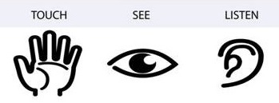
- Touch: I call this the "fingerprint factor". You can observe this when you come across beautiful, expensive Daily Management Boards that are printed daily from computers or displayed as large, electronic displays on the shop-floor or in the office. It's not that I am against technology, however, there is a sort of connection that is lost from the employees tasked with problem solving on a daily basis, when they are not updating and owning the information on it themselves. Over time, people become "numb" to what they are looking at. Therefore, I am a strong proponent of doing the board manually, with dry or wet erase markers/pens. There is more flexibility, creativity, ownership, and pride that emerges as a result.
- See: I call this one "fake lean wallpaper". The Daily Management looks good from a distance, but when you take a closer look you find the following: past due action items, action items without owners, outdated or old data, irrelevant metrics, "green" performance day-after-day, root causes missing, paretos missing or unclear, doesn't pass the 5 seconds at 5 feet - are we winning or losing test, systemic problem solving not being worked on, not in employee's goals or objectives, metrics without owners. With respect to the Daily Management meeting format itself, I see the following: poor attendance, disinterest from the participants, poor body language, leaders running the show only, and no cross-functional interaction.
- Listen: When I first attend someone else's Daily Management meeting, often times I will close my eyes and just listen. I listen to the interactions amongst the team, the tone of the conversation, the volume of the participants, the quality of the dialogue, the passion in their voices, etc. You can learn a great deal just by listening. Is the leader encouraging a collaborative problem solving culture amongst their team? Are they asking clarifying questions? Are they seeking to understand? Do they encourage and motivate their team to keep them on track with solving problems? Are they asking for feedback on how to have a better Daily Management meeting?
Conclusion
Daily Management is powerful process that can truly drive breakthrough performance for your business regardless of the industry or function that you work in. If you are thinking Daily Management does not apply to you, and cannot help you improve your business, I have seen and used Daily Management in virtually every setting imaginable: Sales, Marketing, R&D, Quality, Operations, Supply Chain, Legal, Finance, HR, and on-and-on...Additionally, I have used, applied, installed, led, or participated in Daily Management in 35 different major corporations across 13 different countries. The process works consistently everywhere it can be applied, but to be successful, it requires strong leadership commitment, consistent application, willingness to learn, grow, make mistakes, and a commitment to improving the problem solving skills of the organization. Collectively, you can use these observations and guidelines the next time you are having your Daily Management meeting, or if you are just getting started, better yet, do it as a team and commit to making the process better each and every day.
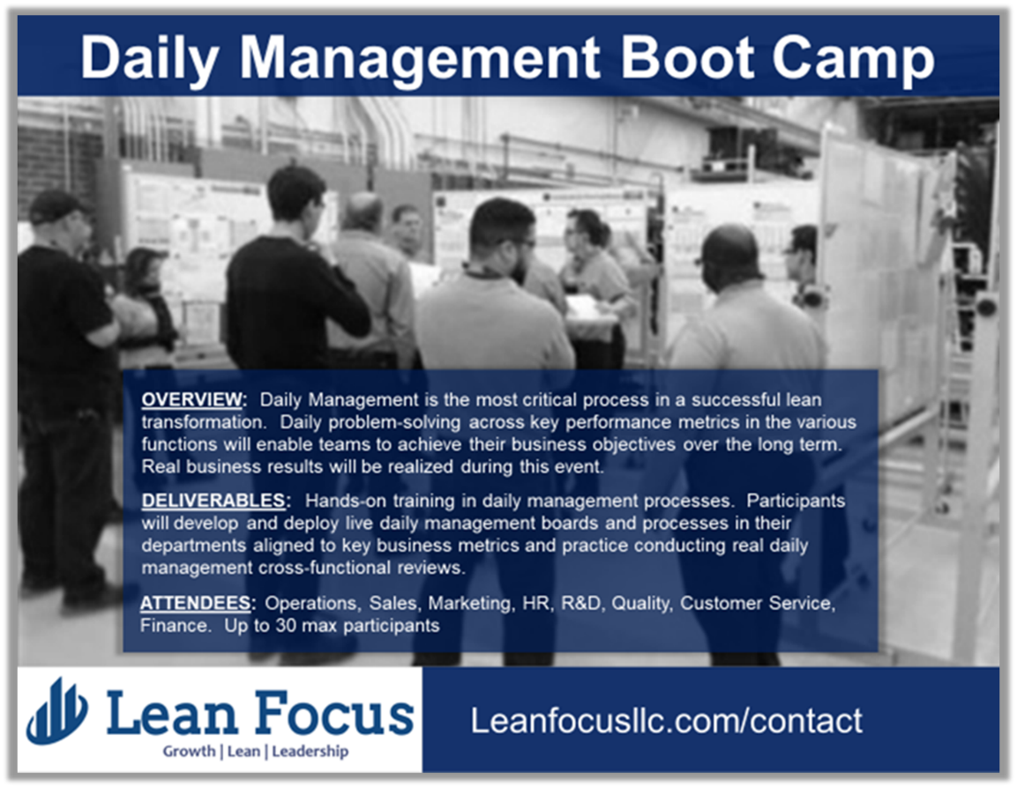
If you like this article, you can read more by following our Lean Focus LLC company page on LinkedIn below...
https://www.linkedin.com/company-beta/16215687/
Lean Focus LLC is a results-based Leadership consultancy that deploys our system to drive growth, profit, and working capital.
https://www.leanfocusllc.com/
© 2018 All Rights Reserved. Do not reproduce this or portions of this document without written permission from Lean Focus LLC, Damon Baker. (630) 800-8519
