5 WHY Analysis and the 20 Common Pitfalls to Avoid in Problem Solving
By Damon Baker
February 3, 2018
- Logic gap errors: Generally, this occurs because leave out or fail to properly identify all parts of the causal chain in our analysis.
- Logic sequence errors: Generally, this occurs because we get the parts of the causal chain in our analysis out of order in terms of timing.
- Logic path errors: Generally, this occurs because we include information on the causal path that is unrelated to the cause path being explored.
- Asking the wrong questions: We have a preconceived idea of what happened, therefore we ask and lead off with questions that send us down the wrong path of cause analysis.
- Jumping to conclusions without facts: We do not remain “root cause agnostic” and seek out the first person that agrees with our conclusion without true supporting facts.
- Using Blaming language: During our cause analysis we redirect the causes towards blame of an individual or department without understanding how the process could have led to the outcome.
- Excessive Qualitative statements: Using and abundance of qualitative words as adjectives to explain the causal chain analysis. Generally, the more qualitative the words are, the less the investigation was rooted in facts. Examples include: good, bad, poor, inconsistent, nice, mean, etc.
- Disconnected units of measure: In problem solving we are tasked with uncovering causes that contribute to GAPs that add up to the problem statement we are trying to improve. When we identify unrelated causes that do not connect to the problem statement, we might countermeasure something unnecessary.
- Missing splits: 5 whys, like tree root want to split and expand. It can be challenging for the problem solver to notice when these causes the need to split because they are separate contributors to cause and each has their own impact in measures on the problem statement.
- Stopping too soon: This happens when teams believe they reach a deep enough point to correct the issue, but sometimes miss the system deficiencies that lead to the recurrences of the issues. There are 2 types of fixes to be on the look-out for: physical countermeasures and system countermeasures.
- Going too deep: This is the opposite, where the team digs far too deep into the process and winds up taking on areas of the problem solving that fall out of their control and complicate the size and complexity of the problem.
- Incorrect format (write out the question, document the answer, include the Gemba evidence): The correct format for 5 why analysis should be to step 1: Write out the question being asked. Step 2: Document the answer with a fact-based conclusion. AND 3. Document the Gemba evidence that supports the fact-based conclusion, essentially answering the “how do you know question.”
- Picking up the problem too low or high: Declaring a problem too high or too low will lead to the team to have to deal with team trade-offs in the following problem characteristics: impact, timing, complexity, size, cross-functional nature, and ease/difficulty.
- Dead end causes or out your span of control: Teams have a tendency to take their cause analysis efforts to areas out of their control or they pursue fixing something that cannot be undone or corrected after the fact.
- Not using where, what, when, who, how AND why questions: Why is one of the most USELESS questions in problem solving because it instigates people to identify the answer while not encouraging them to get direct knowledge of the situation. This encourages jumping to conclusions.
- Doing 5 whys without direct access to Gemba: The number one reason Problem Solvers fail. They jump to preconceived ideas or reference/access their already known experience when explaining the events in the causal chain.
- Solutions presented in the 5 why: Similar to the one above, but the they take the statements a step further and propose solutions/countermeasures in the 5 why statements to support the actions that they believe are necessary.
- Impact of causes not understood on GAP: The 5 Why analysis is completed while losing site of the fact that they are being tasked with closing the gap on their problem statement. They identified causes that cannot be tied back to the problem statement in a consistent way.
- Missing Gemba evidence: The HOW DO YOU KNOW statements are not captured as a countermeasure to prevent the problem solvers from jumping to preconceived conclusions.
- Incorrect identification of 3 cause types: There is mis-usage or mis-identification of the 3 cause types being used; Sequential Direct, independent Direct, and Combined Effect.

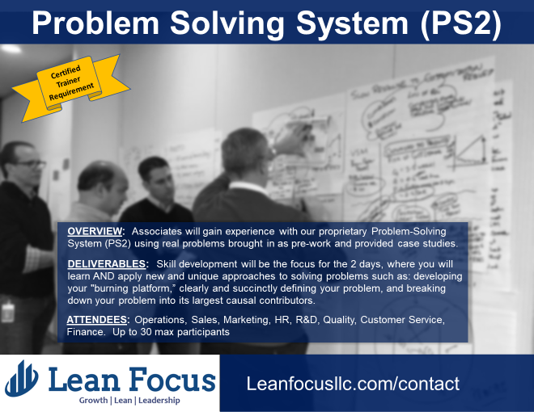
- Participants will leave with the following materials:
- "Managing to Learn" book by John Shook
- Lean Focus Problem Solving System Training Manual
- Problem Solving System Quick Guide
- Lean Focus Problem Solving Form Template
- Lean Focus Action Plan Template
- Hands-on problem-solving training and application to a real-life problem
- Certificate of Course Completion
If you like this article, you can read more by following our Lean Focus LLC company page on LinkedIn below...
https://www.linkedin.com/company-beta/16215687/
Lean Focus LLC is a results-based Leadership consultancy that deploys our system to drive growth, profit, and working capital.
https://www.leanfocusllc.com/
© 2018 All Rights Reserved. Do not reproduce this or portions of this document without written permission from Lean Focus LLC, Damon Baker. (630) 800-8519

