



**15 Strategy Mistakes Your Company is Making Right Now**

By Damon Baker

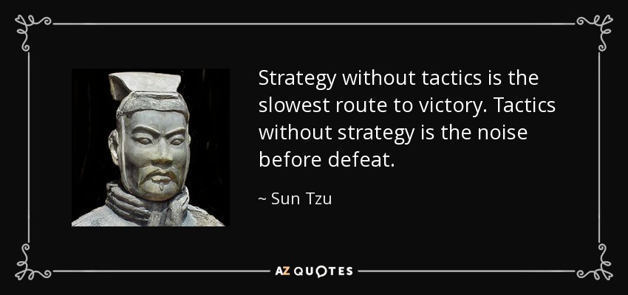

Strategic planning is an organization's process of defining its strategy, or direction, and making decisions on allocating its resources to pursue this strategy. When done well, this process also includes the mechanisms and methods used to deploy it, for example Strategy Deployment, a.k.a. Hoshin Kanri or Policy Deployment processes.

Strategic Plans at their most basic level answer two primary questions:

1. What game are we playing?
2. How do we play to win?

While it is vital for the organization to align on a strategy that creates significant competitive advantage, more important is the deliberate act of prioritizing and deciding what the organization will not do in pursuit of its' overall strategy. As you kick off your annual cycle of building the company strategy for the next 3 to 5 years, we at Lean Focus would like to share our experience of how and why the process fails so that you can prevent it from happening this year. The shelf in your office just cannot stand to bear witness to one more dusty binder of good intentions.

**15 Strategy Mistakes Your Company is Making Right Now:**

1. Lack of commitment and involvement by the leadership team
2. Lack of ability, objectivity, and meaningful perspective
3. Making the process too complex
4. Failure to start on time or create and stick to a schedule
5. Not enough emphasis on external/internal environment and capabilities
6. Over-focusing on threats and weaknesses
7. Dogmatic use of templates and process
8. Allowing the strategic plan to be reduced to budgeting and forecasting
9. Poorly thought out action plans and problem solving on initiatives
10. Underestimating resource requirements and availability
11. Not building strategic planning into the regular business cadence
12. Incorrect assumptions or presumption errors (jumping to conclusions/solutions)
13. CEO as dictator that abdicates the process
14. Failure to monitor progress at the right cadence and frequency (weekly/bi-weekly vs. monthly or longer)
15. Not defining what winning and losing looks like in quantifiable terms

**Call to Action**: As a team, you should discuss and assess the effectiveness of your current state Strategic Planning and Deployment Process, and take action to correct it.

**Scale of Maturity: # of Strategy Mistakes in Your Process**

* 3 or less = Pat yourself on the back...you're doing pretty good.
* 4 - 6 = You are in the danger zone.
* 7 or more = Give us a call immediately at (630) 800-8519...we can help. :)

*What types of mistakes does your company fall victim to?*

*If you like this article, you can read more by following our Lean Focus LLC company page on LinkedIn below...*

<https://www.linkedin.com/company-beta/16215687/>

*Lean Focus LLC is a results-based Leadership consultancy that deploys our system to drive growth, profit, and working capital.*

<https://www.leanfocusllc.com/>

*© 2018 All Rights Reserved. Do not reproduce this or portions of this document without written permission from Lean Focus LLC, Damon Baker.*[*(630) 800-8519*](http://tel:6308008519/)

