Master These 5 Habits and Dominate Your Competition

By Damon Baker

“Greatness is not a function of circumstance. Greatness, it turns out, is largely a matter of conscious choice, and discipline.”
James A. Collins
1. Raising the Bar
Behind every great team is a great leader who sets the bar higher for performance. As human beings, we are programmed to avoid pain and seek out pleasure. Improving our work is hard and painful at times. Left to our own devices, we will choose the easy way out, or be satisfied with a lower level of performance to avoid further pain and the emotional stress of falling short of our own goals and aspirations. Leaders who set high expectations, effectively raising the bar, are a countermeasure against our own natural human tendency to avoid pain. If this were not true, the personal training industry would not exist, professional sports teams would not need coaches, and all of us would just over-deliver our goals by our own accord.
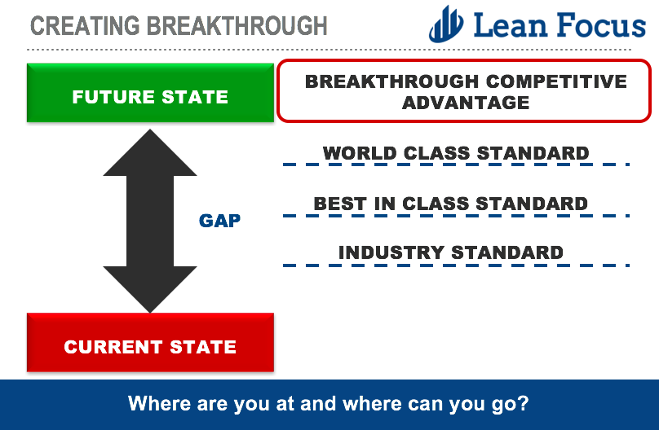

If an organization is historically underperforming the expectations of shareholders, one cannot look any further than the leadership that exists within that organization. The resulting performance that is achieved is a function of what leaders accept or do not accept, by the expectations they set or do not. Some questions to consider: How are your leaders being measured and rewarded in terms of their performance? Does this level of performance match the type of rewards they are getting? If not, what message are we sending to these leaders, and to the rest of the organization? In your organization, when was the last time someone lost their job or was coached for not delivering the desired level of performance? An organization that sets high expectations at every level has a healthy level of productive tension in the system at all times to instigate continuous improvement and drive sustainable, breakthrough results.
Key Action to take: Assess your team's goals vs. performance and commit to setting a higher expectation for results. Ask them what they need and give them the tools and skills needed to deliver on the challenge. What people can truly achieve when stretched will surprise you. Stretch Target Rule of Thumb: If the metric is “a reduction”, i.e. costs, cut it by 50%. If the metric is “an increase”, i.e. sales, do 50% more than we are doing today.
2. Learning by Doing

“The best way about learning about anything is about doing.”
Richard Branson

I continue to be amazed by the amount of investment organizations make in training their people that provide little to no impact on the bottom line. Entire organizations or internal universities exist within companies to “certify” individuals in various tools and purchases of capital intensive Learning Management Systems (LMS) are justified with imaginary returns-on-investment. The primary training method is usually PowerPoint or some type of module-based e-learning with a memory recall-based quiz at the end to validate learning. Employees typically are given a list of training modules they must complete by functional responsibility and are lambasted when they do not complete them on time. This type of training eventually gets reduced down to a compliance-based activity on someone else's checklist instead of a development-focused one that grows the capabilities of our associates. These organizations then justify their existence by tracking a laundry list of proxy metrics such as: number of Black Belts certified, completion percentage of e-learning modules, # classes taught, etc.
Repeat after me…nothing gets truly learned without the physical act of DOING it. You cannot watch YouTube videos to learn how to play guitar like Eric Clapton. At some point, you have to pick up an instrument and start playing. We did not learn how to ride our bikes by watching a Ted Talk about it. We got on, held tight, crashed a few times, and eventually, we figured it out.

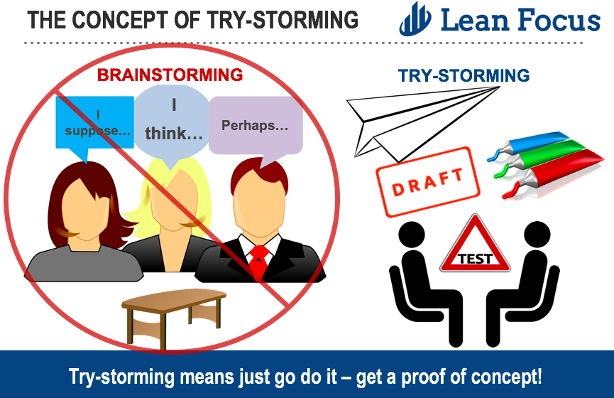

Training and development should be delivered just-in-time and within the context of applying the new skill on-the-job at the gemba (real place) within a real situation. Use real business problems and challenges as the framework to deliver new skills to the people in your organization. The aim of training is to transfer a new skill that will become the new way the work is carried out versus just amassing an interesting set of training experiences that may or may not ever get used again. Put down that book and start practicing that new skill.
Key Action to take: Review your existing training programs and demand that all training & development activities be delivered within the context of real application, on-the-job learning, and the tackling of real business challenges.
3. 80/20 Thinking

“Aiming for perfection causes frustration at best and paralysis at worst.”
Sheryl Sandberg

In research that was conducted about the productivity habits of high achievers, using interviews of hundreds of self-made millionaires, straight-A students and even Olympic athletes, a common theme emerged with respect to how they handle every task that gets thrown their way — or even every task that they would like to handle. They use the Pareto principle, or 80/20 thinking to help them determine what is of vital importance (the 20% of things contributing to 80% of impact). Then, they delegate the rest (the 80% of things they won't do), or simply let it go. Repeat…let it go.
Proliferation of priorities and initiatives cripples an organizations’ ability to execute effectively. We must be clear on the things that we will not do, in order to keep the business focused on the critical few things that matter. There will never be enough data to draw a perfect conclusion, and in our attempt to achieve this, we waste valuable time that could have been spent otherwise improving the business. Do not let perfect get in the way of better. When we adopt 80/20 thinking, we are committing to focus on the few things that represent the greatest impact on achieving our strategic objectives. Remember…20% of your work drives 80% of your outcomes.

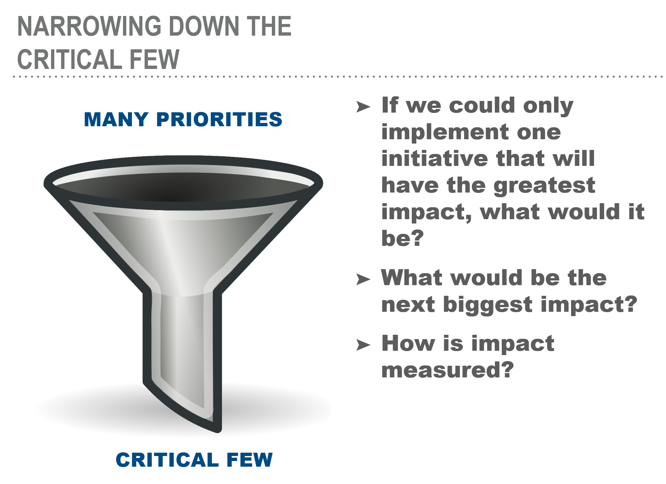

Key Action to take: Make a list of the following: initiatives, projects, tasks, metrics. This can be done as a team at the business level or individually. Group them into the following categories in terms of their impact to your overall strategy: must have, nice to have, not necessary. Reduce this list by 50% and redirect your focus towards the 50% that matters to the business.
4. Dynamic Resource Allocation

“Game management, game decisions, adjustments, seeing things during games – it’s all important.”
Bill Belichick

Organizations tend to adopt a fixed mindset when it comes to resources. For instance, budgets are prepared annually by department and submitted and committed to for the following year. This budget then becomes the standard everyone works toward. The minute you put the plan down on paper, it is wrong. As the year progresses, things get off track, new opportunities present themselves, or assumptions change. Most organizations “play the victim” and do not look for ways to achieve the plan in other, more creative ways using the same budget. As an example, a new growth opportunity presents itself in an adjacent market. Marketing does not have the budget allocated to go after this opportunity, and therefore, is unable to execute a critical lead generation campaign. Meanwhile in another area of the business, we are “doubling down” with spending in a low-growth or negative growth market. Rather than foregoing this opportunity, the organization dynamically reviews the budget and allocates the necessary resources (spending dollars) from other departments or initiatives, while maintaining a zero-based budgeting viewpoint on the overall financial impact to the organization. The business wins more growth and achieves the budget. It’s a win-win situation.

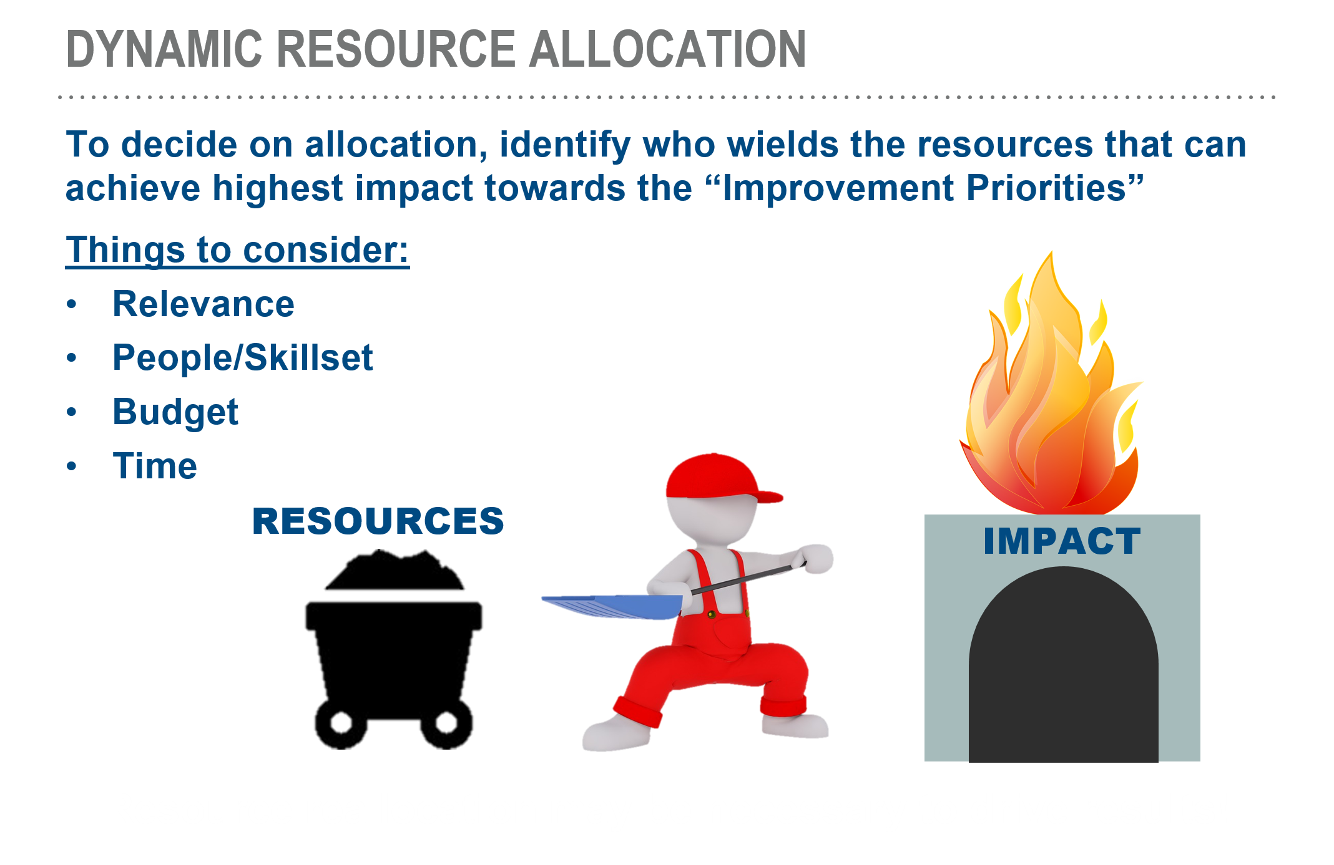

To get better at this habit, an organization must do the following: seek solutions within your control, identify current & existing resources to get the job done, reallocate resources based on prioritization and impact, spend the company’s money as if it were your own (think smarter, not spend harder), and think hard about investments that would take significant approval, time & resources. Will it achieve your goal in the time you expect? For people who are afraid to forfeit their budget to another department, ensure the leadership's objectives are based on shared company/team objectives, not just individual budget control over their department.
Key Action to take: Start a monthly process of keeping a “checkbook list” of the opportunities that exist within your business for revenue growth, cost out, etc. Once you have the list, prioritize the list based on Feasibility, Impact, and Timing (F.I.T.). Reallocate your business resources accordingly (spending) based on the impact of these initiatives to fully capture the opportunity.
5. Leaders “Go See” & Fix It Now

“You cannot fix what you will not face.”
James A. Baldwin

In many businesses, we spend far too much time in meetings preparing PowerPoint decks, providing updates, hypothesizing, hearing anecdotes, generating opinions, dealing with cognitive biases, not following up, and otherwise listening to B.S. Very rarely in these meetings are people able to articulate the situation using real facts and data, to construct a logic-based point-of-view on what to do next. The main reason for this is that we do not go to the gemba (“go see” where the work is done) and critically examine the process using PDCA (problem solving technique of Plan, Do, Check, Act) to formulate a perspective grounded in reality based on the true state of current or past events. Going to the gemba and seeing for yourself helps us to visualize the problem & see if the process is being followed without taking others’ word for it. Regularly going to the gemba reinforces the principle of leading by example and encourages cycles of continuous improvement. This behavior (way of thinking) should be consistently practiced and built into the culture of how we operate as a team.

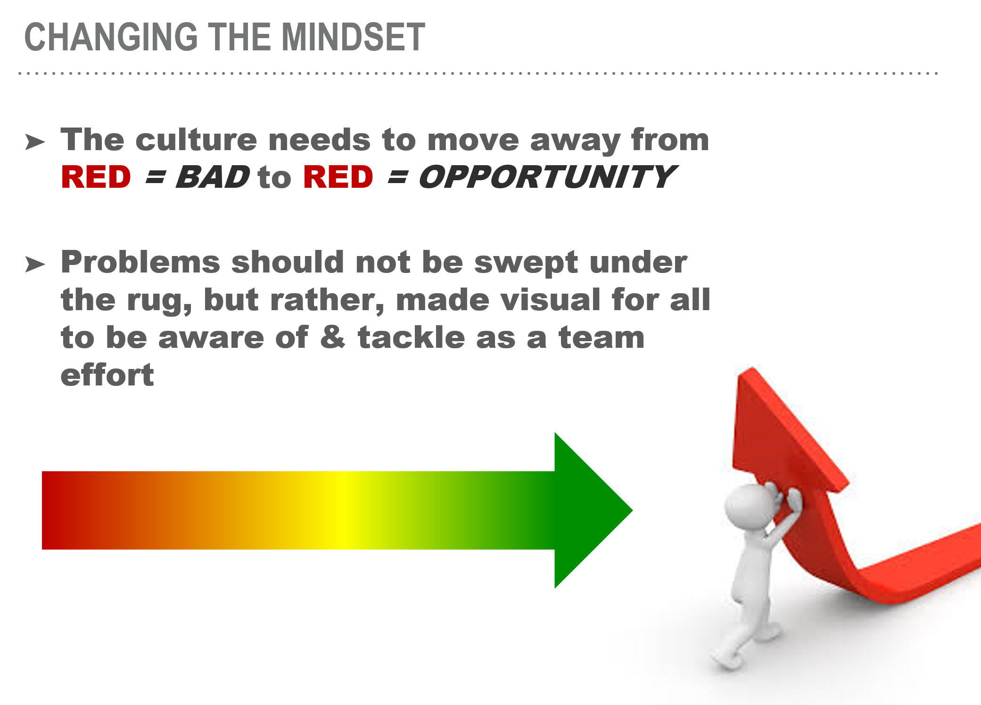

To drive results consistently over time, an important part of the culture lies in creating a “fix it now” mentality around problems that exist within the business. The business must maintain a healthy level of dissatisfaction with the status quo in order to shine a spotlight on key areas of opportunity to improve. I am not advocating a total shift away from focusing on the positive aspects of what we do altogether, however, I have seen many organizations fall victim to a shared behavior where they justify their lack of urgency around making things better based on how good they think they already are. Celebrating our past successes to the detriment of ongoing improvement is a short-lived strategy and a costly one. The season starts the day after the Super Bowl is won. As uncomfortable as it sounds, this is the mindset we must all embrace, and leadership is responsible for creating this level of intensity within the organization. Leaders must help the team to overcome obstacles and act as a champion behind the necessary improvements and dedicate resources to support them.
Key Action to take: A key question to ask in your organization is the following: Do our collective actions around the problem(s) we face match the level of importance we place on them in our organization and would our customers agree with our own assessment of the situation? If not, what behaviors or actions will we take to align and take action accordingly?
Bringing It All Together
The best organizations have figured out that in order to create lasting competitive advantage, they must embrace a common set of principles by which they operate and make decisions. Together these 5 habits serve as a "True North" reminder of the behaviors we must embrace and model as leaders to move our organizations forward down the path towards our envisioned future.
How well does your organization demonstrate these 5 traits?

If you like this article, you can read more by following our Lean Focus LLC company page on LinkedIn below...
https://www.linkedin.com/company-beta/16215687/
Lean Focus LLC is a results-based Leadership consultancy that deploys our system to drive growth, profit, and working capital.
https://www.leanfocusllc.com/
© 2018 All Rights Reserved. Do not reproduce this or portions of this document without written permission from Lean Focus LLC, Damon Baker. (630) 800-8519
