



**Ready...$et...GROW! 14 Sales Principles to Sell By**

**By Damon Baker**

**Published on March 15, 2017**

Throughout my career, I've had the opportunity to work with with many different Sales teams, across a vast array of industries. One thing they've all shared in common; is that when I first engaged them in the idea of continuous improvement, there was a firmly held belief that the principles of lean, kaizen, or continuous improvement, did not apply to them. While working with a Sales team, in the beginning of my career, many years ago, I remember a particular gentlemen, pulling me aside after delivering what I thought was a "fantastic" Lean Overview training, and he said the following:

*"Lean Manufacturing and kaizen is great and all, but you need to understand something Damon...we are in Sales. We sell medical devices. We don't build cars out in the field."*

Upon hearing this, I began to think about how to formulate my quick and witty response. Something along the lines of you're a concrete head, or CAVE dweller, or perhaps my all time favorite...a Debbie Downer. Any of these would've sufficed in the moment. However, thankfully, I stopped myself. In an instant, I started to remember something a wise mentor of mine once told me:

*"If the student hasn't learned, the teacher hasn't taught."*

After a brief moment of reflection, I decided to do something completely different than I was used to. I simply asked the man to tell me exactly why he didn't think lean and kaizen applied to Sales. After pausing for awhile, as if he was carefully creating a cross-off list of which swear words he was going to hurl at me, he said the following:

*"All of your 8 waste examples were about the shop floor! When you talked about one-piece-flow, you showed us a picture of a manufacturing cell! When I asked you to give us an example of standard work in Sales, you talked about Toyota. Toyota this, Toyota that...all of your stories and examples were about manufacturing. Don't you get it? We don't build cars, we sell sh*t!"*

Finally it dawned on me. I must have delivered this Lean Overview Training a hundred times, but each time with my background and knowledge in Operations in mind, and not my learners'. I failed to truly understand the steps of the selling process, nor did I ask. I missed the opportunity to relate the concepts and ideas of lean and kaizen to their work. I didn't even ask if they understood what it was I was presenting. Ultimately, I failed to teach them. Therefore, making any lasting changes to the culture and ways of working of this Sales team would be next to impossible.

I vowed to myself from that day forward, that regardless of who I was teaching lean concepts to, I would relate it to their work. This day would go on to trigger my journey in learning how to apply these concepts in a variety of settings: Sales, Marketing, R&D, Legal, Finance, HR, IT, Customer Service, and on, and on. Quite frankly, I failed more times than I care to remember. It was ugly at first, but over time, I began to develop and trust a repeatable and reliable set of principles, that apply to all of these functions, irrespective of where they happened in the business. I call these principles the *"14 Ways of Working"*, and they serve as the foundation of the Lean Focus Business Excellence Model. When applied together in an integrated business system comprised of Leadership, Growth and Lean systems, they deliver consistent outcomes and breakthrough results year-after-year.

**14 Ways of Working - (adapted for Sales...see, I learned my lesson)**



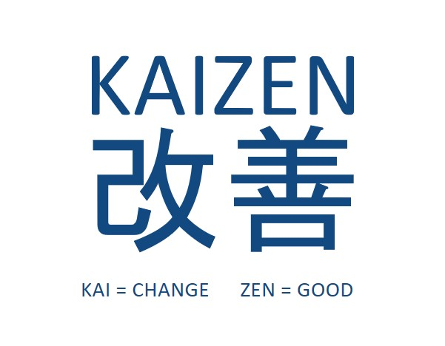**Kaizen Mindset** - Kaizen means “continuous improvement”, and any type of improvement involves change. If you have no real intention in enabling change, no matter how small, kaizen will fail. As a Sales Leader, do you have a documented funnel of kaizen ideas, projects, or events teed up, that align to your company's strategic plan or objectives? Does your team adopt a "spirit of inquiry" and possess the determination to make the Selling process better, faster, and cheaper every day? How are you ensuring this happens?

**Continuous Flow -**This involves moving work one unit at a time between each step of the sales process with no breaks in time or sequence. When done well, it reduces waste, saves money by reducing selling process inventory (leads) and selling costs, increases sales productivity – more leads closed in less time, improves quality by making it easier to spot and correct errors in the process, cuts down on overhead via increased stability and reduced lead times, adapts to customer needs more effectively than batch processing. Some questions to consider: Are sales orders being batched at certain points in the process? Are leads being acted on in batch vs. one-piece-flow? Are internal hand-offs reduced throughout the selling process?

**Create Pull -**Think of Prospects and Leads as a form of inventory in your selling process. There is a desired amount you need to hit your revenue target based on the following factors: how long is the selling cycle? what is the conversion rate? what is the average sales price? How many deals are in the funnel? At what stage are those deals currently residing? Once we understand the math, we can ensure we have systems in place to replenish (pull) the additional prospects and leads into the process. Using simple math, we are able to pinpoint the opportunities of focus for improvement in the selling process.

**Level the Work -**is a technique for reducing the Mura (Unevenness) which in turn reduces muda (waste). It is vital to improve efficiency in the selling process. The goal is to carry out units of work at a constant rate so that further processing may also be carried out at a constant and predictable rate. For example, do you wait till the end of the week to submit your orders to Customer Service, thus creating a spike on each and every Friday? Do you send your quotes for pricing approvals in batches to your manager? Do you work on multiple contracts at the same time, then send them to legal for review and approval, thus impacting the lead time to the customer? All of these personal choices being made to batch work affect the length of your selling cycle negatively.

**Stop and Fix -**From a leader’s perspective, it requires great courage to stop the process long enough to understand the root cause and take counter-measures that prevent the process from reoccurring. For the leader, this often means trading any short-term loss for substantial long-term gain. From a manager’s perspective, systems must be in place to ensure that any result that varies from the standard, even slightly, creates an expectation of and support for immediate action. Do you rely on the back office to deal with errors submitted on selling proposals, effectively using them as a catch-all for defects? Do you ever give feedback to the salesperson on the level of quality that they are producing?

**Standardize the Work -**Standardization is the supporting principle behind maintaining improvement, rather than reverting back to the old practices and results. When standardization is in place, the work itself serves as the management control mechanism. What does a good proposal look like? What does a good selling pitch sound like? What tactics should you be using to handle objections? What is your clearly articulated value proposition over each and every competitor? Can your sales team recite these value propositions on command? What are the stages of the sales funnel? What is the definition of a qualified lead? Does everyone in your company define it the same way?

**Visualize Problems -** Arrange the flow of work so that problems are highlighted as they arise, enabling and encouraging individuals and teams to tackle them right away. The point is to create a culture of relentless problem solvers. What mechanisms exist in the sales process to draw attention to these types of problems: Low conversion rate? Long selling time? Inadequate funnel size? Inadequate funnel shape? Low number of leads? Over-abundance of discounting? Low number of appointments? High selling costs?

**Mind vs. Wallet -**Before you spend money, think first. Before you ask for resources, use your problem solving skills first. Adopt a bias for "try-storming" not brainstorming. Think of try-storming as mini experiments that are tried on the fly, where the real work happens in a live environment in front of Customer, where you can observe first-hand the impact of your actions, and make the necessary adjustments going forward. For example, you observe one of your sales reps deliver their pitch to a prospective customer. You notice that they didn't deliver the value proposition correctly, and as a result, lost the sale. Immediately in the car afterwards, you role play a new selling pitch with the rep, and try it on the next customer. The point being DO IT NOW! Do your sales leaders think that all of their problems can only be solved by big ticket item purchases like CRMs, territory planning software, fancy motivational speakers, etc? What can you fix today without spending any money?

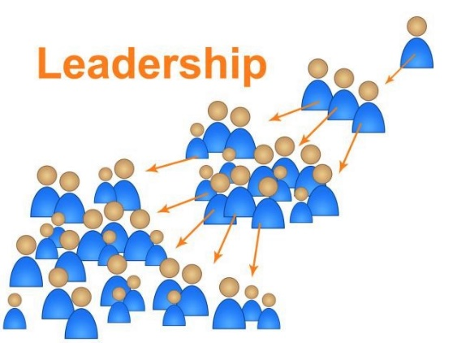**Leaders Teach -**In a teaching organization, leaders benefit just by preparing to teach others. Because the teachers are people with hands-on experience within the organization—rather than outside consultants—the people being taught learn relevant, immediately useful concepts and skills. Teaching organizations are better able to achieve success and maintain it because their constant focus is on developing people to become leaders. What skills and training do you have your Sales leaders teaching? How many times per year are they expected to deliver this training? Are they proficient in the CI tools related to improving Sales? Are they leading and participating on Sales kaizens and other problem solving projects?

**Develop People -**Through people development, the organization creates the problem solvers that will drive future improvement. People development is far greater than just classroom training. It includes hands-on experiences where people can experience new ideas in a way that creates personal insight and a shift in mindsets and behavior. What development plans have you identified for your people to enhance their core skills to make them more successful at selling? What real life development opportunities are you giving them to practice and hone these new skills? How will you measure whether they have gained any functional competency? How are you holding your Sales leaders accountable for developing their people?

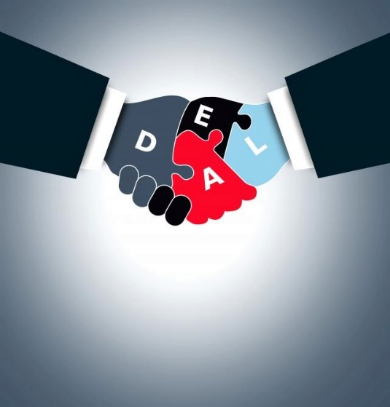**Respect Others -** Should go without saying, but individuals are energized when this principle is demonstrated. Most associates will say that to be respected is the most important thing they want from their employment. When people feel respected, they give far more than their hands; they give their minds and hearts. I am truly convinced that the reason organizations fail more than 75% of the time in driving TRUE lean transformation is a LACK OF TRUST. Bottom line: you can't have RESPECT without TRUST, end of story. How do you encourage your team to express their opinions and ideas? Do you routinely listen to what others have to say before expressing your viewpoint? Do you use people's ideas to change or improve the work? What do you know about the personal lives of your employees?

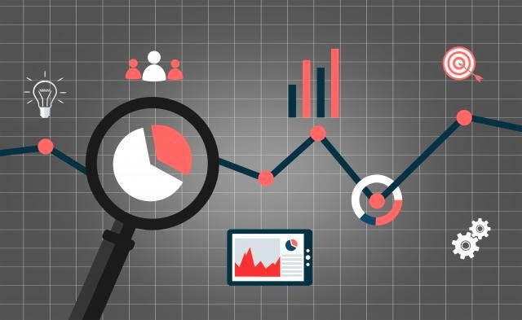**Go See Yourself -**Direct observation is necessary to truly understand the process or issue being investigated. All too frequently, perceptions, past experience, instincts and inaccurate standards and processes are misconstrued as reality. Tell me if you ever heard this...

*"Trust me on this one. I have 20 years of experience in selling into this market."*

If I had a dollar for every time I heard that one, I wouldn't be writing this article right now. Through direct observation, reality can be seen, confirmed and established as the consensus. Go see, ask questions, show respect. How often are you in the field with your team in front of customers observing the selling process first hand? What standards in the selling process are you ensuring are being upheld? Trunk/demo stock, appearance, sales pitch, selling tools/templates, value propositions, appointment planning, territory action plan...these are just a few of the things that should be standardized and reviewed by leaders in the selling process.

**Eliminate Waste -**One way to view waste is that it is anything that slows or interrupts the continuous flow of value to customers. In the end, identifying and eliminating waste is a concept that effectively engages the entire sales organization in the continuous improvement effort. How are you engaging your sales team in continuous improvement? Are you soliciting ideas for improvement in the selling process? Are sales associates forthcoming with ideas to improve? Are salespeople trained on how to identify and eliminate waste in their selling process? Are they empowered to do so?

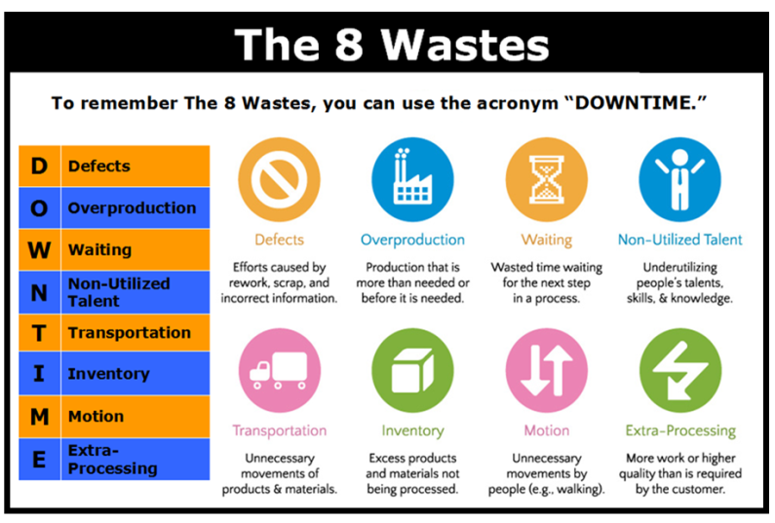

**High Expectations** - Low expectations won’t drive you to outperform your sales targets. But maybe you’ve heard that it’s good to have low expectations in order to reduce disappointment and set the bar low? The problem with that theory is it assumes that humans are incapable of dealing with failure. The truth is that the less you deal with failure, the worse you’ll handle it. Avoiding failure by setting expectations low will backfire. High expectations, however, make greatness possible by giving us confidence to take chances. What is the market growing at? What are your sales quotas growing by? Are you aggressively taking share and outperforming the market? Do you create productive tension in the team by displaying performance for all to see and react to? Setting high expectations forces us to look inward at ourselves and our own processes. We have no option but to improve the processes, if we truly expect to win.

*A short 3 min video by Bill Stainton "Why You Should Set High Expectations"*

<https://youtu.be/aqhW6l0Me6Y>

*When we treat man as he is, we make him worse than he is; when we treat him as if he already were what he potentially could be, we make him what he should be.*

*— Johann Wolfgang von Goethe*

**Conclusion**

In short, as lean practitioners, we still have a long way to go in terms of bridging the gap with Sales professionals. I am a firm believer that if we lose the "lean jargon", tailor our message and meaning to reflect the challenges that Sales teams face today, we will be much better off. Who knows...perhaps someday I'll get a chance to redeem myself, and prove to that Sales leader that "lean sales ain't about making cars".

*If you like this article, you can read more by following our Lean Focus LLC company page on LinkedIn below...*

<https://www.linkedin.com/company-beta/16215687/>

*Lean Focus LLC is a results-based Leadership consultancy that deploys our system to drive growth, profit, and working capital.*

<https://www.leanfocusllc.com/>

*© 2018 All Rights Reserved. Do not reproduce this or portions of this document without written permission from Lean Focus LLC, Damon Baker.*[*(630) 800-8519*](http://tel:6308008519/)

