

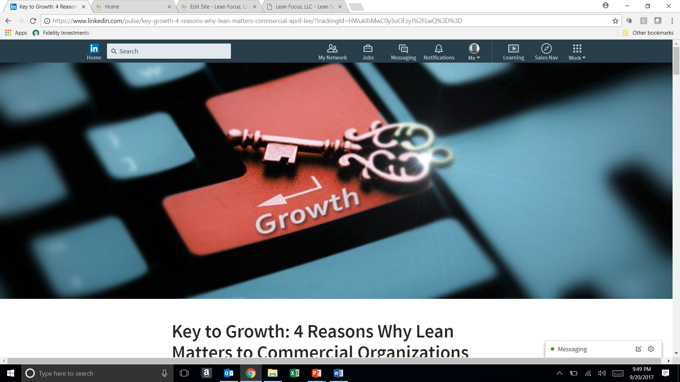

**Key to Growth: 4 Reasons Why Lean Matters to Commercial Organizations**

By April Lee

I get it. I was in the same mind set as you. I worked in Marketing and Sales Operations and had only heard the terms "Six Sigma" and "Total Quality Management" applied to our manufacturing and operations team. Lean was a foreign concept to me known only as the land of black belts, audits, and certificates. Typically, I heard these terms come up when we had run into a product quality snafu of some sort or had issued a recall. To me, it was like the flavor of the month - what new thing was manufacturing working on now?

But what I didn't realize was how critical Lean Concepts are to the big picture of how a successful commercial organization operates. My past sheltered experience didn't allow me to see how critical every department is within an organization to drive delivery of products and services to the marketplace or what happens down the rabbit hole after a sale is closed. I let myself stay only focused on my piece of the pie. That was where I was comfortable and that is what I knew.

But I was wrong in that thinking. Once exposed to the concepts of lean, I quickly understood how critical each of the operations in a company are to the same organizational end game - delivering quality product quickly offering the highest value to the needs, wants and expectations of the customer.

What happens if we close a sale and we don't have the product on hand to deliver it? Well, dear sales representative, the revenue will not be recognized if the product does not go out the door on time, ultimately impacting your commission. What happens if our accounts receivable team isn't able to collect cash in the amount of time expected? Well, commercial team, your cash flow will be impacted, resulting in game plan changes to your ability to reallocate or resource funding for new growth investments. And what happens if our customer support and distribution teams can't handle the massive wave of orders inundating them at quarter end? Don't even get me started! It all matters. But what happens if your commercial organization does not scale productivity and efficiency in alignment with your year-over-year growth achievements? While your sales and marketing teams are grinding away trying to hit a number, what happens if your internal operations are not in line to support?

Within commercial organizations, the entire process flow matters, from the time a customer is a bleep on our prospective radar through the life cycle of their engagement with the organization. Here are 4 reasons why lean concepts matter when applied to commercial organizations:

https://media.licdn.com/mpr/mpr/AAEAAQAAAAAAAAp-AAAAJGYxZTg5ZDJjLTE2ODYtNDc0Yy1hOGQ0LTJlZjJlNmI0NWY1Zg.png

**Reason 1: You are only as strong as your weakest link in your commercial organization.**When we look at the sequence of events, you may have a sales team that is killing it out there in the market, but if any of the support functions down the line falls short of delivery, you will not realize the results of that sale when you expect it. Think of your team like the parts of the human body - every organ / department has a function critical to the workings of the body / organization. If any one of those organs is down, it will impact another organ, and another, etc. in some way. But do you have a health check process on all your body parts to know where your team could be ailing?

**Lean Application to this mess:** Process mapping the critical value streams will allow you to see the big picture of how your team's operations are moving for or against one another. It will allow you to identify potential bottlenecks occurring between the hand-offs between teams or functions and can help you identify areas for improvement. When the arm and the leg are moving to a different beat, you will see that result play out in your top and bottom line. Visualizing the big picture is critical. Using tools like Value Stream Mapping and Commercial Process Engineering will help you identify these pitfalls.



**Reason 2: You cannot grow what you do not know.**Ask yourself how many of your departments are held (I mean, REALLY held) to KPIs? In today's world, it is not enough for your marketing team to tell you how many digital impressions they made or how many prospects they reached. What happens when you ask them, "Show me the MONEY?" in terms of how much revenue they actually pulled through as sales against the spend they incurred? How many of your departments simply shrug when asked what their Key Performance Indicators (KPIs) are and instead, direct you to the company KPIs? How many meetings about meetings about meetings have you had to sit through, watching the clock and hoping to move on to meaningful work? Without knowing exactly how each department/function moves the needle on the bigger picture, you cannot know if the arm or the leg of the organization is delivering what you are expecting it to deliver.

What if I asked you if your team/department is winning or not? "April, we know we're doing a good job. Our boss says we are." Really? How do you know? What is your benchmark against? Are you improving or staying the same over time? Are you stretching yourselves to achieve new targets each year in alignment with the company's overall objectives? And is your pay or incentives tied to the delivery of those KPIs?

**Lean application to this challenge:**First, understanding the overall company's vision and related KPIs is critical. The concept of Strategy Deployment can be used to align the top leadership's vision in alignment with expectations for the different branches of the organization (the arms and the legs, so to speak). From there, a concept of Daily Management (the application of routine management of team/departmental KPI delivery with application of problem solving and countermeasures) will help your team quickly answer whether they are delivering what they said they would in alignment to the beat of the rest of the body/organization.

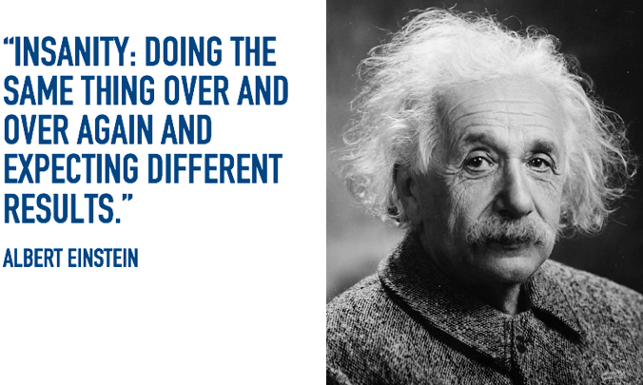

**Reason 3: When you allow your team to operate the same way as always but expect different results, you're already losing.**Think about your team - have any of your team members been there 3 or more years and you rely on them knowing how to do their job? You take comfort in leaving them alone to get the job done and only intervene when something is amiss? Janice has been on the job 15 years, is a hard worker, and is the only one who knows how to do her role. As her boss, you think you're sitting comfortably? What happens when Janice retires, takes vacation, falls ill or decides to move on elsewhere? How about when you on-board a new associate? Is there a playbook of best practices - a training manual with an expert trainer who trains new hires to keep up with the growing organizational demands? Or has that 2006 instruction book sat collecting dust on a shelf and not been updated until it was on someone's checklist to do so? When you train your team on the old way of doing things, you cannot expect them to be successful in today's demanding environment. Or worse yet - what if your organization builds its standard training instructions on the average performance of its associates in that function or task? Ask for the average and you will get average performance as a result.

**Lean application to this challenge:**The concept of Standard Work will allow you to not only identify the best practices (fastest, easiest, most efficient, innovative, creative, quality, you get the picture.....) of an approach to a function or process but ensure your full team benefits from this new standard towards your growing demands. By providing your team with a road map for success and ensuring they follow the process, you can quickly identify if something goes awry where and when it might happen in the process. Control your controllable, don't just take Janice's word for it that things are as good as ever.



**Reason 4: When you make decisions based on gut-feeling, you lose credibility and opportunity.** How often does the team make quick decisions that didn't result in improved performance or are paralyzed from making a decision at all? How often do you hear leaders say "I've been doing this for 20 years and in my experience this will/will not work!" and that's the end of the conversation? How long do strategic initiatives sit in limbo while the team hashes out what to do next or where the resources to take the next step will come from? Without hard data, evidence, and facts, it is difficult to gain buy-in on what to do and where to go next when faced with a big challenge. Organizations are often stuck in this vicious limbo, losing time and opportunity cost.

**Lean application to this challenge:** By building a problem-solving culture within your team and using real evidence to make clear decisions that the team can stand behind is a powerful tool to keep you moving forward. This culture can be developed through the PDCA process - taking time to **Plan** (clearly identify the problem statement, uncover the potential causes to the problem, gather real evidence to drive to a root cause), **Do**(identify countermeasures that will have real impact, pilot test them for proof of concept, and measure real impact), **Check** (put processes in place that will hold the team accountable to the delivery of the countermeasures and performance), and **Act**(building a sustainable culture of reinforcement to continuously improve and drive results over the long term).

Lean doesn't have to be a foreign language to a commercial organization. By taking these complex challenges and using these tools to simplify the processes, you can make real sustainable improvements over the long run. Lean is for everyone, applied strategically, diligently, and not as a "flavor of the month."

*How could your organization benefit from these 4 reasons to apply lean concepts?*

*If you like this article, you can read more by following our Lean Focus LLC company page on LinkedIn below...*

<https://www.linkedin.com/company-beta/16215687/>

*Lean Focus LLC is a results-based Leadership consultancy that deploys our system to drive growth, profit, and working capital.*

<https://www.leanfocusllc.com/>

*© 2018 All Rights Reserved. Do not reproduce this or portions of this document without written permission from Lean Focus LLC, Damon Baker.*[*(630) 800-8519*](http://tel:6308008519/)

