DOES YOUR COMPANY SUFFER FROM SQDIP DYSLEXIA?

By Damon Baker
Dyslexia. According to the Mayo Clinic, dyslexia “…is a learning disorder that involves difficulty reading due to problems identifying speech sounds and learning how they relate to letters and words (decoding)” (Mayo Clinic 2018). Can you imagine struggling to survive in a world where you decode the sound created by “P-R-O-D-U-C-T-I-V-I-T-Y” as “POSITIVITY”, or as “PROFESSIONAL, or even as “POSSIBILITY” instead? Finally, in a gesture of resignation and perhaps embarrassment, you give up, knowing your way is simply not the right way.
Just as a dyslexic must struggle to master basic math and reading skills, the organizational SQDIP dyslexic is faced with the challenge of decoding and applying crucial daily management metrics which are part of the daily lean management system.
Fortunately, the SQDIP dyslexic has more tools at his disposal than a person who suffers from the actual medical diagnosis. Armed with information and effort, the SQDIP dyslexic can navigate, and ultimately master, the Department Daily Management Board meeting. An indispensable acronym, SQDIP, determines the aggregate effects of metrics (or Key Performance Indicators) across departments. Decoded, SQDIP translates to Safety, Quality, Delivery, Inventory, and Productivity.
SQDIP matters. An organization, department, team, or process can fully expect to yield less-than-zero productivity without SQDIP metrics.
I have previously written about the necessity of SQDIP. The visual below is crucial to its understanding and successful implementation. It is a good idea to commit this table to memory. It is well worth the effort, and will help prevent the effects of SQDIP dyslexia.
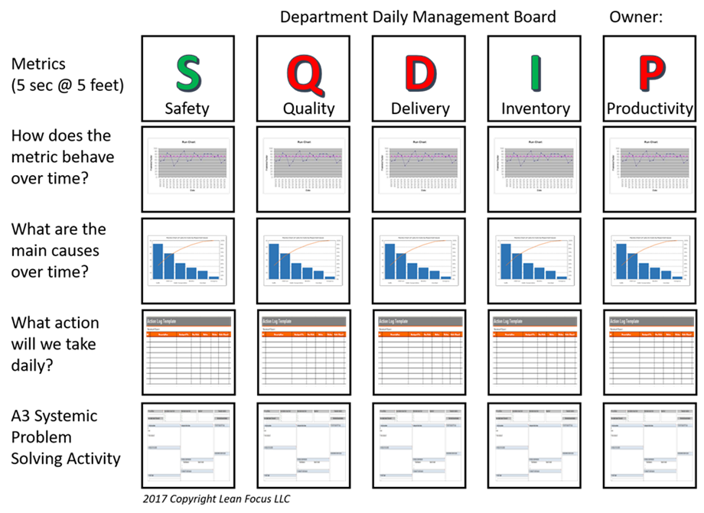
It should be remembered that each metric of SQDIP is not assigned an equal value in rank of importance. Since each metric is ranked according to its overall effect on productivity, think in terms of permutations and combinations. A permutation is the more accurate term for a lock combination, where the sequence of numbers is important. Imagine if your lock combination was “65432”, and you thought it was “56432” (Berry 2017). Indeed, one transposed digit makes a huge difference in whether you can get your lock open.
Likewise, if your organization fails to stick to the basic order of SQDIP, you are left making sense out of exactly 24 permutations of the acronym, rather than decoding only five actionable, easy to explain metrics. Without using SQDIP, you are doing guesswork by trying to open a lock randomly.
Without SQDIP, your organization is only betting on success. Since each metric has its own rank and order, avoiding SQDIP dyslexia is important. A dyslexic department manager may mistakenly emphasize the “Q” (quality) before the “S” (safety), forming “QSDIP” rather than SQDIP and inadvertently prioritizing quality before safety.
Of course, a good mnemonic to keep in mind is: Safety first -- always.
How can you possibly manufacture a quality product without a safe workplace? Questions to ask yourself include: how safe are my employees, their work spaces, and my value-added processes? Every step in your process must reflect your organization’s commitment to safety, as well as the commitment to its overall improvement to safety standards and practices. Safety is perhaps our most vital asset, but also tends to be downplayed, taken for granted, or even forgotten.
Applying the correct SQDIP order simplifies what could otherwise end up being a daunting, time-consuming process for all stakeholders.
A dyslexic department manager may even place the “D” (delivery) before the “Q” (quality). Do you really want to deliver parts and/or finished goods that do not meet your quality standards, or specs? Thus, Quality must precede Delivery. Business history is filled with avoidable quality failures, but they still contain valuable lessons.
Historic dyslexic moments in Total Quality Management (TQM) include the tragic 1986 Space Shuttle Challenger “O”-ring failure, the recent BP Deepwater Horizon oil explosion and spill, and the legendary (and incendiary) Ford Pinto manufactured during the 1970s (Miranda 2014).
“Quality is never an accident. It is always the result of intelligent effort.”
John Ruskin
Finally, imagine if your company prioritizes Inventory before Delivery. By doing so, it may be holding less stock to reduce its working capital. However, the company now finds itself with not enough inventory on hand to deliver to its customers. A common dyslexic error, it makes the balance sheet look better at month-ends and quarter-ends. Nonetheless, this type of dyslexia runs the risk of not satisfying the customer’s short- and long-term product needs.
It is easy to see how SQDIP dyslexia jeopardizes the final metric: Productivity. You can think of “P” as the outcome of good Safety, Quality, Delivery, and Inventory. Without the preceding being in the right order, you will not improve your company’s productivity.
Indeed, like the abovementioned combo lock, each iteration of SQDIP dyslexia removes the process one step further away from its ownership. Of course, without necessary countermeasures, SQDIP dyslexia will continue indefinitely, to the detriment of your departmental and organizational goals. At some point, every metric will succumb to a domino-like effect, showing departments how interconnected they really are, negatively impacting your bottom line.
It is now long past the quick fix stage.
Certainly, every manager would prefer meeting sales and revenue targets rather than gambling on their livelihoods and their bottom lines. Untangling and teasing out what went wrong and how it affects a given metric takes extra time. Thus, everyone has a vested interest in knowing and applying SQDIP metrics, making it a vital part of their daily lean management system.
Based on what I have learned from nearly two decades of daily lean management systems, unlike the abovementioned SQDIP dyslexia horror stories, I have had the privilege of helping organizations big and small, come to understand the power of prioritizing the right metrics that matter, and charting a course for sustainable improvement. Do not succumb to SQDIP dyslexia and the temptation to execute short-sighted strategies, as they will create unintended consequences.
If you like this article, you can read more by following our Lean Focus LLC company page on LinkedIn below:
https://www.linkedin.com/company/lean-focus-llc/
At Lean Focus LLC, we are results-driven Leaders that use our system to help clients capture Growth, Profit, and Working Capital opportunities.
https://leanfocus.com/
© 2018 All Rights Reserved. Do not reproduce this or portions of this document without written permission from Lean Focus LLC, Damon Baker. (630) 800-8519
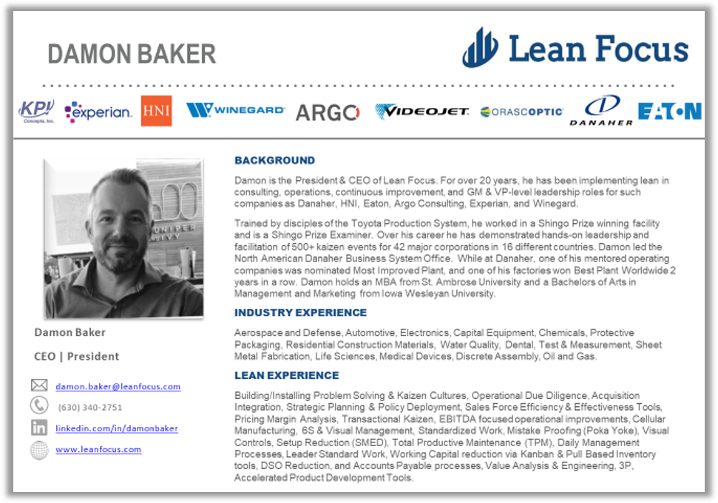
References
- Berry, B. (14 Jun. 2017). Combinations vs. permutations. Math Memoirs. Retrieved from: https://medium.com/i-math/combinations-permutations-fa7ac680f0ac
- Mayo Clinic. (2018). Dyslexia. Retrieved from https://www.mayoclinic.org/diseases-conditions/dyslexia/symptoms-causes/syc-20353552
- Miranda, S. (08 Aug. 2014). 5 quality failures that shook the world. PEX. Retrieved from: https://www.processexcellencenetwork.com/lean-six-sigma-business-performance/articles/5-quality-failures-that-shook-the-world

