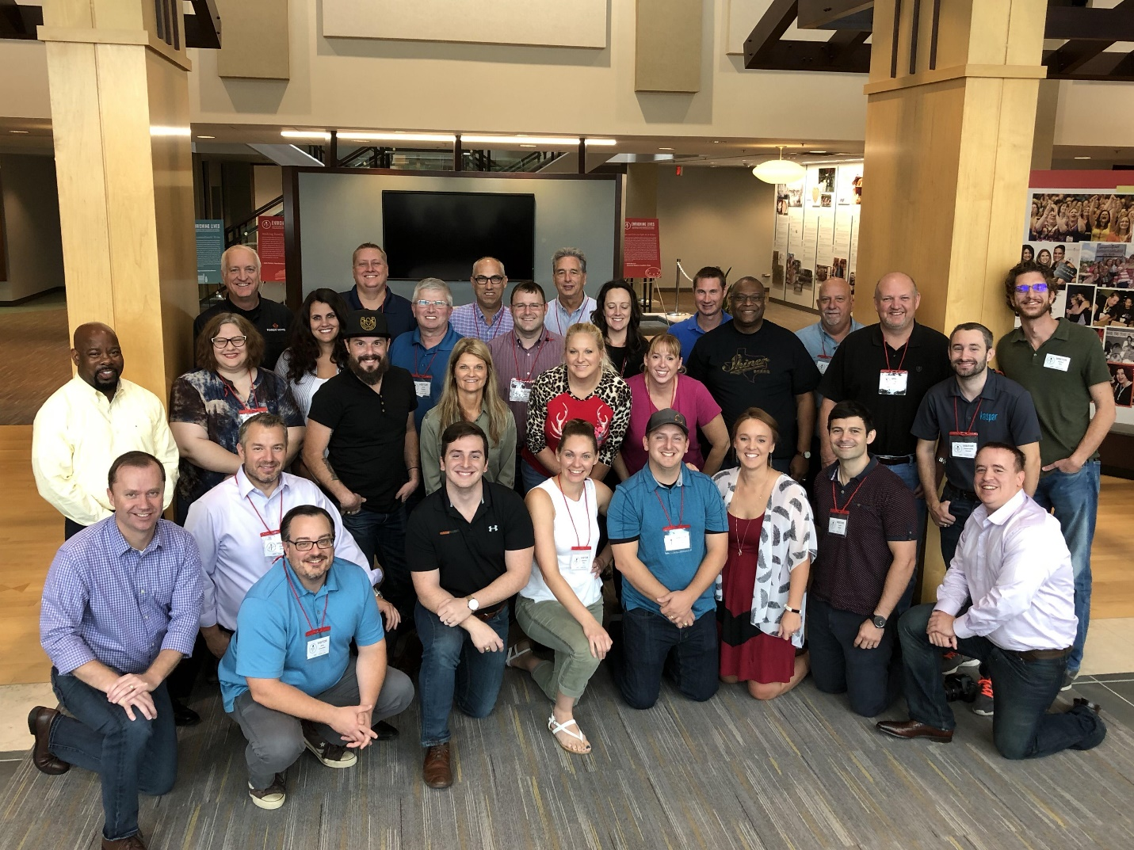

The Language of Lean: Kaspar Companies Attends LBSU Leadership System Boot Camp
By Deron Reed and Damon Baker
Note: This is the first installment of a two-part series that examines Lean Focus Business System University (LBSU) Boot Camp, a five-day intensive training curriculum that teaches lean management, continuous improvement, and Kaizen principles with hands-on applications.
As the week of August 13-17 drew to a close at Lean Focus Business System University’s Leadership System Boot Camp, Kaspar Companies’ leaders took home some critical lessons to all nine of its subsidiaries, in both the theory and application of lean manufacturing principles. Headquartered in Shiner, Texas, Kaspar Companies was represented by top managers from BEDROCK Truck Beds, Espresso Marketing & Design, Horizon Firearms, iota Outdoors, Kaspar Manufacturing, Ranch Hand, Silverback Homes, Texas Precious Metals, and Truckfitters.
Lean Focus CEO Damon Baker leads and conducts the LBSU Boot Camp, which convenes regularly at Pampered Chef in Addison, Illinois. A Berkshire Hathaway company, Pampered Chef has also implemented LBS lean principles with a view to improve both its market share and profitability.
Led by CEO Jason Kaspar, KCI is committed to three core values: stewardship, versatility, and family. Those values were exemplified well by all thirty participants during the week-long event. Not only did everyone graduate with flying colors, they showed -- lesson after lesson -- what leadership, teamwork, and winning look like in an environment that is fully committed to the lean journey.
The “language of lean” covers a lot of territory, but, in essence, boils down to improving organizational team problem-solving skills. While Kaspar Companies has been on the lean journey for the past 18 months, this is their first rodeo using Lean Focus’s problem-solving methodology. LBSU’s Boot Camp course offerings are divided into three broad categories, each with specific courses chockfull of real-world problems: Problem-Solving (PS2), Daily Management, and Strategy Deployment.
“The creation of the Lean Focus Business System University (LBSU), affords participants the unique, cost-effective opportunity to receive coaching and training from expert practitioners that otherwise would be unavailable in their organizations,” Baker said. “Our instructors average over 20 years of hands-on lean experience, in leadership roles, with such companies as Danaher, Boeing, and John Deere, which have a long track record of driving results by employing a culture of continuous improvement.”
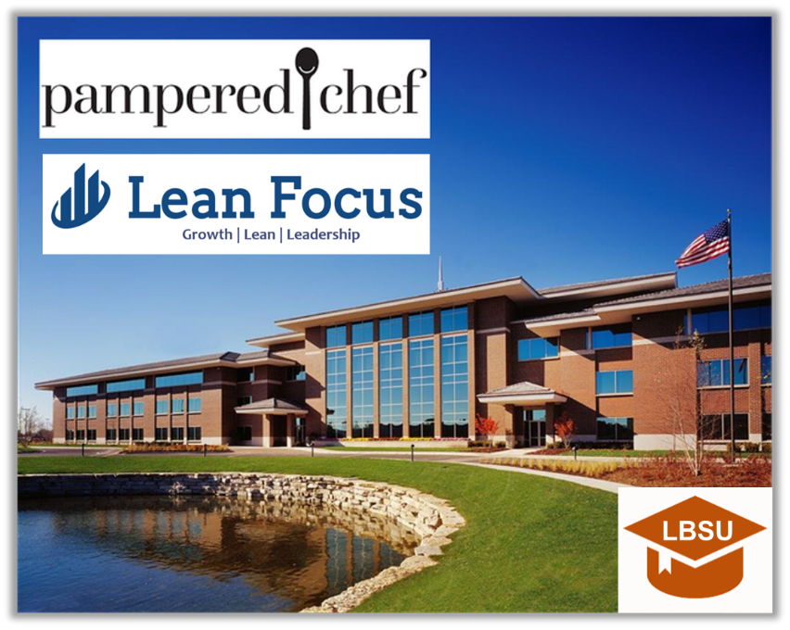
Indeed, one of the problems with any organization that does not practice lean management principles is that their organizations suffer from being in a constant firefighting mode. Typically, a firefighting culture will rely on management “experience” to solve problems whereas a problem-solving culture will depend on factual evidence and root-cause analysis in its logical decision-making processes.
Moreover, a problem-solving culture nurtures a team approach to solving problems, but firefighting cultures resort to blaming others for organizational problems. Exhaustive firefighting requires costly, time-consuming countermeasures which may fan the flames even further, transforming mere hot spots into a raging inferno.
“An organization that is characterized by widespread firefighting to conduct day-to-day operations will not dedicate the necessary time to truly solve problems in a sustainable way that delivers improved performance,” Baker said. “The types of behaviors you can expect to observe are the following: responding to any and every problem without regard to priority level, a lack of clear standards in the organization that clearly determine what is and is not a problem, and the loudest or most persistent person determines priorities.”
Another serious impediment to effective problem-solving is characterized by the failure to go to the “gemba”. Translated from Japanese, the term “gemba” means the workplace, roughly. Going to the “gemba” means going to where the work is done – where the problem is. At the LBSU Boot Camp, Baker used the analogy of a crime scene investigation when going to the “gemba”. In lean organizations “gemba walks” are a matter of course.
“One of my favorite examples of going to the gemba comes from the old television show, Columbo, and some of the things Detective Columbo did included working backwards, collecting fact-based evidence, and observing for one’s self – never just taking someone’s word for it,” Baker said. “Like any good CSI, Columbo started with the crime scene…he always started with the original problem, and he asked questions incessantly in order to identify the root cause, i.e. whodunit, in this case.”
Like the determined detective, Lean Focus CEO Damon Baker has been identifying root causes of organizational problems for nearly two decades. He has found that one of the problems management leaders face is their confusion between symptoms, problems, and root causes. In the LBSU Boot Camp, simple visual aids such as brightly-colored Post-It notes and easel sticky paper help students more easily identify root causes using nothing more than hand-drawn trees. Baker asserts that such visuals simplify the problem-solving process, while adding a kinesthetic feature that is glaringly absent from much lean management curricula and many so-called modern organizations which may rely solely on touch screen layouts.
LBSU has its sights set on a bright future and Baker’s enthusiasm is contagious. “I really enjoy observing the leaders evolve and improve throughout the week in terms of their understanding of what this system can do to drive results in their business,” he said. “They come in searching for direction and leave with laser-focused clarity on how and what to focus on in their business, (and) this makes it all worthwhile.”
If you like this article, you can read more by following our Lean Focus LLC company page on LinkedIn below:
https://www.linkedin.com/company/lean-focus-llc/
At Lean Focus LLC, we are results-driven Leaders that use our system to help clients capture Growth, Profit, and Working Capital opportunities.
https://leanfocus.com/
© 2018 All Rights Reserved. Do not reproduce this or portions of this document without written permission from Lean Focus LLC, Damon Baker. (630) 800-8519

