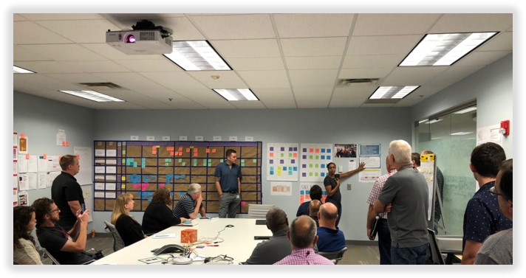

The Lean Transformation: In the Obeya Room and Beyond
By Deron Reed and Damon Baker
Note: This is the second installment of a two-part series that examines Lean Focus Business System University (LBSU) Boot Camp, a five-day intensive training curriculum that teaches lean management, continuous improvement, and Kaizen principles with hands-on applications.
Surrounded on one wall of the Obeya room by a brown paper analysis with neatly-organized tables and enclosed by colorful Post-It notes on the other three walls, both Arielle Deane, Senior Manager of Consumer Experience, and Eric Buckner, Senior Product Manager, explained the dynamics of their strategy deployment meetings at Pampered Chef in Addison, Illinois to a roomful of Lean Focus Business System University (LBSU) Boot Camp students from Kaspar Companies, located in Shiner, Texas.
For nearly the past two years, Lean Focus has consulted Pampered Chef, training the internationally-renowned kitchen company how to transform their organization using lean management principles and practices. Pampered Chef’s embracement of lean thinking has helped increase their market share and profitability. In addition, Pampered Chef has more social media followers -- including Facebook and Twitter – than at any other time in their history. The Obeya Rooms have helped moved this process along at a faster, more efficient pace. Japanese for “great room”, an Obeya Room is where management meetings rely on factual analyses to solve organizational problems.
“One of the benefits of the (Obeya Room) is to take all our work and take it out of PowerPoint…which helps us talk about the most important points…so the meetings (there) really save us a lot of time from trying to make PowerPoint look reflectable and readable. The meeting allows us instead to focus in on some of the more important things without having to do a lot of pre-work, ahead of time,” Deane said. “We have five strategic initiatives, and each strategic initiative has its dedicated room…Each project team has a chance to work with a broader team and each team has a dedicated wall space which can be used to make it easier to talk about what is on the wall instead of what is ‘my opinion versus your opinion’. We do have cross-functional viewpoints participating in that discussion. The teams can also use (the Obeya Room) as a meeting room for working space and team collaboration -- and with the officers, we can walk them around and show them where we are on our projects.
“One of our biggest success stories was having the opportunity…of developing a better delivery mechanism to talk to our sales team and our consultants so we addressed the issue by forming a team to prioritize and work directly with that,” she continued. “The second part of that piece is that we work much more cross-functionally now than we have in the past…and better together as a team.”
Their five dedicated Obeya Rooms are a testament to Pampered Chef’s commitment to their management meetings and their overall success with lean management applications, which include the brown paper analysis. A crucial aspect of any daily management meeting, a brown paper analysis works well for solving cross-functional problems.
Moreover, a brown paper analysis is a visual that is presented in an easy-to-understand format – revealing to management exactly where organizational “pain points” are located. More than a flowchart, a brown paper analysis tells the story of the real process (a tale of facts rather than opinions) as it happens. Pampered Chef’s Obeya Rooms accurately reflect both the flow and format of the problem-solving process.
Spearheaded by CEO Damon Baker, Lean Focus, LLC operates its Lean Focus Business System University Boot Camps at Pampered Chef’s campus. Pampered Chef also caters food and provides conference space for classes at the campus during scheduled LBSU Boot Camps.
Rob Bennett, Director of Talent Management at Pampered Chef, also spoke before Kaspar Companies’ management leaders about the company’s lean transformation. Bennett explained that stakeholders have quickly adapted to the lean transformation at Pampered Chef, stating “We have really embraced lean practices…we use the A3 in a number of areas, and we use KPIs in a number of areas as well”. Bennett added, “We are building a small internal team as well. Our work with (Baker and Lean Focus) has really created that road-map we need to get where we want to be.”
“A3 is a structured problem-solving approach that is highly collaborative in nature and tends to be best suited to systemic, recurring issues, whereas the daily management system is geared towards day-to-day resolution of issues,” Baker said. “Each day’s results in daily management are captured to allow the teams to visualize the most chronic problems, of which a formal A3 activity can be initiated against.”
Pampered Chef’s success has been intricately intertwined with their lean transformation – catalyzed by LBSU.
Baker stated, “The creation of the Lean Focus Business System University (LBSU), affords participants the unique, cost-effective opportunity to receive coaching and training from expert practitioners that otherwise would be unavailable in their organizations.”
“Our instructors average over 20 years of hands-on lean experience, in leadership roles, with such companies as Danaher, Boeing, and John Deere, which have a long track record of driving results by employing a culture of continuous improvement.”
Indeed, LBSU’s Boot Camp imparts a great deal of hands-on experience to organizations such as Kaspar Companies and Pampered Chef, organizations which are fully committed to their lean journeys. In turn, such companies utilize Boot Camp principles on-site, putting them into immediate action and earning timely results.
Jason Kaspar, CEO of Kaspar Companies, a self-confessed “voracious reader and financials man” with Wall Street experience, addressed the highly-organized, intentional nature of LBSU’s Boot Camp experience -- a context that nevertheless makes sense of the inherent chaos of any manufacturing environment. Kaspar likened their previous lean manufacturing process to treading cautiously through the darkness.
“I finally put all the pieces together in July of 2017 and put into motion what was designed to be a more intentional strategy…Company-wide, everything that was formulated in an embryo stage was kicked off in February of 2018. Since then, we have been following a defined cadence (and) I consider the business system a subset of our overarching strategy…The launch of the business system, the boot camp, was the foundational map of the aspect of the ‘how’ and that all kicked off in Chicago at the Lean Focus event,” Kaspar said.
“What Damon (Baker) did at this event was ensure that all 27 of the participants ‘have the vision’ and know how it can work in the other companies and the enthusiasm and excitement for where we are now going is tangible. What (Baker) was able to do was communicate what Danaher did and convey the vision of a proven concept…and we immediately saw how that works.
“When we got back, we looked at four things that we want to accomplish over the next 60 to 90 days,” he continued. “Those four things are systematic Lean Daily Management (LDM) boards across subsidiaries, an A3 problem-solving initiative, a Kaizen calendar ‘resourcing exercise’ so we do not over-extend everybody, and an off-shoot of an Obeya Room -- an experiential room where all the information would flow from all the different subsidiaries to a headquarters.
“I have never heard of a systematic problem-solving process (such as LBSU’s approach), and I loved the way, from a training perspective, mock trials were employed using the LDM boards,” Kaspar added. “I give kudos to Baker because a lot of consultants for a lot of organizations set them up for failure, whereas the Boot Camp’s overall openness and very pragmatic approach tailored to our specific problems was very helpful and added value to our experience.”
“One lesson that clearly jumps out to me for the participants, is that achieving better results in a business should not be left up to chance,” Baker concluded. “We teach Leadership System Boot Camp participants that in order to improve performance, your organization must learn and practice a structured, repeatable problem-solving process to attack the problems that exist at multiple levels of the organization.”
Indeed, this problem-solving process continues to benefit Pampered Chef, while Kaspar Companies has already begun to feel the momentum of its company-wide adoption.
To learn more about upcoming Lean Focus Business System University workshops/events, you can click the LBSU image / link below:
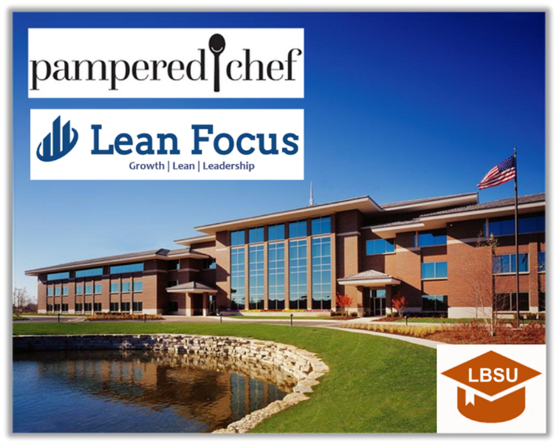
If you like this article, you can read more by following our Lean Focus LLC company page on LinkedIn below:
https://www.linkedin.com/company/lean-focus-llc/
At Lean Focus LLC, we are results-driven Leaders that use our system to help clients capture Growth, Profit, and Working Capital opportunities.
https://leanfocus.com/
© 2018 All Rights Reserved. Do not reproduce this or portions of this document without written permission from Lean Focus LLC, Damon Baker. (630) 800-8519
