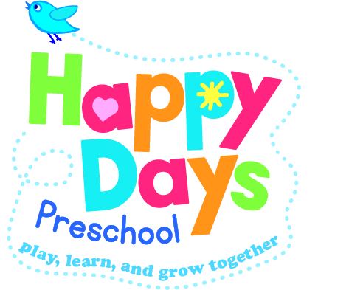
Maintaining children’s safety and security on premises

Policy statement

We maintain the highest possible security of our premises to ensure that each child is safely cared for during their time with us.

Procedures

Children's personal safety

We ensure all employed staff have been checked for criminal records via an enhanced disclosure with children’s barred list check through the Disclosure and Barring Service.

All children are supervised by adults at all times.

Whenever children are on the premises at least two adults are present.

We carry out risk assessments to ensure children are not made vulnerable within any part of our premises, nor by any activity.
We carry out regular fire practice drills and lock down (snuggle down) practices.

Security
- Systems are in place for the safe arrival and departure of children.
- A register is taken in the morning and after lunch.
- Our systems prevent children from leaving our premises unnoticed.
- We only allow access to visitors with prior appointments.
- We keep the front doors locked shut at all times. Back doors are kept locked shut at all times where they may lead to a public or unsupervised area. The back door is hooked open when the children are in the back garden.
- When the children are in the garden the garden gate must be closed and the top latch on to prevent children getting out.
- The personal possessions of staff and volunteers are securely stored during sessions.
- Minimal petty cash is kept on the premises.

This policy was adopted by | Happy Days Preschool | (name of provider)
On | 04/10/2021 | (date)
Date to be reviewed | As needed | (date)

