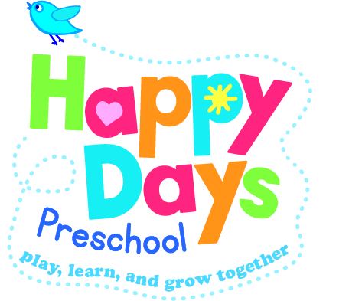
Nappy changing. Toileting.

Policy statement

No child is excluded from participating in our setting who may, for any reason, yet be toilet trained and who may still be wearing nappies or equivalent. We work with parents towards toilet training, unless there are medical or other developmental reasons why this may not be appropriate at the time.

We provide nappy changing facilities and exercise good hygiene practices in order to accommodate children who are not, yet toilet trained.

We see toilet training as a self-care skill that children can learn with the full support and non-judgemental concern of adults.

Procedures

- We have a check list which is completed when a nappy is changed. This is timed dated and signed by the staff member who has changed the child. Nappies are checked regularly and changed when needed.
- We encourage young children from two years to normally wear pull ups, or other types of trainer pants, as soon as they are comfortable with this and if their parents agree.
- Our changing area is warm, with a safe area to lay children.
- Each child has their own bag to hand with their nappies or pull ups and changing wipes.
- Our staff put on gloves (aprons if necessary) before changing starts and the areas are prepared. The changing mat is sprayed and cleaned after every use.
- All our staff are familiar with our hygiene procedures and carry these out when changing nappies. Gloves are not always required for a wet nappy where there is no risk of infection, however, gloves are always available for those staff who choose to wear them. Gloves are always worn for a ‘soiled’ nappy.
- Our staff never turn their back on a child or leave them unattended whilst they are on the changing mat.
- We are gentle when changing; we avoid pulling faces and making negative comments about ‘nappy contents.
- We do not make inappropriate comments about children’s genitals when changing their nappies.
- In addition, we ensure that nappy changing is relaxed and a time to promote independence in young children.
- We encourage children to take an interest in using the toilet; they may just want to sit on it and talk to a friend who is also using the toilet.
- We encourage children to wash their hands and have soap and towels to hand. They should be allowed time for some play as they explore the water and the soap.
- Older children access the toilet when they have the need to and are encouraged to be independent.
- Due to the nature of where the toilet is, an adult always accompanies children to the toilet. (only staff who have been DBS checked by Happy Days can take children to the toilet). Making a log of who has been, the time and which staff member took them. This also allows us to see who has and who needs to go to the toilet.
- We dispose of nappies and pull ups hygienically. Any soil (faeces) in nappies or pull ups is flushed down the toilet and the nappy or pull up is bagged and put in the bin. Cloth nappies, trainer pants and ordinary pants that have been wet or soiled are rinsed and bagged for parents to take home.
- We have a ‘duty of care’ towards children’s personal needs.

This policy was adopted by | Happy Days Preschool | (name of provider)
On | 20/02.202 | (date)
Date to be reviewed | As needed | (date)

